Stars
SECTION 29.1 The Sun
In your textbook, read about the properties of the Sun and the Sun’s atmosphere.
Use each of the terms below just once to complete the passage.
chromosphere | corona | gaseous | ions | mass
photosphere | solar eclipse | solar system | solar wind
The Sun is the largest object in our (1) __solar system_______ . Its (2) ___mass______
controls the motions of the planets. The center of the Sun is very dense. The high temperature
at its center causes the solar interior to be (3) _____gaseous_______ throughout.
The visible surface of the Sun is called the (4) ____photosphere_____ . It is the lowest layer
of the Sun and is approximately 400 km in thickness. The average temperature is 5800 K.
Above the visible layer is the (5) ___chromosphere____ . It is approximately 2500 km thick and
has an average temperature of 15,000 K. Without special filters, this layer is visible only
during a (6) ___solar eclipse____.
The top layer of the Sun’s atmosphere is the (7) ___corona____. It has a temperature
of about 3 million to 5 million K. Plasma flows outward from this layer at high speeds and forms
the (8) ____solar wind______ . It is made up of charged particles, or (9) _______ions__________ ,
which flow outward through the entire solar system.
In your textbook, read about solar activity.
For each term in Column A, write the letter of the matching item in Column B.
Column A Column B
___c.___ 10. Cooler areas on the surface of the photosphere that
appear darker than the surrounding areas on the Sun
- prominence
- solar flares
- sunspots
- coronal holes
- solar activity cycle

__e.____ 11. A period of 22 years in which the number of sunspots
on the Sun changes regularly and the Sun’s magnetic field
reverses
___d.___ 12. Areas of low density in the gas of the corona from
which particles escape
___b.___ 13. Violent eruptions of particles and radiation from the
surface of the Sun
___a.___ 14. Arc of gas ejected from the photosphere

SECTION 29.1 The Sun, continued
In your textbook, read about the solar interior.
Use the terms below to label the diagram.
convection zone | radiation zone | core
15. ____radiation zone____ (116. _____convection zone___
17. _____core________
Answer the following questions.
- What is fusion? Where does it take place in the Sun?
Fusion is the combining of lightweight nuclei into heavier nuclei. It takes place within the core of the Sun / where plasma is
- What is fission?
Fission is the opposite process of fusion. It is the splitting of heavy atomic nuclei into smaller, lighter atomic nuclei
- How is Einstein’s theory of special relativity expressed? What does each letter stand for?
E=mc^2. E is energy measured in joules, m is the quantity of mass that is converted to energy measured in kilograms, c is the speed of light measured in m/s.
- What is the process that transfers the Sun’s energy from particle to particle? Where does this process take place?
The process is radiation. It takes place in the radiation zone.
- What is the process that carries the Sun’s energy the rest of the way to the Sun’s surface?
What carries the energy?
The process is convection. The energy is carried by moving volumes of gas.
- How far, as a percentage, does the radiation zone extend to the photosphere?
The radiation zone extends approximately 86 percent of the way to the photosphere.

SECTION 29.2 Measuring the Stars
In your textbook, read about groups of stars and stellar positions and distances.
Circle the letter of the choice that best completes the statement or answers the question.
1. Constellations are
a. the brightest stars.
b. stars over Greece.
c. groups of stars named after animals, mythological characters, or everyday objects.
d. found only in the northern hemisphere.
2. Ursa Major, which contains the Big Dipper, is an example of a
a. circumpolar constellation.
b. constellation that can be seen only in winter.
c. constellation that can be seen only in summer.
d. constellation that can be seen only in the fall.
3. Scientists measure distances to stars and observe how stars interact with one another to
a. determine if stars are right next to each other.
b. determine if stars are touching.
c. determine the names of constellations.
d. determine which stars are gravitationally bound to each other.
4. Astronomers can identify binary stars by
a. comparing the colors of the stars.
b. measuring the parallax of the stars.
c. measuring the position of the visible star in the pair and noting shifts as it orbits the center of mass between it and the unseen companion star.
d. examining the stars’ absorption spectra.
5. When estimating the distance of stars from Earth, astronomers use the fact that nearby stars shift in position as observed from Earth, which is called
a. parsec. b. parallax. c. precision. d. shafting.
In your textbook, read about the basic properties of stars.
For each term in Column A, write the letter of the matching item in Column B.
Column A Column B
____d.__ 6. Ancient Greek classification system based on how
bright a star appears to be
- luminosity
b. absolute magnitude
c. watt
d. apparent magnitude

___b.___ 7. Brightness of an object if it was placed at a distance
of 10 pc
___a.___ 8. Energy output from the surface of a star per second
___c.___ 9. Unit of measurement used to express the energy
emitted per second

SECTION 29.2 Measuring the Stars, continued
In your textbook, read about the spectra of stars.
Use the diagram below to answer the questions.
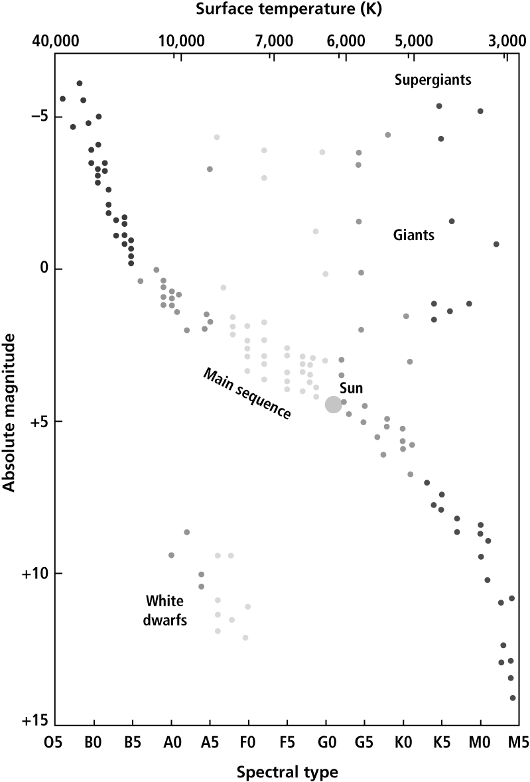
- The spectral types—O, B, A, F, G, K, M—were originally based on the pattern of spectral lines. What else did astronomers discover that the classes corresponded to? What is the difference from O to M?
The classification also corresponds to stellar temperatures. O, the hottest star, is about 50,000 K. While M, the coolest star, is as low as 2000 to 3000 K.
- What type of star is the Sun? What is its surface temperature? What is its absolute magnitude?
The Sun is a type G2 star. It has a surface temperature of just under 6000 K. Its absolute magnitude is about a +5.
- What is the typical composition of a star?
Stars are typically composed of about 73% hydrogen, 25% helium, and 2% other elements.
- What makes a star’s spectrum appear to be different from another star’s?
The difference in the appearance of stars’ spectra are the result of temperature effects.

SECTION 29.3 Stellar Evolution
In your textbook, read about the basic structure of stars.
Use each of the terms below just once to complete the passage.
carbon | helium | hydrostatic equilibrium | iron
luminosity | magnesium | mass | neon
nuclear fusion | oxygen | silicon | temperature
For a star to be stable, it must have (1) __hydrostatic equilibrium_____ , which is the balance between gravity
squeezing inward and pressure from (2) ____nuclear fusion____ and radiation pushing outward. This
balance is governed by the (3) ____mass____ of the star. The (4) ____temperature_____
inside a star determines the star’s energy output, or (5) ____luminosity_____.
Stars on the main sequence produce energy by fusing hydrogen into (6) ___helium____.
Once a star’s core has been converted into helium, it may react if the temperature is high enough.
If the temperature is high enough, (7) ____carbon_____ can react with helium to form
(8) ____oxygen____ , then (9) ______neon_____ , then (10) _____magnesium_____ ,
and then (11) _____silicon_____ . Other types of reactions can produce even heavier
elements, the heaviest being (12) ______iron______ .
In your text, read about stellar evolution and life cycles.
For each statement below, write true or false.
_____false_____ 13. As a star ages, its internal composition changes as a result of rising
temperature.
______true_____ 14. As nuclear fuel runs out, a star’s internal structure and its mechanism for producing pressure change to counteract gravity.
______true_____ 15. The formation of a star begins with a cloud of interstellar gas and dust called nebula.
______false______ 16. A nebula collapses on itself as a result of its high temperature.
______true______ 17. As a nebula contracts, its rotation forces it into a disk shape with a hot
condensed object at the center, which will become a new star.
______true______ 18. A new star often illuminates the gas and dust surrounding it.

SECTION 29.3 Stellar Evolution, continued
In your textbook, read about the Sun’s life cycle.
Answer the following questions.
- How many years does it take a star with the mass of the Sun to convert all the hydrogen in its core? To what is the hydrogen converted?
About 10 billion years; its hydrogen is converted to helium
- What happens to a star when it becomes a red giant?
When the hydrogen in the core is gone, the star has a helium center and outer layers made of hydrogen-dominated gas. Some hydrogen continues to react in a thin layer at the outer edge of the helium core. The energy produced at this level forces the outer layers to expand and cool. Then the star loses gas from its outer layers.
- A star of the Sun’s mass never becomes hot enough for carbon to react, and the star’s energy production is at an end. What happens to the outer layers? What is this star called?
The outer layers expand and contract, and subsequently are driven off by pulsations. The core of the star becomes exposed as a small, hot object about the size of Earth. Then it is a white dwarf.

In your textbook, read about life cycles of massive stars.
Circle the letter of the choice that best completes the statement.
22. A star that begins with a mass 8 to 20 times that of the Sun’s mass will
a. undergo the same evolution as the Sun.
b. become a white dwarf.
c. end up with a core too massive to be supported by pressure and come to a violent end.
d. remain at the same stage and not evolve.
23. The resistance of a star’s core to being squeezed halts the collapse of the core and the core becomes a
a. supernova. b. neutron star. c. red dwarf. d. protostar.
24. During a supernova,
a. infalling gas remains trapped in the core.
b. the core continues to fuse helium.
c. the resistance of electrons being squeezed counteracts gravity and supports the core.
d. the entire outer portion of the star is blown off in a massive explosion.
25. A star that starts with more than about 20 times the Sun’s mass will
a. become a neutron star.
b. continue to fuse iron in its core.
c. end up with a smaller mass.
d. collapse forever and become a black hole.
Study Guide – Chapter 29 – Stars
Section 29.1 The Sun
- solar system
- mass
- gaseous
- photosphere
- chromosphere
- solar eclipse
- corona
- solar wind
- ions
- c
- e
- d
- b
- a
- radiation zone
- convection zone
- core
- Fusion is the combining of lightweight nuclei into heavier nuclei. It takes place within the core of the Sun.
- Fission is the opposite process of fusion. It is the splitting of heavy atomic nuclei into smaller, lighter atomic nuclei.
- E = mc². E is energy measured in joules, m is the quantity of mass that is converted to energy measured in kilograms, c is the speed of light measured in m/s.
- The process is radiation. It takes place in the radiation zone.
- The process is convection. The energy is carried by moving volumes of gas.
- The radiation zone extends approximately 86 percent of the way to the photosphere.

Section 29.2 Measuring the Stars
- c
- a
- d
- c
- b
- d
- b
- a
- c
- The classification also corresponds to stellar temperatures. O, the hottest star, is about 50,000 K. M, the coolest star, is as low as 2000 to 3000 K.
- The Sun is a type G2 star. It has a surface temperature of just under 6000 K. Its absolute magnitude is about a +5.
- Stars are typically composed of about
73 percent hydrogen, 25 percent helium, and 2 percent other elements.
- The differences in the appearance of stars’ spectra are the result of temperature effects.
Section 29.3 Stellar Evolution
- hydrostatic equilibrium
- nuclear fusion
- mass
- temperature
- luminosity
- helium
- carbon
- oxygen
- neon
- magnesium
- silicon
- iron
- false
- true

- true
- false
- true
- true
- About 10 billion years; its hydrogen is converted to helium.
- When the hydrogen in the core is gone, the star has a helium center and outer layers made of hydrogen-dominated gas. Some hydrogen continues to react in a thin layer at the outer edge of the helium core. The energy produced at this level forces the outer layers to expand and cool. Then the star loses gas from its outer layers.
- The outer layers expand and are driven off by pulsations. The core of the star becomes exposed as a small, hot object about the size of Earth. It is then a white dwarf.
- c
- b
- d
- d

