**Galaxies**  Name: _____________________

**Background: How Are Galaxies Classified? What Do They Look Like?**

Edwin Hubble classified galaxies into four major types: **spiral, barred spiral, elliptical,**

**and irregular**. Most galaxies are spirals, barred spirals, or ellipticals.

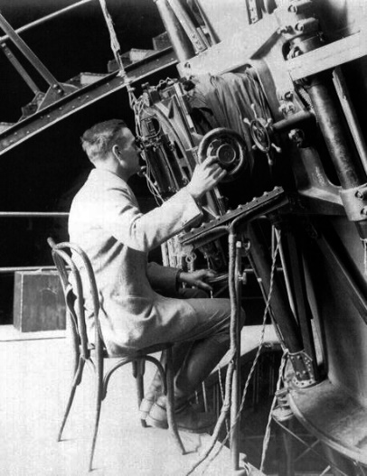

**Edwin Hubble** was an American astronomer who, in 1925, was the first to demonstrate the existence of other galaxies besides the Milky Way

**Spiral galaxies** are made up of a flattened disk containing spiral (pinwheel-shaped)

arms, a bulge at its center, and a halo. Spiral galaxies have a variety of shapes and are

classified according to the size of the bulge and the tightness and appearance of the

arms. The spiral arms, which wrap around the bulge, contain numerous young blue

stars and lots of gas and dust. Stars in the bulge tend to be older and redder. Yellow

stars like our Sun are found throughout the disk of a spiral galaxy. These galaxies

rotate somewhat like a hurricane or a whirlpool.

**Barred spiral galaxies** are spirals that have a bar running across the center of the

galaxy.

**Elliptical galaxies** do not have a disk or arms. Instead, they are characterized by a

smooth, ball-shaped appearance. Ellipticals contain old stars, and possess little gas or

dust. They are classified by the shape of the ball, which can range from round to oval

(baseball-shaped to football-shaped). The smallest elliptical galaxies (called "dwarf

ellipticals") are probably the most common type of galaxy in the nearby universe. In

contrast to spirals, the stars in ellipticals do not revolve around the center in an

organized way. The stars move on randomly oriented orbits within the galaxy like a

swarm of bees.

**Irregular galaxies** are galaxies that are neither spiral nor elliptical. They tend to be

smaller objects that are without definite shape and tend to have very hot newer stars

mixed in with lots of gas and dust. These galaxies often have active regions of star

formation. Sometimes the irregular shape of these galaxies results from interactions or

collisions between galaxies. Observations such as the Hubble Deep Fields show that

irregular galaxies were more common in the distant (early) universe.

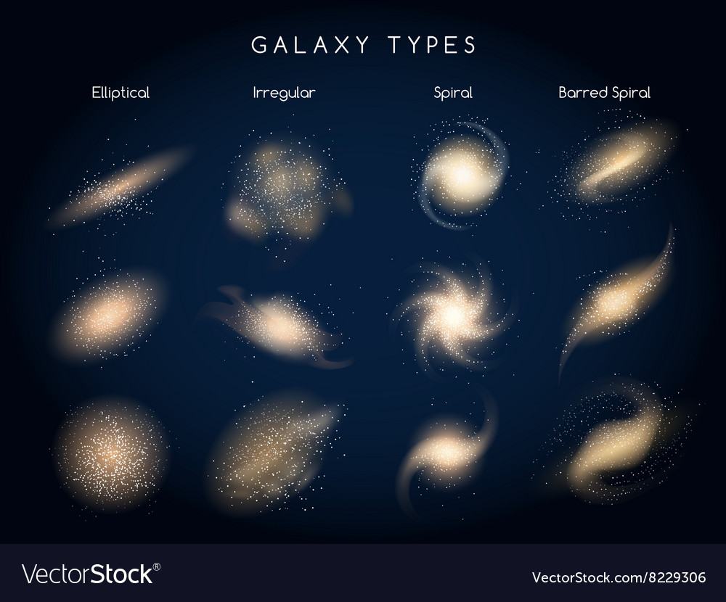

**How Do You Classify Galaxies Today?**

Today we classify galaxies mainly into two major groups following Hubble’s examples

(top of next page). Elliptical galaxies range from round shapes (E0) to oval shapes

(E7). Spiral galaxies have a pinwheel shape and are classified according to their bulge,

as well as how tightly their arms are wrapped around the bulge. They range from (Sa),

which has a large bulge and tight, smooth arms, to (Sc), which has a small bulge and

loose, lumpy arms.

Barred spiral galaxies classified as (SB) are pinwheel-shaped and have a distinct "bar"

of stars, dust and gas across their bulge. They range from an (SBa), which has a bar

across its large bulge and tight, smooth arms, to an (SBc), which has a bar across its

small bulge and loose, lumpy arms. Irregular galaxies have no definite shape but still

contain new stars, gas, and dust. The chart below summarizes the properties of the

main classes of galaxies.

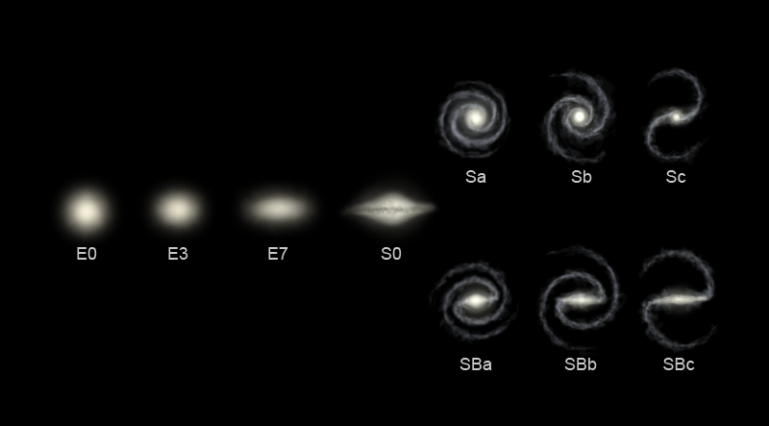

|  |  |  |  |
| --- | --- | --- | --- |
|  | **SPIRAL / BARRED SPIRAL (S, SB)** | **ELLIPTICAL (E)** | **IRREGULAR (Irr)** |
| **Shape and Structural Properties** | Disks of stars, gas, and dust containing spiral arms that thicken to central bulge. **Sa** and **SBa** have largest bulge. **SB** galaxies have central bar. | No disk and no arms. Stars distributed evenly from near circular to oval (football). | No structure. |
| **Stellar Content** | Have both young and old stars. Halos consist of old stars only. | Contain mostly old stars. | Contain both young and old stars. |
| **Gas and Dust** | Disks contain gas and dust. Halos contain little gas or dust. | Little or no gas or dust. | A lot of gas and dust. |
| **Star Formation** | Stars form in arms. | No formation seen. | A lot of star formation. |
| **Stellar Motion** | Gas and stars rotate around the center of the galaxy. | Stars swarm like bees. | Stars and gas have irregular orbits. |

**What Are Colliding Galaxies?**

When two or more galaxies are close enough to each other, gravitational forces will pull

the galaxies toward each other. This gravitational attraction increases as the galaxies

travel toward each other. The galaxies may pass by each other or collide. Two galaxies

that are interacting or colliding may be referred to as a pair, or one galaxy may be

referred to as a companion of the other.

These HST images show how different colliding galaxies can look. The appearance of

an interacting system of galaxies depends on many factors, including the number of

galaxies involved in the interaction, their masses and types, how close they are, and

how they approach each other. The Antennae galaxies are an example of two spirals

that are in the process of colliding. We will not see the end result during our lifetimes

because this process takes hundreds of millions of years.

Sometimes smaller galaxies plunge into larger galaxies. This type of collision produces

a ripple effect, like a rock thrown into a pond. The Cartwheel galaxy is an example of

this type of collision. The outer ring of blue stars in this galaxy indicates a ripple of star

formation resulting from the collision. The Milky Way and Andromeda are examples of

two spiral galaxies that may eventually collide (about 5 billion years in the future).

Galaxy Names Are Identified by a Group of Letters and Numbers.

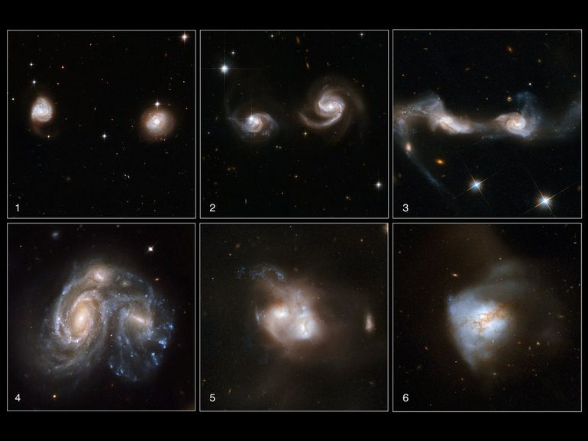

**What Do They Stand For?**

Scientists classify galaxies in different catalogs. The most common catalog is NGC,

which stands for New General Catalog. Other catalogs include M (Messier), ESO

(European Southern Observatory), IR (Infrared Astronomical Satellite), Mrk (Markarian),

and UGC (Uppsala General Catalog).

The numbers following the letters help scientists to locate the galaxy in its relative

position in the sky, such as NGC 1433 (SB). Sometimes a galaxy

appears in more than one catalog and can have more than one name.

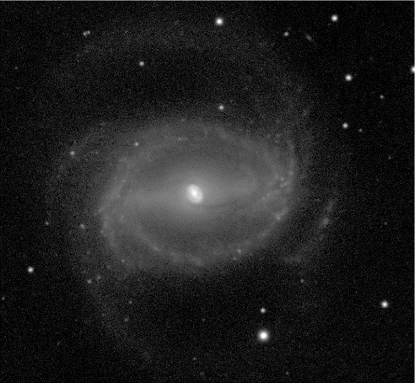

NGC 1433 (SB)

**Galaxies**  Name: _____________________

1. Who was Edwin Hubble?
2. What was one of Edwin Hubble’s contributions to Astronomy?
3. What are the four major types of galaxies?
4. What is a Spiral galaxy?
5. What is a Barred Spiral galaxy?
6. What is an Elliptical galaxy?
7. What is an Irregular galaxy?
8. What kind of galaxy is the Milky Way?
9. What are colliding galaxies?
10. What two spiral galaxies that are in the process of colliding?
11. What galaxy may eventually collide with the Milk Way?
12. What does NGC stand for? What is it used for in astronomy?
13. Which type of galaxy has little or no gas or dust?
14. Which type of galaxy has no structure?
15. Which types of galaxies have arms?
16. Which galaxy has no star formation seen?
17. Which galaxy has mostly old stars?
18. Which galaxies have both young and old stars?
19. Which galaxy was more common in the early universe?
20. Which galaxy has stars that move randomly?
21. Which galaxies have nuclear bulges?
22. Explain how galaxies can change over time.