LAKE POLLUTION
Use with Chapter 9
Section 9.3

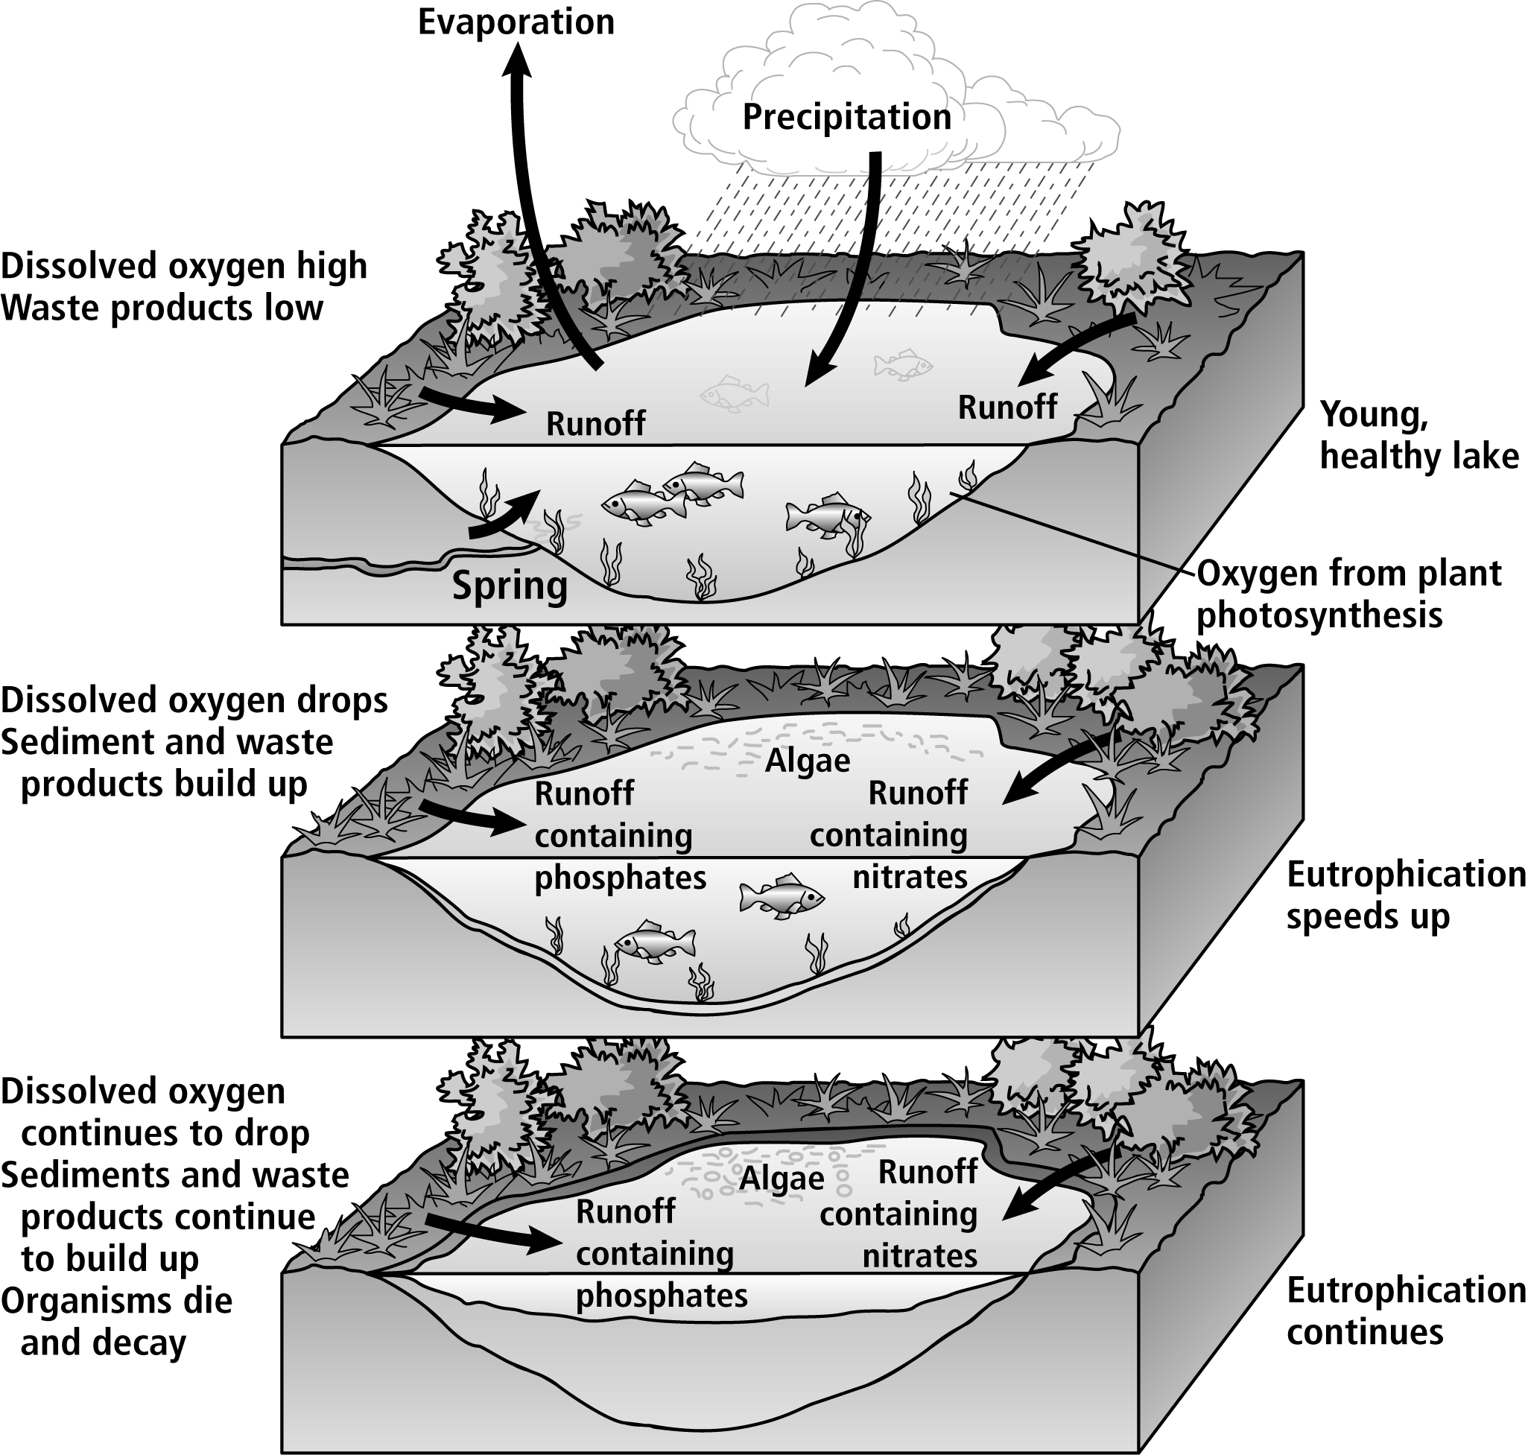

Lake Pollution
- What sources supply water to the lake?
Use with Chapter 9
Section 9.3

____________________________________________________________________________________
____________________________________________________________________________________
- Describe the characteristics of the young, healthy lake.
____________________________________________________________________________________
____________________________________________________________________________________
____________________________________________________________________________________
- What is eutrophication?
____________________________________________________________________________________
____________________________________________________________________________________
____________________________________________________________________________________
- How does the dissolved oxygen content of the lake change during eutrophication?
____________________________________________________________________________________
- How does eutrophication speed up?
____________________________________________________________________________________
____________________________________________________________________________________
- What other changes occur in the lake as eutrophication continues?
____________________________________________________________________________________
____________________________________________________________________________________
____________________________________________________________________________________
Teaching Transparency 24 – Lake Pollution
- precipitation, runoff, and a spring
- The lake has a high dissolved oxygen content and a low waste product content. It supports a variety of abundant organisms, and its plants contribute oxygen to the water through photosynthesis.
- Eutrophication is a successional process that begins with the addition of nutrients and continues with the filling in of a lake as a result of excessive organic growth.
- It drops.
- Phosphates and nitrates picked up by runoff enter the lake, resulting in excessive algae growth.
- Sediment and waste products build up, filling in the lake. Algae thrive and excessive growth occurs. Many organisms die and decay.

