Name:__________________ Due Date:_________________

Regents Earth Science

Sunspot Analysis Lab

**Introduction:** Photographs of the sun show dark areas on its surface which are believed to be due to magnetic storms that take place within the sun. These spots are actually very bright, however they appear darker than the surrounding areas on the Sun because they are cooler. The number and pattern of these spots change with time.

When the data collected over many of years are graphed, a pattern emerges. This picture-like representation makes it easier to see relationships that are not obvious from a column of numbers.

**Objective:** You will see how graphing data can aid in deciphering patterns and predicting future events.

**Vocabulary:** Answered in complete sentences

Independent variable

Dependent variable

Cyclic relationship

Direct relationship

Inverse relationship

Extrapolate

**Procedure:**

1. Create a graph on the graph paper provided in which the independent variable is plotted on the x-axis and the dependent variable is plotted on the y-axis. Be sure to label your axes and include a title.
2. Using the data given, graph the number of sunspots in the years from 1950 to 2004.

**Average Annual Sunspot Numbers**

|  |  |  |  |
| --- | --- | --- | --- |
| **Year** | **Number of Sunspots** | **Year** | **Number of Sunspots** |
| 1950 | 84 | 1980 | 146 |
| 1951 | 69 | 1981 | 134 |
| 1952 | 30 | 1982 | 116 |
| 1953 | 13 | 1983 | 72 |
| 1954 | 4 | 1984 | 46 |
| 1955 | 38 | 1985 | 18 |
| 1956 | 141 | 1986 | 13 |
| 1957 | 176 | 1987 | 29 |
| 1958 | 185 | 1988 | 50 |
| 1959 | 158 | 1989 | 145 |
| 1960 | 112 | 1990 | 155 |
| 1961 | 54 | 1991 | 150 |
| 1962 | 38 | 1992 | 94 |
| 1963 | 28 | 1993 | 55 |
| 1964 | 10 | 1994 | 30 |
| 1965 | 15 | 1995 | 18 |
| 1966 | 47 | 1996 | 7 |
| 1967 | 94 | 1997 | 21 |
| 1968 | 106 | 1998 | 64 |
| 1969 | 105 | 1999 | 93 |
| 1970 | 105 | 2000 | 120 |
| 1971 | 67 | 2001 | 111 |
| 1972 | 69 | 2002 | 104 |
| 1973 | 38 | 2003 | 64 |
| 1974 | 34 | 2004 | 44 |
| 1975 | 16 | 2005 | 38 |
| 1976 | 13 | 2006 | 20 |
| 1977 | 27 | 2007 | 18 |
| 1978 | 93 | 2008 | 10 |
| 1979 | 155 | 2009 | 4 |

**Discussion Questions: These questions need to be answered on a separate piece of paper. All answers must be answered in complete sentences.**

1. Of the three types of relationships found in the vocabulary section of this lab, what type of relationship is the data that you graphed? Explain.
2. Each peak on the graph represents a sunspot maximum. In which years do these maxima occur?
3. According to the data graphed, during which year did the last maximum occur?
4. What is the average time span between maxima? ***Round to the nearest tenth place****.*

Show all work.

1. What is the average time span between minimum? ***Round to the nearest tenth place****.* Show all work.
2. Predict when the next minimum will occur after the last one plotted on your graph.
3. Predict when the next maximum will occur after the last one plotted on your graph. Use your answer to question 4 to assist you on this question. Show all work.
4. Extrapolate your data at its present rate to determine approximately how many sunspots will occur in the year that you will graduate from high school. **Show and explain all.**
5. There does appear to be about a decade or 11 years between each solar maximum on average. See if you can find another larger pattern that might be happening?

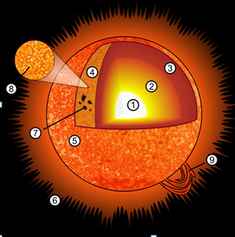Layers of the Sun

8.

9.

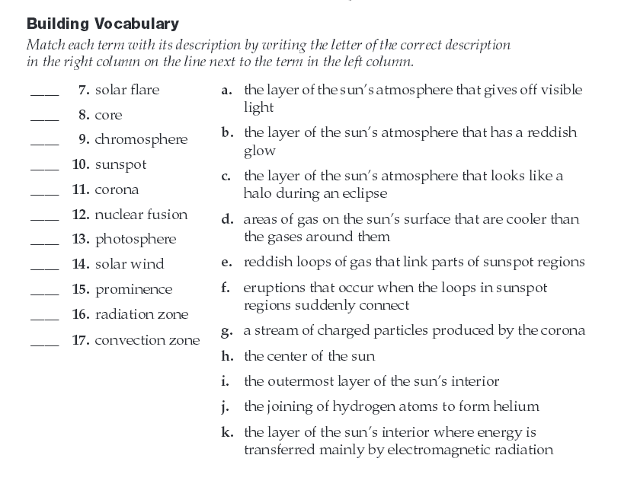

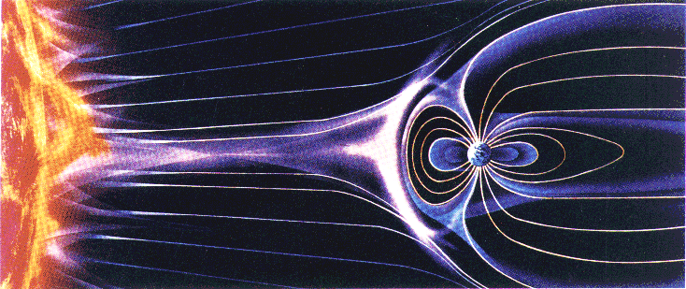The solar wind is a stream of plasma released from the upper atmosphere of the Sun. It consists of mostly protons. The stream of particles varies in density, temperature, and speed over time and over solar longitude. These particles can escape the Sun's gravity because of their high energy, from the high temperature of the corona and magnetic, electrical and electromagnetic phenomena in it. These particles can eventually get trapped by the Earth’s magnetic field and create the Aurora Boralis or Northern lights. Go to www.spacewather .com to answer the following questions.

Solar Wind Speed: _________

Density:_________

Sunspot Number:_________

What is the formula for calculating the Sunspot Number?

Click on the picture of the sun and use that to calculate the sun spot number – see how close you get to the actual number. Assume that k=1.

Draw the sun and its sunspots from the image on spaceweather.com