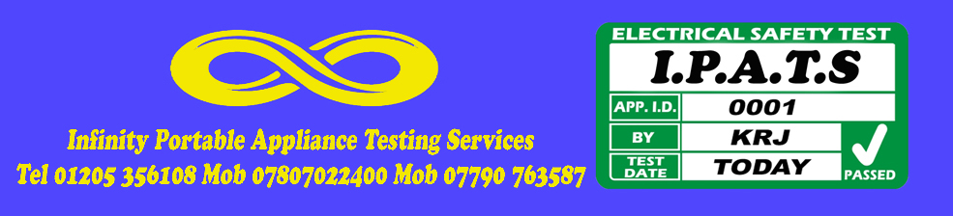

Portable Appliance Test Certificate

Health and Safety at Work (etc) Act 1974
Electricity at Work Regulations 1989
Management of Health and Safety at Work Regulations 2003
Provision and Use of Work Equipment Regulations 1998

This is to certify that an inspection and test of
Electrical equipment owned/managed by

Infinity Entertainment
22 Blackthorn Lane
Boston
Lincs PE21 9BG

was carried out by
Infinity Portable Appliance Testing

on
^{03.05.2025}

The inspection and tests were carried out in accordance with the above legislation, and in accordance with the guidance laid down by the Institution of Electrical Engineers in their Code of Practice for In-Service Inspection and Testing of Electrical Equipment. The schedule which is provided with this certificate details the appliances tested and the results that were obtained.

Number of appliances tested: 97
Certificate reference: IE9

Signed
Kevin R Johnson
Infinity Portable Appliance Testing (I.P.A.T )
22 Blackthorn Lane, Boston , Lincolnshire, PE21 9BG
Tel 01205 356108 Mob 07807 022400 Mob 07790 763587

