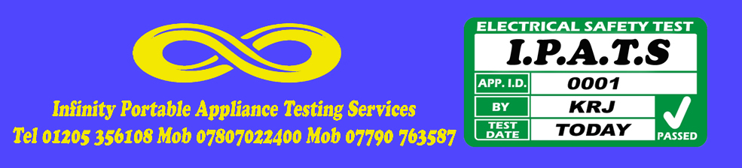

Portable Appliance Test Certificate

Health and Safety at Work (etc) Act 1974
Electricity at Work Regulations 1989
Management of Health and Safety at Work Regulations 2003
Provision and Use of Work Equipment Regulations 1998

This is to certify that an inspection and test of
Electrical equipment owned/managed by
Infinity Entertainments
22 Blackthorn Lane
Boston
Lincolnshire
PE21 9BG

was carried out by
Infinity Portable Appliance Testing

on
25 Jan 2021

The inspection and tests were carried out in accordance with the above legislation, and in accordance with the guidance laid down by the Institution of Electrical Engineers in their Code of Practice for In-Service Inspection and Testing of Electrical Equipment. The schedule which is provided with this certificate details the appliances tested and the results that were obtained.

Number of appliances tested: 093
Certificate reference: INF1AMK

Signed
Infinity Portable Appliance Testing (I.P.A.T )
22 Blackthorn Lane, Boston , Lincolnshire, PE21 9BG
Tel 01205 356108 Mob 07807 022400 Mob 07790 763587
Anthony Kelham

