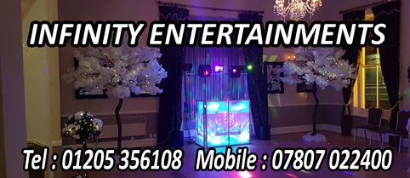
SELECTING THE RIGHT MUSIC FOR YOUR WEDDING

We have provided a selection of songs that we have found to be very popular at Wedding Receptions

This is not an exhaustive list of available songs (over 20,000 tracks currently available) it is not in any particular order and is there to provide a guide.
It is designed to give you an idea of what is popular and perhaps help remind you of songs/artists you may wish to hear, as well as those that you don’t. Remember that someones favourite track is anothers most hated.
We cover all genres of music and all eras from the 60s to current charts

Things to remember :
- You want your guests to enjoy your reception and remember it for the right reasons. (Remember it is possibly the longest part of your day)
- Your taste in music and your guests may well be very different.
- To give you an idea when selecting favourite songs, the list provided would give over 20 hours playtime,the average reception playtime is around 80/90 songs. Our recommendation is to select no more than 20/30 of your favourites, and allow guests to make requests on the day or in advance. (We can provide request forms)
- Your first song selection is always personal, we have included a section at the end of popular songs, but we will always endeavour to make sure we have the song of your choice.
- We welcome your suggestions, either from the list or songs of your choice, you can email your list to info@infinity-disco.com or telephone us to discuss any particular arrangements you want for your big day.

Many Thanks
INFINITY ENTERTAINMENTS

FOR BOOKING INFORMATION AND AVAILABILITY
Tel: 01205 256108
Mob: 07807 022400
Visit our Website: www.infinity-disco.com

