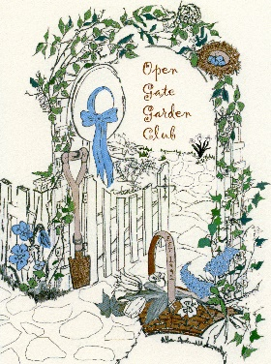
The Open Gate Garden Club of Fenton

Fall 2023
Greetings-
The Open Gate Garden Club of Fenton will once again be hosting their annual Silent Auction. We are in the planning and preparing stage! Our auction will take place on November 15th at 600 N. Adelaide in Fenton, Michigan. This event is one of two fundraisers Open Gate holds in order to raise funds for some of our many projects and charities we give to annually. Historically donations from the club have been given to:
Benefactors:
St. John Church, Rose Hill Center, JR Winegarden Public Library, Adopt-A-Pet Gardens, Fenton Museum/Historical Society and the Junior Master Gardener Program
Open Gate Garden Club is currently seeking donations from local business to incorporate in our Silent Auction. The club would appreciate any donation/item you would like to contribute. Each item will be posted as a donated contribution and credit given to the donator. Donations such as gift certificates, plants, services, percentage off, as well as products and individual items are very much appreciated.
We sincerely appreciate your consideration to provide a donation. The Garden Club donates to many worthwhile projects in our community. Additionally, this silent auction is a great way to remind our community about our local businesses and remind them to shop local during the Holiday season.
Thank you for your support,
Lynn Behr and Linda VanCamp
Silent Auction Committee
Open Gate Garden Club

