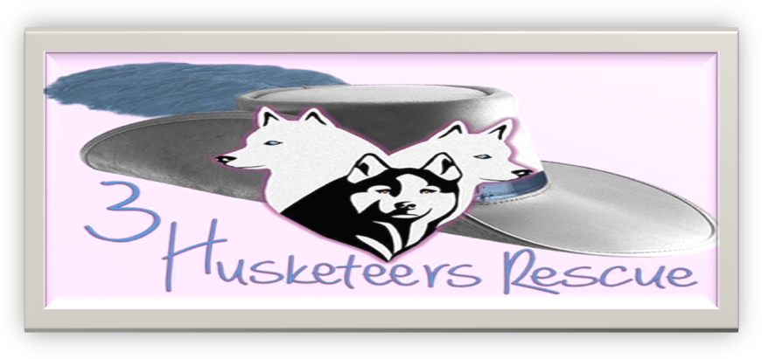
A NON-PROFIT ORGANIZATION
WE RESCUE NORTHERN BREEDS FROM SAUDI ARABIA
484-350-8656
Website www.husky-rescue-3.com
Email info@husky-rescue3.com

FOSTER APPLICATION/CONTRACT
Name __________________________________________________________________
Address________________________________________________________________
City __________________ State __________ Zip Code _____________
Phone Number(s) Home ___________________ Cell _________________________
Email __________________________________________________________________

I _____________________________________________ (name of foster applicant) agree that all statements in this application are made based on personal knowledge and are made for my application to foster through 3 Husketeers Rescue foster care program.

Name of dog you would like to foster ____________________________________________
Where my foster dog will stay during the day when I am home __________________________
Where my foster dog will stay during the day when I am NOT home ______________________
Where my foster dog will sleep at night _______________________________________________

I own my own home and am permitted to bring an animal into said home
YES___________ NO _____________

I rent my home and am permitted to bring an animal into said rental property
YES ________ NO __________
Landlord information
Name ____________________________________ Phone Number ___________________________
Address ____________________________________________________________________________
City, State, Zip ______________________________________________________________________
Length of time at residence ________________________
I have companion animal(s) at my home currently YES __________ NO ____________
Please list all
Name(s) _______________________________________________________________________
Age(s) _________________________________________________________________________
Species ________________________________________________________________________
Breed_________________________________________________________________ (dogs only)
Gender _________________________________________________________________________
Spayed / Neutered _______________________________________________________________
Are all animals in your home currently UP TO DATE ON VACCINATIONS?
Yes____________ No_________ (if no please explain why) _________________________________________________________________________________________________________________________________________________________________________________________________________________________________________________________________________________________________________________________________________________________________________________________________________________________________________
Are you willing to provide proof of vaccinations to 3 Husketeers Rescue before we place a foster animal in your home? Yes_________ No________

I have _______ children in my home. Ages ____________________________________________

If you currently have pets, please provide the name, address, and phone number of your vet. Please also contact them to give permission for them to speak with us. If this is a new vet (a year or less) please provide contact information for your previous vet where your pet's records can be verified. __________________________________________________________________________________________________________________________________________________________________________________________________________________________________________
List all the people living in your home or will have regular contact with any animals and their relationship to you.

Name ______________________________ Relationship ____________________________
Name ______________________________ Relationship ____________________________
Name ______________________________ Relationship ____________________________
Name ______________________________ Relationship ____________________________

List two references who are not related or reside in the same household with you and who have recently been to your home and around any of your current animals
Name ______________________________ Relationship ____________________________
Phone Number ______________________________
Name ______________________________ Relationship ____________________________
Phone Number ______________________________
Signature of Foster Applicant ___________________________________ Date____________

FOSTER CARE AGREEMENT INFORMATION

I ______________________________________ (name of foster applicant) make the following statements and voluntarily enter into this agreement to provide temporary care and custody and necessary sustenance as a foster caregiver to 3 Husketeers Rescue Animal _____________________ (hereafter known as “my foster animal”)

- I understand that I could be required to provide foster care to my foster animal for an extended period. I agree that the period covered by this agreement is the entire time during which I have custody of my foster animal.
- I agree that I am over 18 years of age.
- I understand that 3 Husketeers Rescue makes no guarantee of the health of my foster animal, that my foster animal may have medical needs, socialization issues and may not be housebroken.
- I will not arrange or pay for or otherwise cause any elective veterinary procedure to be performed on my foster animal during the period covered by this agreement, without the express written consent of the Authorized Rescue Representative.
- I understand I may only have my foster animal temporarily.

- I agree to notify and abide by 3 Husketeer Rescues veterinary care wishes and instructions and to use Alburtis Animal Hospital (3 Husketeer Rescues veterinary office) and if I must take my foster animal to another veterinary office that all records will be sent to Alburtis Animal Hospital and / or to 3 Husketeer Rescue.
- I agree that 3 Husketeers Rescue is the owner of my foster animal and will be responsible for all financial issues with my foster animal unless I am deemed negligent in my care for my foster animal.
- I agree to provide my foster animal with proper and routine veterinary care including yearly wellness exams, current and required and recommended vaccinations and urgent emergency care as needed. And to notify 3 Husketeers Rescue of all appointments and findings. (3 Husketeers will also help arrange these routine appointments and be involved in such care when needed)
- I agree that I am fostering this animal for 3 Husketeers Rescue and that I do not have any right of ownership over my foster animal. I further agree that 3 Husketeers rights in and to my foster animal are superior to mine. I also agree to provide the Authorized Representative or his/her designate, access to my home and property to check on my foster animal at any time that I am in possession of my foster animal
- I agree to immediately return any foster animal in my care to 3 Husketeers Rescue at the request of the Authorized Rescue Representative, or his/her designate, at any time and for any reason. If 3 Husketeer Rescue is forced to undertake any action to enforce this provision of the agreement, I agree to indemnify the Rescue for all court costs and attorneys feed connected with such an action.
- If I am planning to move at any time during the period covered by this agreement, I agree to contact the Authorized Rescue Representative prior to my move with new contact information. I understand that the Rescue has the right to request the return of my foster animal based on such a change of residence and agree that I will surrender my foster animal to 3 Husketeers Rescue immediately upon request.
- I understand that as long as I provide foster care to my foster animal to the Rescues satisfaction, I will be given the first right of adoption of my foster animal at such time as 3 Husketeer Rescue decides to off my foster animal for adoption,
- If at any time I can no longer or do not want to continue to provide care for my foster animal I agree to contact the Authorized Rescue Representative and arrange for surrender and return of my foster animal.
- I will not transfer possession or custody of my foster animal to any other person at any time except for temporary, short term possession for the purpose of vet care, grooming, etc.
- I agree to contact the Authorized Rescue Representative with any and all questions or concerns about my foster animal or the fostering program as well as with updated contact information. I also agree to contact the Authorized Rescue Representative with quarterly reports on the health status of my foster animal.
- I agree that if I refuse to comply with any provisions of this agreement, 3 Husketeers Rescue has the right to terminate this agreement and also has the right to the immediate surrender and return of my foster animal and any other animals for whom I am providing foster care for said Rescue. I further consent to provide the Rescue with access to my premises if necessary, to facilitate the return.
- I agree that the opportunity given to me to help rehabilitate my foster animal as well as the chance of a potential future adoption is of significant benefit to me and serves as proper legal consideration in exchange for my agreements stated in this contract.

I have read this Agreement in its entirety, and I agree that all statement and stated agreements contain in this document are made by me and are truthful and forth coming.

Signature(s) _______________________________ Date____________
_______________________________ Date____________
Print Name ________________________________
________________________________

********************APPROVED********************

3 Husketeers Rescue Signature ____________________________________ Date______________
Print Representative Name ________________________________________
Title _____________________________________________________________

