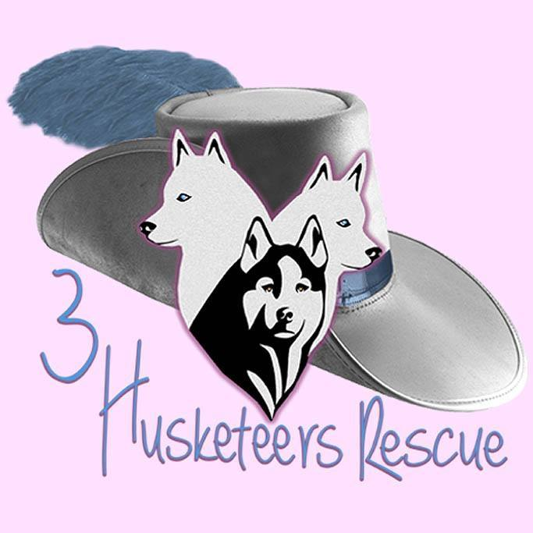

A NON-PROFIT ORGANIZATION
WE RESCUE NORTHERN BREEDS FROM SAUDI ARABIA
WEBSITE: www.husky-rescue-3.com
EMAIL: info@husky-rescue3.com
OFFICE: 484-350-8656

ADOPTION APPLICATION

Today's Date ___________________ Animal Name _____________________

Name________________________________________ Date of Birth__________________

Address______________________________________________________________________

County___________________________ Phone Number___________________________

Your Email_________________________________

How did you hear about us _________________________________________________________________________________________________________________________________________________________________________________________________________________________________________________________

When is the best time to call Morning______ Afternoon________ Evening_____________

ADOPTION INTERESTS:
What dog are you interested in adopting? Put “any suitable” if you don't know yet or would
just like to get through the approval process in the meantime. ____________________________________________________________________________________________________________________________________________________________________

Age Group Preference – Select all that apply:

Puppy 3-18 months ______ Young 19 months to 3 years __________
Adult 3 years to 8 years _______ Senior 9 + years _____________

Gender Preference
Male _______ Female_______ Doesn't Matter _____________

HOME INFORMATION:

Own or Rent? How Long? __________________________________________________________

Type of Home?
Single ________ Townhouse_________Row Home________ Apartment_______

If renting landlord name and contact information ______________________________________________________________________________________________________________________________________________________________________

Does your lease or Homeowners Association have pet breed or weight restrictions? If so, please provide details _________________________________________________________________________________________________________________________________________________________________________________________________________________________________________________________

How many adults live in your home? ___________________________
How many children live in your home? Please provide ages: _________________________________________________________________________________________________________________________________________________________________

Is everyone in the household in agreement with the adopting of a dog? _____________

CURRENT PETS:

Please list any pets that currently live in your home.
Species, Breed, Gender, Age, Weight, Personality, Special Needs
_________________________________________________________________________________________________________________________________________________________________________________________________________________________________________________________

Are there any animals that will frequently visit? _____________________________________

Have your current pets ever lived with another dog? Put “I don't have any pets” if you don't currently have any. ___________________________________________

Are your current pets spayed or neutered? If no please explain why.
_________________________________________________________________________________________________________________________________________________________________________________________________________________________________________________________

Are your current pets up to date on vaccinations? _______________________________

If you currently have pets, please provide the name, address, and phone number of your vet. Please also contact them to give permission for them to speak with us. If this is a new vet (a year or less) please provide contact information for your previous vet where your pet's records can be verified. ____________________________________________________________________________________________________________________________________________________________________________________________________________________________________________________________________________________________________________________________________________
Have you ever had to re-home a dog that you previously owned? Please explain the circumstances. _______________________________________________________________________________________________________________________________________________________________________________________________________________________________________________________________________________________________________________________________________________________________________________________________________________________________

Are there any farm animals or livestock on your property? ____________________________

GETTING TO KNOW YOU:

Please tell us about the plans you have for your new dog:
Pet, Guard Dog, Obedience, Agility, Livestock Guardian, Other? ________________________________________________________________________________________________________________________________________________________________________________________________________________________________________________________

Have you ever owned a Norther Breed dog?
Yes_______ No___________ Not Sure____________

Please describe the characteristics and personality of Northern Breed dogs as you understand them:

Since we are committed to finding the most appropriate home for each dog it is helpful to know how long the dog will be left alone each day. Some dogs do better than others with being left alone. _________________________________________________________________________________________________________________________________________________________________________________________________________________________________________________________

Where will your dog be kept when you are not home?
Crate______________ Free Roam of the house______________ Other_____________________

Where will your dog sleep every night? ______________________________________________________________________________________________________________________________________________________________________

Are you willing to crate train your dog? Yes________ No___________

Have you considered the financial responsibilities that comes with adopting a dog? (Quality food, routine and emergency vet expenses, possible additional rental expenses, boarding fees, etc.) Yes ____________ No_____________

Do you understand that as part of the adoption agreement you may not re-home your dog or relinquish it to a shelter? If you can no longer provide a home for your adopted dog, he/she MUST be returned to 3 Husketeers Rescue

Yes____________ No_____________

REFERENCES:

In order to expedite your application, please let your references know we will be contacting them. One can be a relative that does not live in your home.

Reference 1:
NAME: ________________________________________________________

ADDRESS: _____________________________________________________

PHONE: _______________________________________________________

RELATIONSHIP: ________________________________________________

Reference 2:
NAME: ________________________________________________________

ADDRESS: _____________________________________________________

PHONE: _______________________________________________________

RELATIONSHIP: ________________________________________________

Reference 3:
NAME: ________________________________________________________

ADDRESS: _____________________________________________________

PHONE: _______________________________________________________

RELATIONSHIP: ________________________________________________

VETRINARY INFORMATION/REFERENCE

NAME _____________________________________________________________________
ADDRESS __________________________________________________________________
PHONE NUMBER ____________________________________________________________

I _______________________________ give permission to above veterinary practice to release any information regarding my past and present dealings regarding pet care and records for any animals that I have had in my care to 3 Husketeers Rescue.

SIGNATURE________________________________________ DATE_____________________

In the section below please tell us any added information you would like us to know either about you or your home or the members in your family and why you have chosen to seek adoption of this beautiful and majestic northern breeds. _________________________________________________________________________________________________________________________________________________________________________________________________________________________________________________________________________________________________________________________________________________________________________________________________________________________________________________________________________________________________________________________________________________________________________________________________________________________________________________________________________________________________________________________________________________________________________________________________________________________________________________________________________________________________________________________________________________

BY SUBMITTING THIS INFORMATION, I CONFIRM THAT THE RESPONSES PROVIDED ARE TRUE TO THE BEST OF MY ABILITY AND CERTIFY THAT I AM OVER 18 YEARS OF AGE. I AM GRANTING PERMISSION TO THE REPRESENTIVES OF 3 HUSKETEERS RESCUE TO VERIFY THE INFORMAION AND COMMUNICATE WITH ANY REFERENCES PROVIDED DURING THE APPLICATION PROCESS AND I CONFIRM THAT AS THE APPLICANT, I WILL BE THE PRIMARY CAREGIVER RESPONSIBLE FOR A DOG ADOPTED FROM 3 HUSKETEERS RESCUE.

SIGNATRUE OF APPLICANT(S) _________________________________________________

__________________________________________________

Please submit application by email to: info@husky-rescue3.com

Any questions please call 484-350-8656 or email us at info@husky-rescue3.com

