2026 “Fifth Tuesday of the month”
Plus Dances

March 31 – Tom Allen
June 30 – Brad Neutz
September 29 – Larry Pfennig
December 29 – Tom Allen

CAP Building
861 Belsly Blvd
Moorhead, MN

$7.50 per person

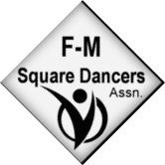

Hosted by FM Square Dancers Association

Info: Bernadette 701-293-6620 or mcneil195421@gmail.com

