North Dakota Square and Round Dance Club, Inc

April 28, 2018
Burleigh County Senior Center, Bismarck, ND

General Membership Meeting

President Mark Krebsbach called the meeting to order at 10:00 am

Roll Call:
Pres: Mark & Bina Krebsbach Present
Secr’y: Greg & Mary Ann Morford Present
Dir at Large: Curt & Rosie Vanek Absent
SW Dist Dir: Vern & Rose Laning Present
NW Dist Dir: Duane & Gayla Haberlock Present
SE Dist Dir: Allan & Carol Currie Absent
NE Dist Dir: Sandy Sathre Absent
Website: Rosie Vanek Absent
License Coord: Gary & Diane Chepulis Present
Treasurer: Vern Laning Present
Pres Elect: Position Vacant Vacant
Historian: Tammie Clemens/Hughes Absent
Insurance: Art & Judi Bakken Present

MINUTES: Minutes from the October 28, 2017 meeting were handed out. Vern made a motion to accept the minutes as read. 2nd by Greg. Motion passed.

TREASURER REPORT: Vern handed out a report and reviewed it. Motion was made by Gary to approve the report and 2nd by Jerry Frye. Motion passed.

GUESTS: Floyd and Judy Engelhardt, Plains Region VP, were present with a display of literature available to take or to download at USDA.org. Judy spoke about the youth scholarship, centennial award and traveler badge. Also, we can follow on facebook at United Square Dancers of America.

REPORTS: (downloadable on website)
Historian: Tammie’s report read by Greg
Insurance: Report given by Bakken’s
Website: Rosie’s report read by Greg
License: Report given by Gary
SW Director: Report given by Laning’s
SE Director: Currie’s report read by Mary Ann
NW Director: Report given by Haberlock’s
NE Director: No report from Sandy
ND caller’s report: Bernadette McNeil’s report read by Greg

OLD BUSINESS:
--Promotion Committee: No one has volunteered to help with this and nothing has been done for several years and not functional, so will do away with the committee.
--2018 State Festival: Morford’s reported that 53 are registered but 3 have contacted us and are not able to make it. Thank everyone for coming. Grand Forks Valley Stars will be hosting the festival next year.

NEW BUSINESS:
--2019 State Officers & Directors
The following slate was presented by Pat Connelly
State President: Ed Stallman
Vice President: Nan Connelly
Secretary/Treasurer: Wanda Huhtala

Motion by Jerry Frye, 2nd by Duane to accept the slate of officers for 2019. Motion passed.

NW Director: Duane & Gayla Haberlock
SW Director: Tim & Doretta Bornemann

Note: NW Director had resigned so Haberlock’s had volunteered to finish the 2 year term so need to elect someone. Need a SW director to replace Laning’s who have completed the maximum 2 times 2 year term. Motion by Jerry, 2nd by Nikki Paulsen to accept these new directors. Motion passed.

--Delegate for USDA annual meeting at National Convention: Morford’s accepted and will have 1 vote for the state in Kansas City, MO in June
--2019 State Festival: Pat Connelly reported the festival will be sponsored by Valley Stars on April 26 & 27, at Parkwood Place Auditorium in Grand Forks. Featured caller will be Noah Siegmann from Iron Ridge, Wisconsin. Registrations will be taken later today.

Morford’s will get the minutes and reports to Rosie to put on the website. Officers and Directors should print them and put them in their handbooks. Only 3 years of records should be kept in the handbooks. The rest can be destroyed.

Meeting adjourned at 10:41 am

Historian Report

I wish I could be there this weekend with all of you. Know that I am thinking of you all and hope to see you soon. I am still keeping the memorabilia safe and even took Tillie to visit my office. The Facebook page is still going if anyone would like to share. If you have photos, news stories, or even stories from the convention, either post them on the page, or send them to me and I will post them. I will try to visit and update the page more frequently than I have been. The facebook page is ND Square and Round Dance Organization. Please let me know what your suggestions are for improvement. One quick note, my grandmother, Evelyn Clemens, just celebrated her 98th birthday this year. She is still full of energy and going strong. Must be from all of the dancing she has done through the years!!

Have a super fun weekend and see you soon across the square!!
Tammie Clemens, Historian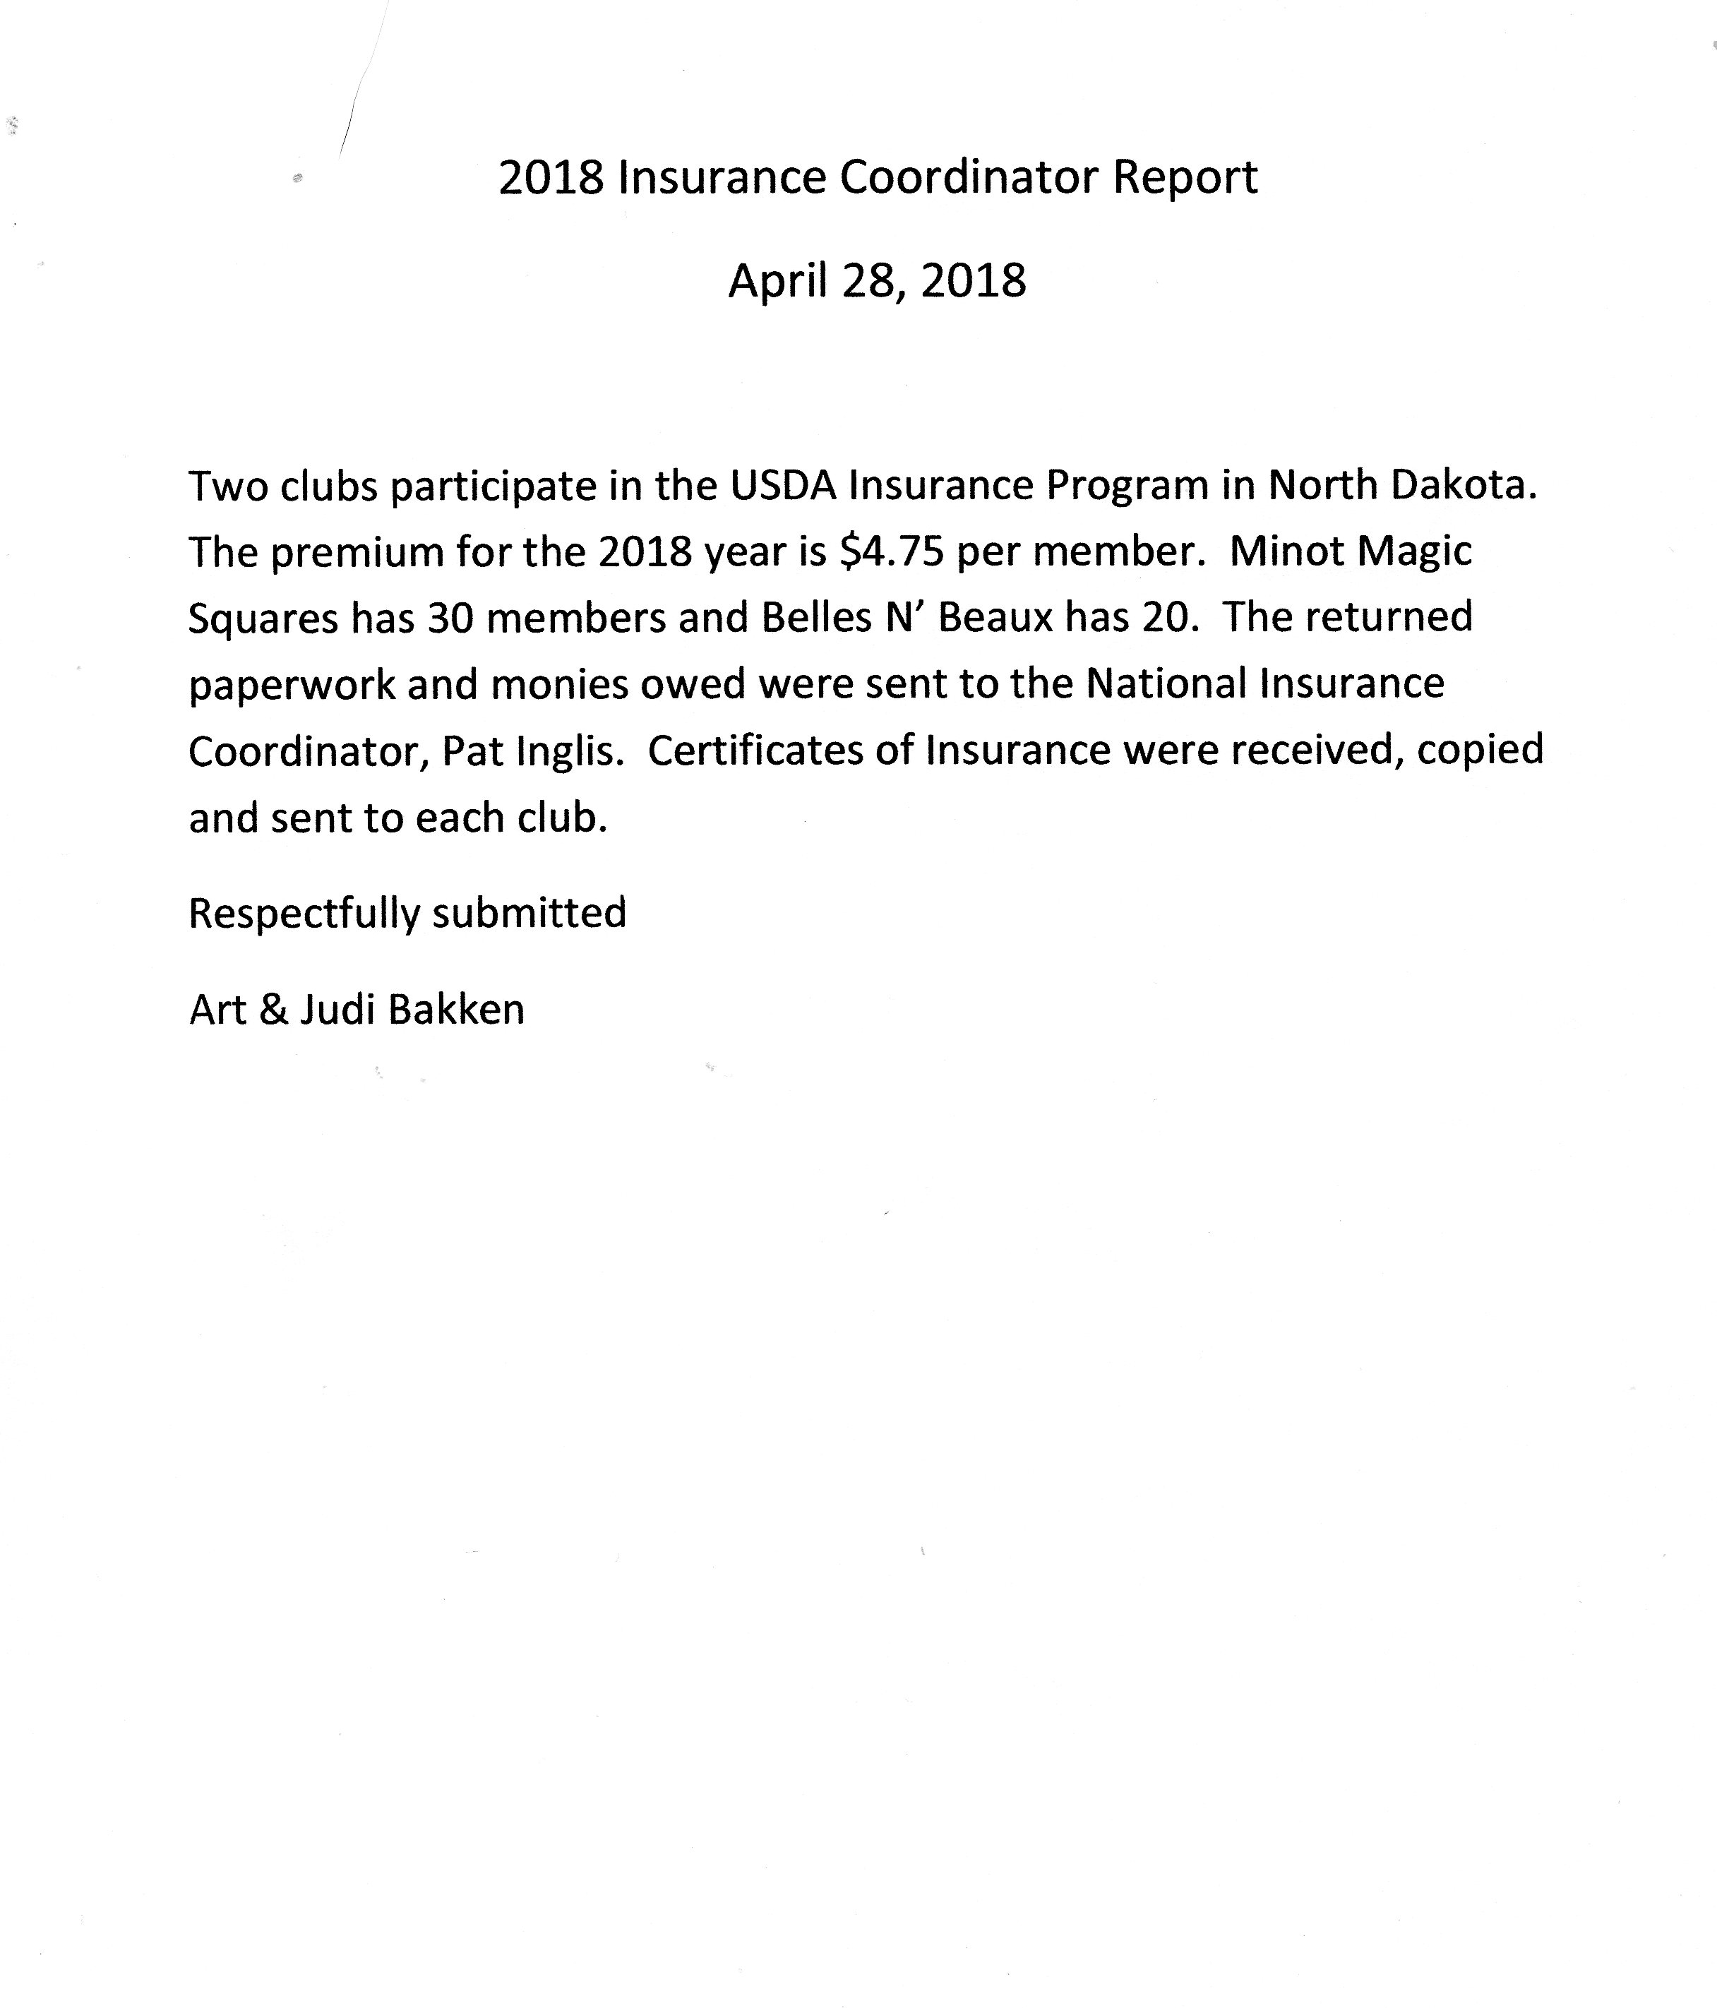

webmaster report

Rosella Vanek (nodakrose2008@gmail.com) 701-261-4396
The website squaredancenorthdakota.com was created in August 2017. It is a website powered by Go Daddy and appears to be working well. By the number of visitors to the site , it appears to be used well. January 1, 2018 to April 16, 2018 there were 1135 visitors to the site. March 2018 had 339 visitors. April 1 to April 16 there were 232 visitors.
The domain name is set to auto renew July 29, 2018 and the go daddy website is set to renew August 28, 2018. If the board is satisfied with the current website, these renewals will take place.
I have made changes and additions the past year as I have been asked. Usually within a day or so of the request. Requests can be made using my email: nodakrose2008@gmail.com

This report has been prepared April 16, 2018
Rosella Vanek

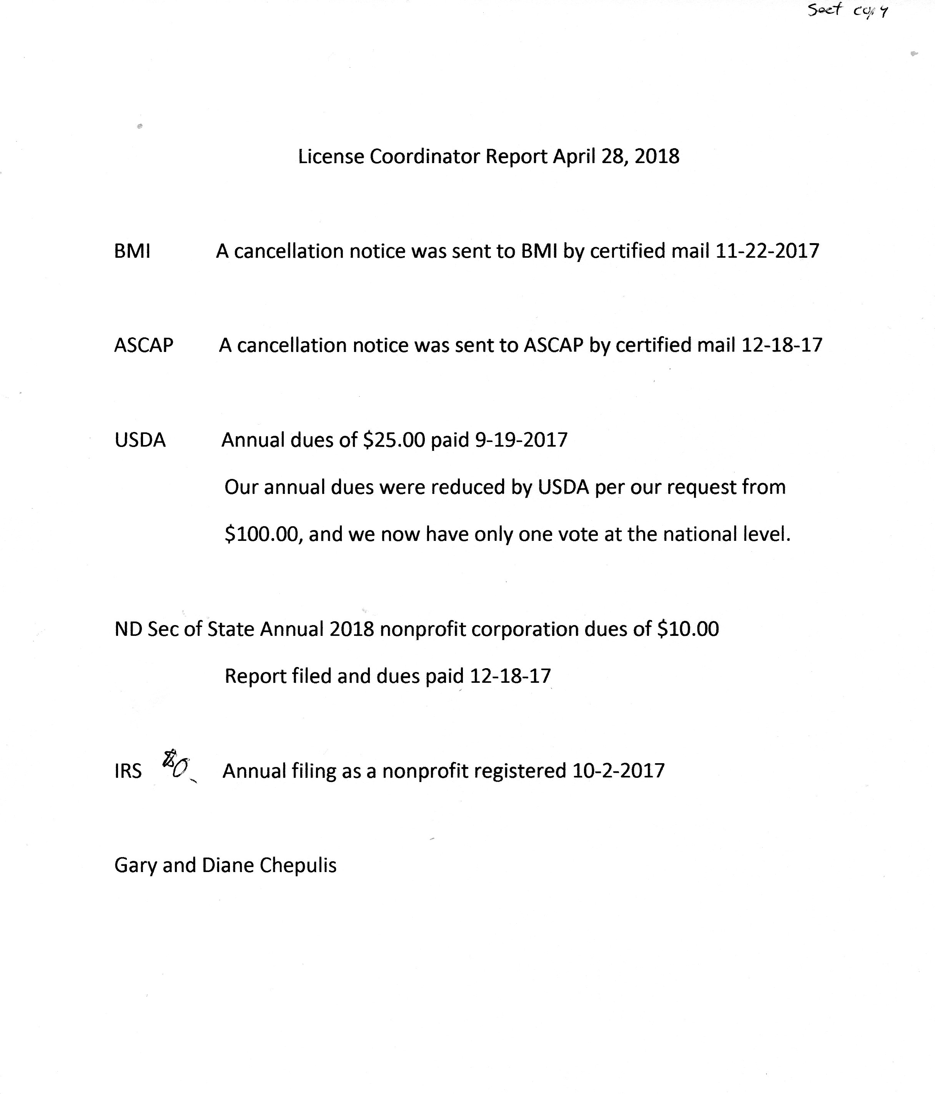
SW District Report for the 2018 State Square and Round Dance Festival
April 28, 2018 at Bismarck, ND

The Belles N' Beaux Square Dance Club in Bismarck continues to be the only active club in the Southwestern Region. As reported last fall, with the loss of our long time club caller, Larry Pfennig, our dancing schedule has had some dramatic changes. For the next dance year we will be having only one dance per month on the second Saturday of each month. Plus dances on Mondays have been cancelled completely with some plus dancing mixed in with our regular dances at the Bismarck Senior Center. Due to snow bird impacts, January and February dances have also been cancelled. Dance nights are scheduled to begin at 7 pm and conclude at 9:30 pm.

Fortunately for our club Doc Brooks has resumed calling and he along with several other Minot dancers regularly join us on dance nights. Additionally, we were able to use the services of Roger and Bernadette McNeil, Jim Lizakowski, Arnold Strebe, and Lurita Fugier during our dance year. Jerry Junck also made his annual visit and called for us at a special August dance.

At our 2018 annual meeting the following new officers were elected:

President: Vernon and Rose Laning
Vice President/Secretary: Art and Judi Bakken
Treasurer: Greg and Mary Ann Morford

The Bismarck Belles and Beaux Square Dance Club is hosting the 2018 festival and we understand the Grand Forks Valley Stars has volunteered to host the 2019 festival. With our state club numbers dwindling, the rotation for hosting the annual state festival comes around quickly. With more flexibility offered to the host club, hopefully the hosting task will be somewhat easier.

Respectfully Submitted:
Vernon and Rose Laning
4121 78th Ave. NE
Bismarck, ND 58503

Southeast District Annual Report April 2018
Saturday Fun Nite Club, Fargo, submitted by Bernadette McNeil
Saturday Fun Nite square dance organization dances in Fargo on the second and
fourth Saturdays of the month during the academic year, going dark on holidays.
The dance is held at St. Anthony of Padua Catholic Church beginning at 7:30 p.m.
The club hires guest callers for the dances and serves lunch after the dance.
Officers of the club are: Bernadette McNeil, President; Corene Geffre, Vice
President; Donna Alby, Secretary and Denny Resendahl, Treasurer. Advisors are
Merrill and Norene Braaten, Past Presidents.
The club has 19 members, most of whom belong to a second club in Fargo. Hosts are
scheduled for each dance and who greet guests and members/ set up and clean up
lunch.
SFN is a member of Square Dance Minnesota (SDM) and is a 501(c)3 organization under
the umbrella of SDM. The IRS designation is renewed each year by completing the
appropriate paperwork.
SFN is also a member of the North West Region based in Minnesota and assists with
the annual Heart Dance benefit and in the printing of Region calendars and pocket
schedules. Both the Region calendars and pocket schedules list the dance schedule
of the Region members to encourage dancers to visit other clubs.
Bernadette McNeil, SFN President
Circle 8 Plus Club, Fargo, submitted by Allan and Carol Currie
The Circle 8 Plus Club of Fargo-Moorhead dances on the first, third, and fifth Saturdays
at St. Anthony's Catholic church in Fargo. We also use the Journey in Faith Lutheran
church in West Fargo on nights that St. Anthony's is not available to us. It is always a
good idea to call ahead to check on the location, as sometimes we don't have much
notice to change the schedule. Our dance time is 7:30 to 10:00 PM. We assign host
couples to help with greeting and setting out the lunch, as well as cleaning up
afterwards.
We have 15 members in the club this year. Allan and Carol Currie are Presidents, and
Treasurer is Marge Swanson. Our Secretary is Corene Geffre, and Vice Presidents are
Mark and Hella Helfter. We have a variety of callers doing our dances, and appreciate
visitors who join us. We have usually had only one or two squares at our dances over the
winter, but now that the snowbirds are coming back, we hope it gets better. Stop in and
join us for some fun plus dancing!
In the fall of 2018, the club will reach its 60th anniversary, having started in 1958. Most
of the original members are now gone, but we appreciate their work in getting the club
started. Thanks to the guests who come out to help us, and we hope to see many plus
dancers in the future.
Allan and Carol Currie, Circle 8 Plus club Presidents
L & M Squares, Inc, submitted by Bernadette McNeil and
LuWayne Barnes.
L & M Squares, Inc square dance organization dances in
Fargo on the second and fourth Tuesdays of the month
throughout the year. The dance is held at the Cash Wise
Community Room, 1401 33 St S in Fargo. Per Cash Wise
rental requirements, the organization offers a catered
dinner for dancers at an additional charge. The dinner is
served at 5:45 p.m. and there is no lunch offered after the
dance. Roger McNeil is the club caller and Bernadette
McNeil is the club cuer. Charley Huhtala was added as an
apprentice caller for the dances. The club has 28 members,
most of whom belong to a second square dance organization
in Fargo.
Officers of the club are: LuWayne and Ken Barnes, Presidents; Donna Alby, Vice
President; Corene Geffre, Secretary and Bernadette McNeil, Treasurer. As Vice
President, Donna orders the catered dinner for each dance. Bernadette has a signed
Conflict of Interest on file as she is both receiving payment for cueing and
holding an office.
L & M Squares is a member of Square Dance Minnesota (SDM) and is a 501(c)3
organization under the umbrella of SDM. The IRS designation is renewed each year by
completing the appropriate paperwork.
L & M Squares is also a member of the North West Region based in Minnesota and
assists with the annual Heart Dance benefit and in the printing of Region calendars
and pocket schedules. Both the Region calendars and pocket schedules list the
dance schedule of the Region members to encourage dancers to visit other clubs.
Bernadette McNeil
L & M Squares Treasurer
With the assistance of LuWayne Barnes, President
Dakota Ramblers Club
No changes other than Rex and Joyce Baker are now the President couple. Lost John
Walsh last summer.
Submitted by Adam and Cecelia Baumstarck, Dakota Ramblers Presidents

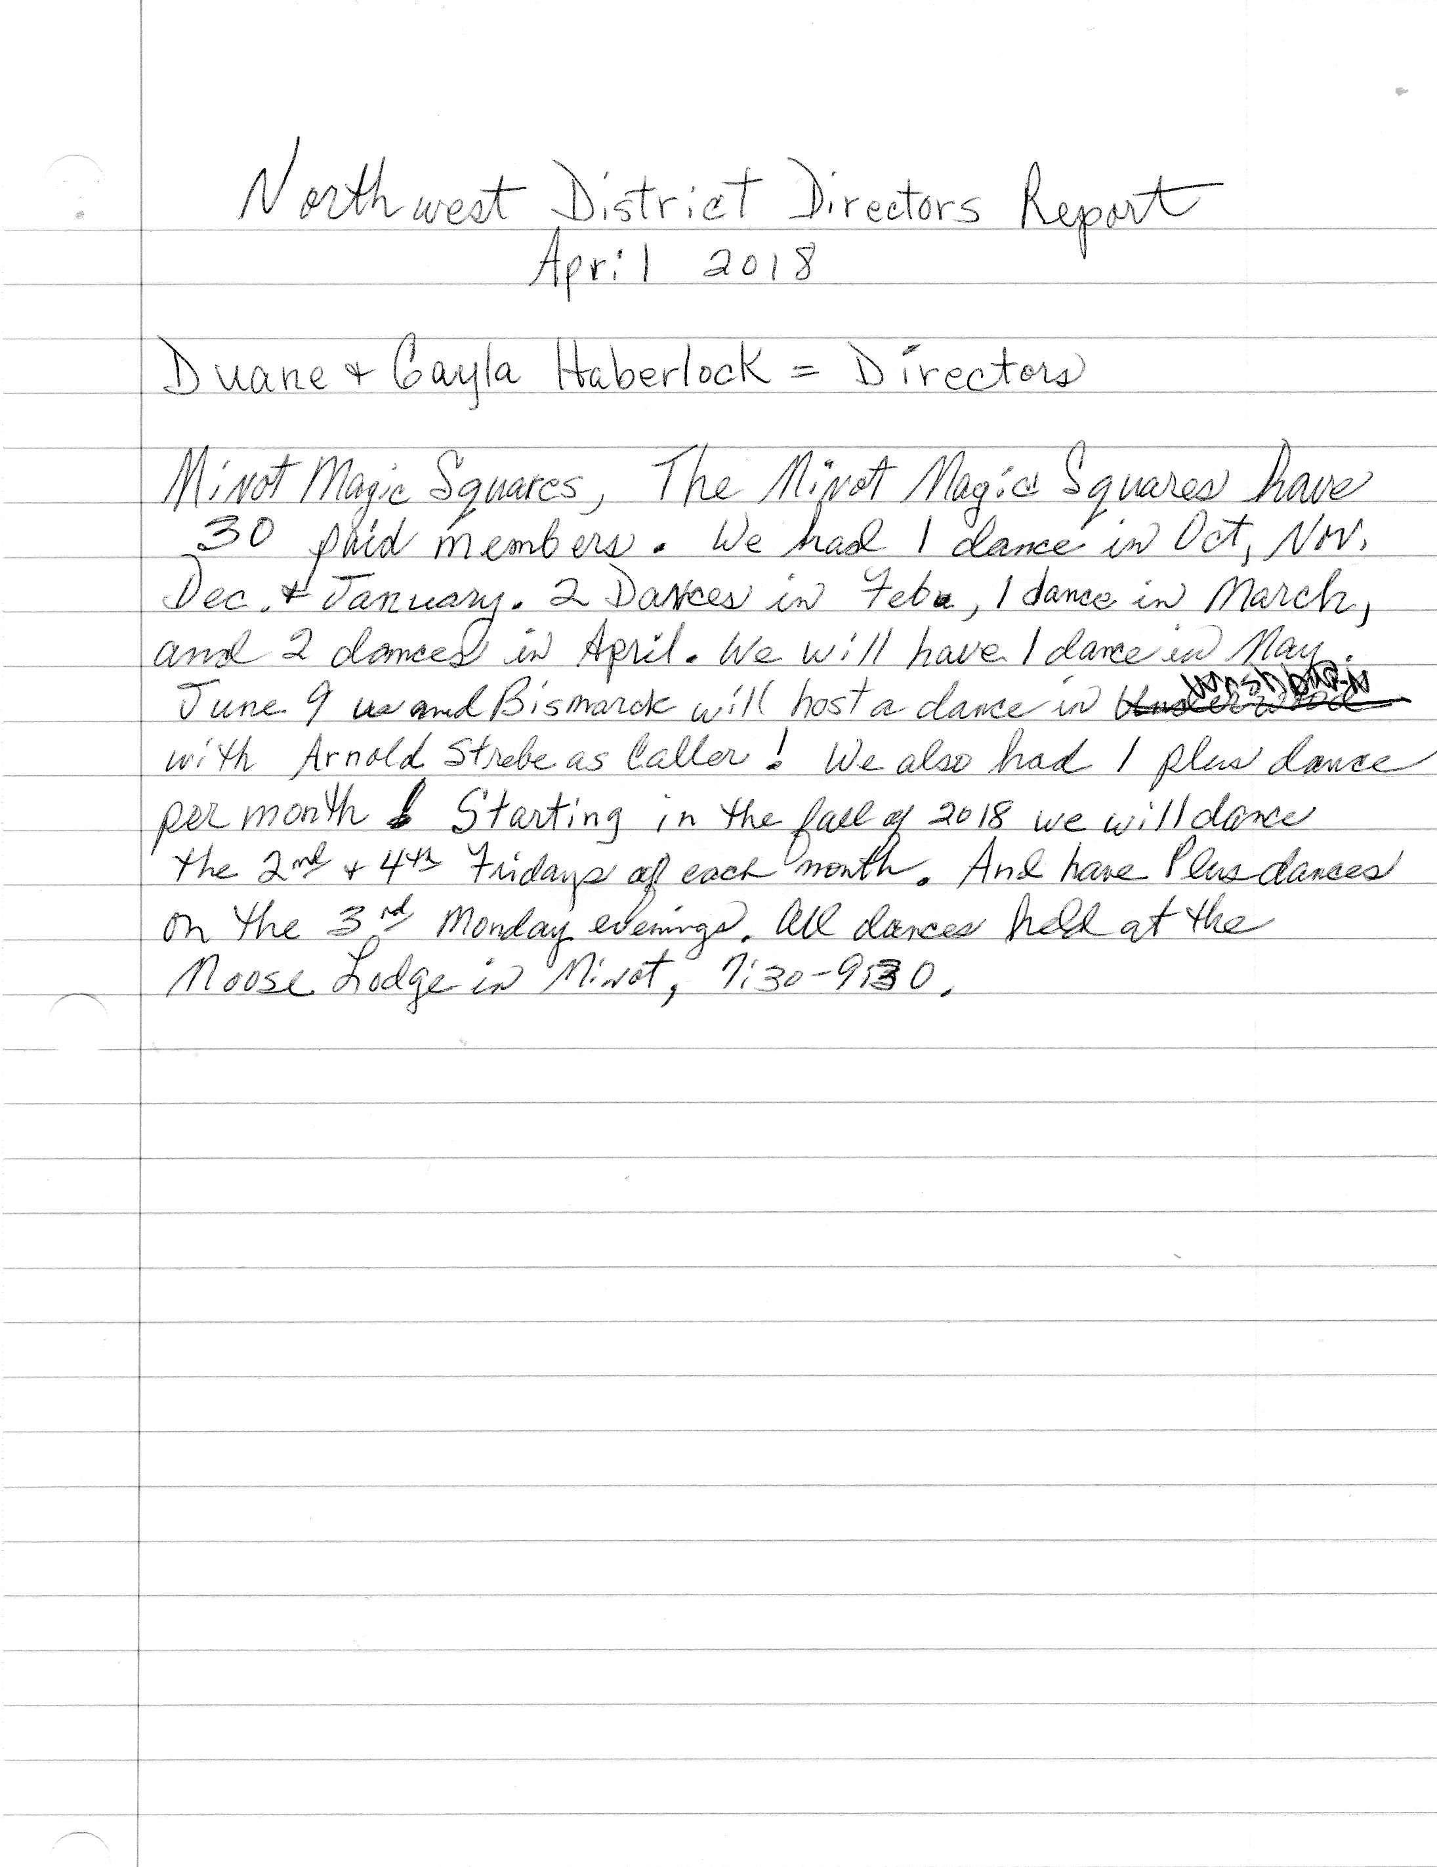

Report from the ND Callers/Cuers Association.

The ND Callers Convention will be held in Fargo on October 27th at St. Anthony’s of Padua Catholic Church with Tom Allen as the featured caller.. Afternoon dancing will be called by Tom Allen and the members of the association. The evening dance will be called by Tom. A flyer is attached for your information.

Thank you
Bernadette McNeil
President

