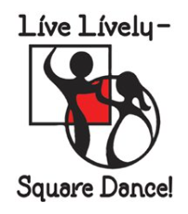

Dance Schedule:
Friday, April 24th - 7:00 p.m. – 10:00 p.m.
Saturday, April 25th – 9:30 a.m. – Combined general
membership/Board meeting
Saturday, April 25th – 1:30 p.m. – 4:00 p.m.
Saturday, April 25th - 7:00 p.m. – 10:00 p.m.

Festival Location:
St. Anthony of Padua Catholic Church
710 Tenth Street South
Fargo, ND

FMSDA Members:
Circle 8 Plus
L & M Squares
Saturday Fun Nite

Thank you for registering for the 68th ND Festival. We look forward to dancing with you!!

Fargo Moorhead Square Dancers
Association (FMSDA)
2020
What a Vision!!

68th North Dakota
State Square
and Round Dance Festival

St. Anthony of Padua Catholic Church
710 Tenth Street South, Fargo, ND
April 24 and 25, 2020

Featured Callers and Cuer:

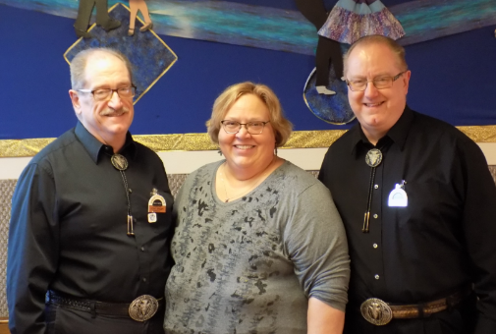

Doug, Natalie and Don Sprosty

www.squaredancenorthdakota.com

Festival Officers:

Chair – Bernadette McNeil 701-293-6620
bernadette@rogermcneil.com
Vice Chair – Harv Hegvick
Secretary/Treasurer – Donna Alby
donnajeanalby@gmail.com
Registration – Gwen and Dave Lass

State Officers:

President – Nan Connelly
Vice President – Pat Connelly
Secretary – Norene Braaten
Treasurer – Wanda Huhtala

Reserved Motel Rooms for the 2020 Festival:
(must ask for Festival Square Dance rate)

Baymont Inn & Suites (1.5 mi. from dance site)
1340 21 Avenue South – Fargo
701-476-3900
Continental breakfast-indoor pool-microwave-fridge
$69.00 for double queen or king
(probable after-party site)

Country Inn & Suites (2.5 mi. from dance site)
3316 13 Avenue South – Fargo
701-234-0565
Continental breakfast-indoor pool-microwave-fridge
$99.00 for double queen or king

No dry camping on St. Anthony grounds

Last Name: __________________________________________

First Name(s):________________________________________

Address: ____________________________________________

City/State/Zip: ________________________________________

Phone: (__________)__________________________________

Email: ______________________________________________

Amount Enclosed: $ _______________________

Dance Fees: ___ Single Couple
All Dancing – Before Feb 1 $30.00 $60.00

All Dancing – After Feb 1 $35.00 $70.00

Individual Sessions:
Friday (7:00 p.m.) $12.00 $24.00
Saturday (1:30 p.m.) $10.00 $20.00
Saturday (7:00 p.m.) $13.00 $26.00

Return Registration Information with Payment to:
Fargo Moorhead Square Dancers Association
c/o Gwen and Dave Lass
29240 170 Avenue South
Pelican Rapids, MN 56572

Notes:
(1) U.S. Funds only. $20.00 NSF fee.
(2) Pre-registration must be postmarked by February 1, 2020 to receive the $30/$60 rate.
(3) Cancellations in writing only must be received by March 15, 2020 to receive a refund. $5.00 cancellation fee per registration may apply.
(4) Registration table opens one hour before dance sessions

