Live Lively ~
Square Dance!!

Tentative Dance Schedule:
Friday, April 28th - 7:00 p.m. – 10:00 p.m.
Saturday, April 29th – 9:30 a.m. – Combined general
membership/Board meeting
Saturday, April 29th – 12:30 p.m. – 3:30 p.m.
Saturday, April 29th - 7:00 p.m. – 10:00 p.m.

Festival Location:
St. Anthony of Padua Catholic Church
710 Tenth Street South
Fargo, ND

Hosted by the Fargo Moorhead Square Dancers Association. Thank you for registering for the 69th North Dakota Festival. We are looking forward to dancing with you!!

Fargo Moorhead Square Dancers
Association (FMSDA)
Fancy Free
In ’23!!

69th North Dakota
State Square
and Round Dance Festival

St. Anthony of Padua Catholic Church
710 Tenth Street South, Fargo, ND
April 28 and 29, 2023

Featured Callers and Cuer:

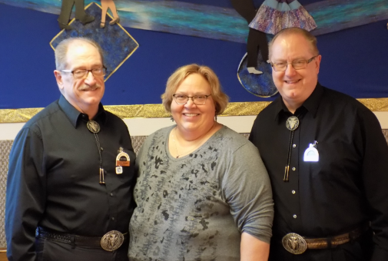

Doug, Natalie and Don Sprosty

www.squaredancenorthdakota.com

Festival Officers:

Chair - Bernadette McNeil 701-293-6620
mcneil195421@gmail.com
Vice Chair - Harv Hegvick
Secretary - Alana Gerszewski
Treasurer - Donna Alby 701-212-0977
donnajeanalby@gmail.com
Registration - JoEllen Harris

State Officers:

Chair - Bernadette McNeil 701-293-6620
mcneil195421@gmail.com
Vice Chair - Pat & Nan Connelly
Secretary - Aileen Stallman
Treasurer – LeAnn Carr

Reserved Motel Rooms for the 2023 Festival:
(must ask for FM Square Dance block rate)

Country Inn & Suites (2.5 mi. from dance site)
3316 13 Avenue South – Fargo
701-234-0565
Continental breakfast-indoor pool-microwave-fridge
$99.00 plus tax for double queen or king
$109.00 plus tax for king suite (with pullout)

With the popularity of “points” and “free nights,” rooms are reserved
at only one motel.

The Committee

No dry camping on St. Anthony grounds

Last Name: __________________________________________

First Name(s): ________________________________________

Address: ____________________________________________

City/State/Zip: ________________________________________

Phone: (__________)_______________________

Email: ______________________________________________

Amount Enclosed: $ _______________________

Dance Fees: Single Couple
All Dancing – Before Feb 1 $30.00 $60.00

All Dancing – After Feb 1 $35.00 $70.00

Individual Sessions:
Friday (7:00 p.m.) $12.00 $24.00
Saturday (12:30 p.m.) $10.00 $20.00
Saturday (7:00 p.m.) $13.00 $26.00

Return Registration Information with Payment to:
Fargo Moorhead Square Dancers Association
c/o JoEllen Harris
1767 Prairie Lane South
Fargo, ND 58103

Notes:
(1) U.S. Funds only. $20.00 NSF fee.
(2) Pre-registration must be postmarked by February 1, 2023 to receive the $30/$60 rate.
(3) Cancellations in writing/email only must be received by April 1, 2023 to receive a refund. $5.00 cancellation fee per registration may apply.
(4) Registration table opens one hour before dance sessions.

