One Great Caller!! Two Great Dances!!


Tom Manning

Monday, June 15 – Plus Dance – CAP Building, 861 Belsly Blvd, Moorhead
Snack table open during the dance – 7:00 p.m. - $7.50 dance fee

Tuesday, June 16 – Mainstream Dance – Holy Spirit Church social hall,
1420 7th St N, Fargo
Potluck dinner at 6:15 p.m. – Dance at 7:00 p.m. - $5.00 dance fee

* * * * * * * * *

Sponsored by the
Fargo Moorhead Square Dancers Association

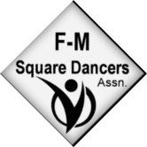

Info: Bernadette 701-293-6620 or mcneil195421@gmail.com
Harv 701-388-5147 or Nan 701-232-4341

