**Get Your Dance Fix in ‘26**

**Hotel information:**

-Holiday Inn Express West Acres

1040 40th St S, Fargo ND 58103

701-282-2000 ext 0

King or double queen - $149 + tax

-Homewood Suites by Hilton (near dance location)

2021 16th St N, Fargo ND 58102

701-235-3150

King - $139 + tax; double queen - $149 + tax

-Country Inn & Suites

3316 13th Ave S, Fargo, ND 58103

701-234-0565

King or double queen - $120 + tax

Hot breakfast included at all motels. All rooms held until 3/24/26 under ND Square Dance Festival and can be booked starting 5/24/25.

No overnight camping in Church parking lots.

******************************

Thank you for attending the North Dakota Festival!!

FM Square Dancers

**Name(s):__**________________________________________

**Address:_**_________________________________________

**City/State/Zip:__**__________________________________

**Phone:____________________________________________**

**Email:_____________________________________________**

**Amount Enclosed:__**_______________________________

**Dance Fees:** **Single** **Couple**

All dancing before Feb 1 $30.00 $60.00

All dancing after Feb 1 $35.00 $70.00

Friday Only $15.00 $30.00

Saturday Only $25.00 $50.00

Registration Form: Please fill in the above requirements. Cut out and mail with payment to:

FMSDA

c/o JoEllen Harris

1767 Prairie Lane S

Fargo, ND 58103

Email: [gogirl114@gmail.com](mailto:gogirl114@gmail.com)

Notes:

1. US funds only - $30.00 NSF fee
2. Pre-registration must be postmarked by Feb. 1, 2026 to receive the $30/$60 rate
3. Registration table opens one hour before dance sessions

**Officers for State and Festival:**

Chair: Bernadette McNeil 701-293-6620

[mcneil195421@gmail.com](mailto:mcneil195421@gmail.com)

Vice chair: Harv Hegvick

Secretary: Alana Gerszewski

Festival Treasurer: Donna Alby

State Treasurer: Greg & Mary Ann Morford

**Dance Schedule:**

Dancing will be mainstream and round dancing with announced plus tips and line dances.

Friday, April 24th 7:00pm-10:00pm

-Dancing

Saturday, April 25th 10:00am-11:00am -General membership/board meeting

Saturday, April 25th 1:00pm-3:30pm

-Dancing

Saturday, April 25th 7:00pm -Opening Ceremony followed by dancing

Festival colors: Royal blue and silver

Contact Info: Bernadette McNeil, Chair

Phone: 701-293-6620 Email: mcneil195421@gmail.com

**72nd North Dakota State**

**Square and Round Dance Festival**

**April 24 & 25, 2026**

**Holy Spirit Catholic Church**

**1420 7th Street North, Fargo, ND**

Featured Caller Round Dance Cuer Line Dance Prompter

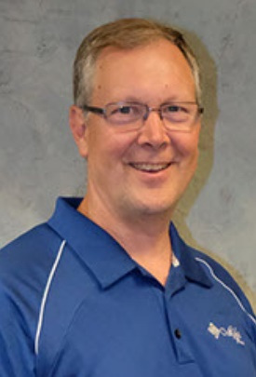 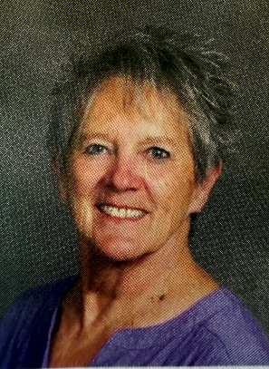

**Curt Braffet** **Bernadette McNeil**

Carlock, IL Fargo, ND

*Sponsored by*

*Fargo Moorhead Square Dance Association*