2019 meeting of North Dakota Square and Round Dance Clubs Inc

Meeting opened 1045. In attendance were:
President: Ed Stallman Present
Vice President: Nan and Pat Connelly Present
Secretary/Treasurer: Wanda Huhtala Present
Dir at Large: Mark and Bina Krebsbach Present
NE Dist Director: Tim and Debbie Schroeder Present (Tim)
NW Dist Director: Duane and Gayla Haberlock Present
SE Dist Director: Denny Resendahl Present
SW Dist Director: Tim and Doretta Bornemann Absent
Website: Rosie Vanek Present
License Coord: Gary and Diane Chepulis Absent
Historian: Tammie Clemens Absent
Insurance: Art and Judy Bakken Absent

Old Business: Minutes of 2018 meeting accepted as recorded.

New Business:

Website: Rosie would like to put your news on the website. Change of officers, change in your calendar, any special events, just let her know and she will tell the cyber world.
nodakrose2008@gmail.com
Rosie also asked if we wish her to continue the website. Gayla made a motion, seconded by Pat to keep site, with Rosie as the webmaster. Motion passed.
North Dakota Square Dance has a Facebook page, Square Dance North Dakota.

MINOT has 3 special dances this summer:
Arnold Strebe will be calling a free square dance at Memorial Hall in Washburn, June 8 from 1:30 to 3:30.
Jerry Junck will be calling in Bismarck at the Eagles Club. This dance will be August 5. All are invited to dine before, and perhaps enjoy a beverage after. Charge will be $7.50.
Hunter Keller will be calling at Riverdale ND on August 17, from 2:30 to 5, at the former Riverdale High School. Charge will be $7.50.
VALLEY STARS will be dancing this summer, 3rd Thursday of each month, from 7 to 9 in the Parkwood auditorium, the same place as the Festival.
Our HISTORIAN has been contacted by Adam Lake, of NDSU, asking for information on square dance in North Dakota. Dorothy Lamond volunteered to contact Adam and Tammie, to learn all the facts.
ND Callers and Cuers. There will be no Caller’s Convention this year, as the area callers had the opportunity to learn from our state Festival caller, Noah Siegmann in April. Bernadette McNeil will continue as President of NDCC, and Charley Huhtala will continue as Secretary/Treasurer.
STATE FESTIVAL 2020
The 2020 Festival will be held at St Anthony of Padua Catholic Church, on April 24 and 25 of 2020. Doug and Don Sprosty will be the callers, with Natalie Sprosty cuing. See website for more info.
Convention officers:
President: Bernadette McNeil
Vice President: Harvey Hegvick
Secretary/Treasurer: Donna Alby
State Officers:
President: Nan Connelly
Vice President: Pat Connelly
Secretary: Norene Braaten
Treasurer: Wanda Huhtala

Meeting adjourned at 11:45

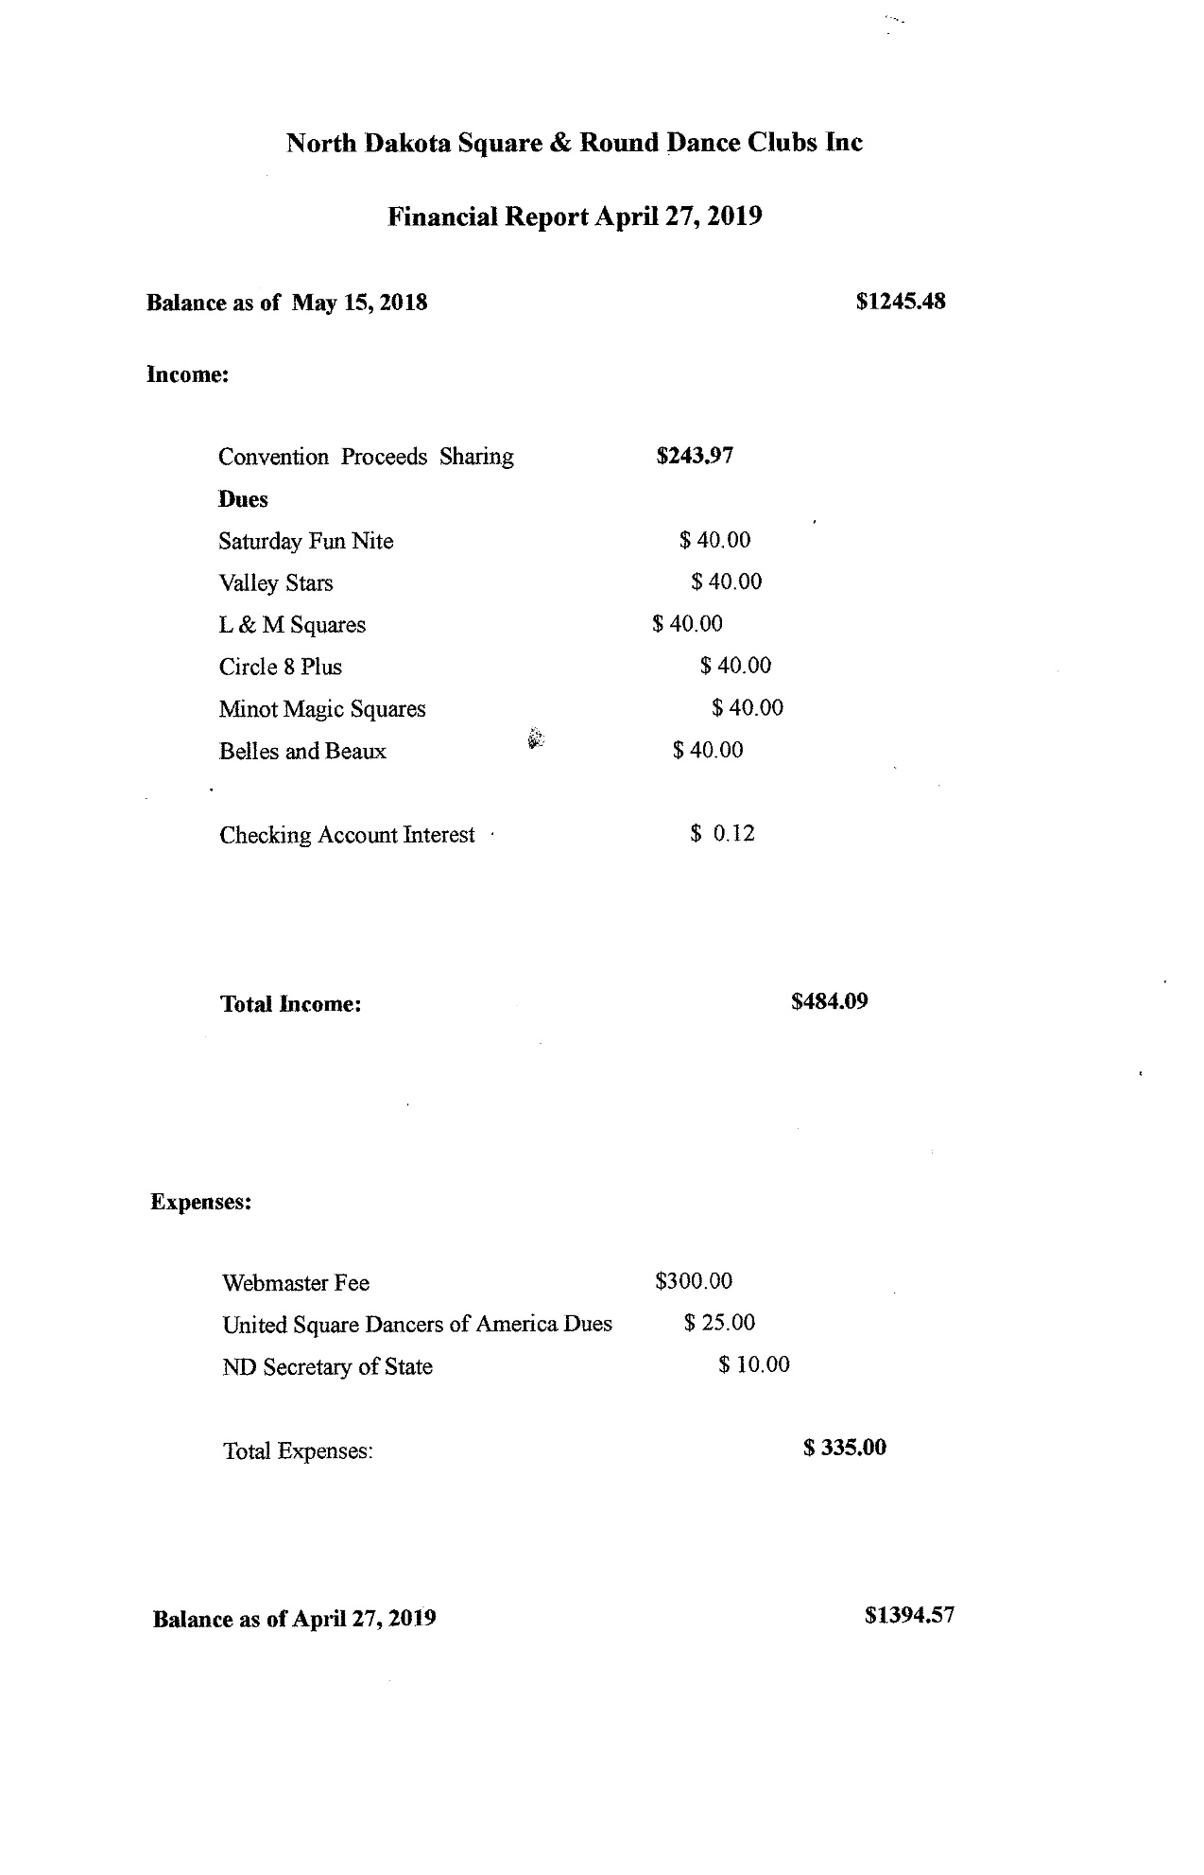

webmaster report

Rosella Vanek (nodakrose2008@gmail.com) 701-261-4396
The website squaredancenorthdakota.com was created in August 2017. It is a website powered by Go Daddy and appears to be working well. By the number of visitors to the site , it appears to be used well. January 1, 2018 to April 16, 2018 there were 1135 visitors to the site. March 2018 had 339 visitors. April 1 to April 16 there were 232 visitors.
The domain name is set to auto renew July 29, 2018 and the go daddy website is set to renew August 28, 2018. If the board is satisfied with the current website, these renewals will take place.
I have made changes and additions the past year as I have been asked. Usually within a day or so of the request. Requests can be made using my email: nodakrose2008@gmail.com

This report has been prepared April 16, 2018
Rosella Vanek

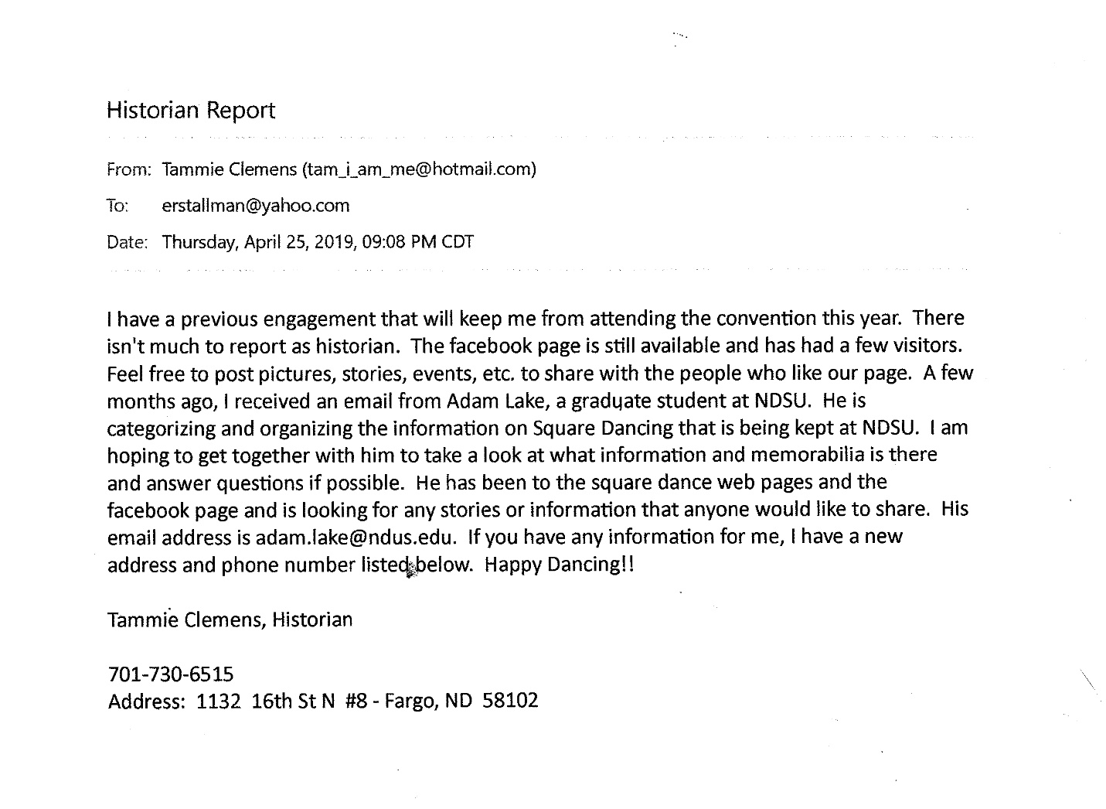

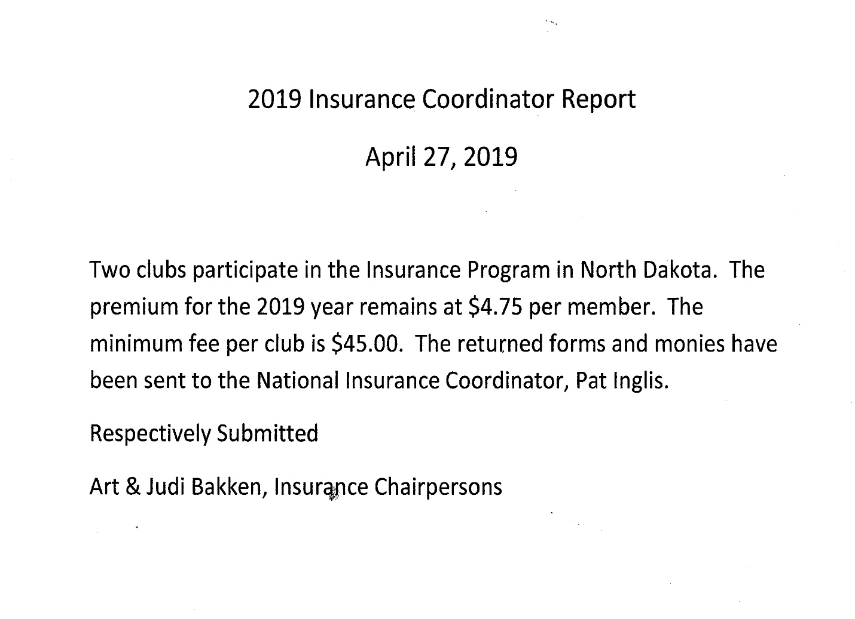

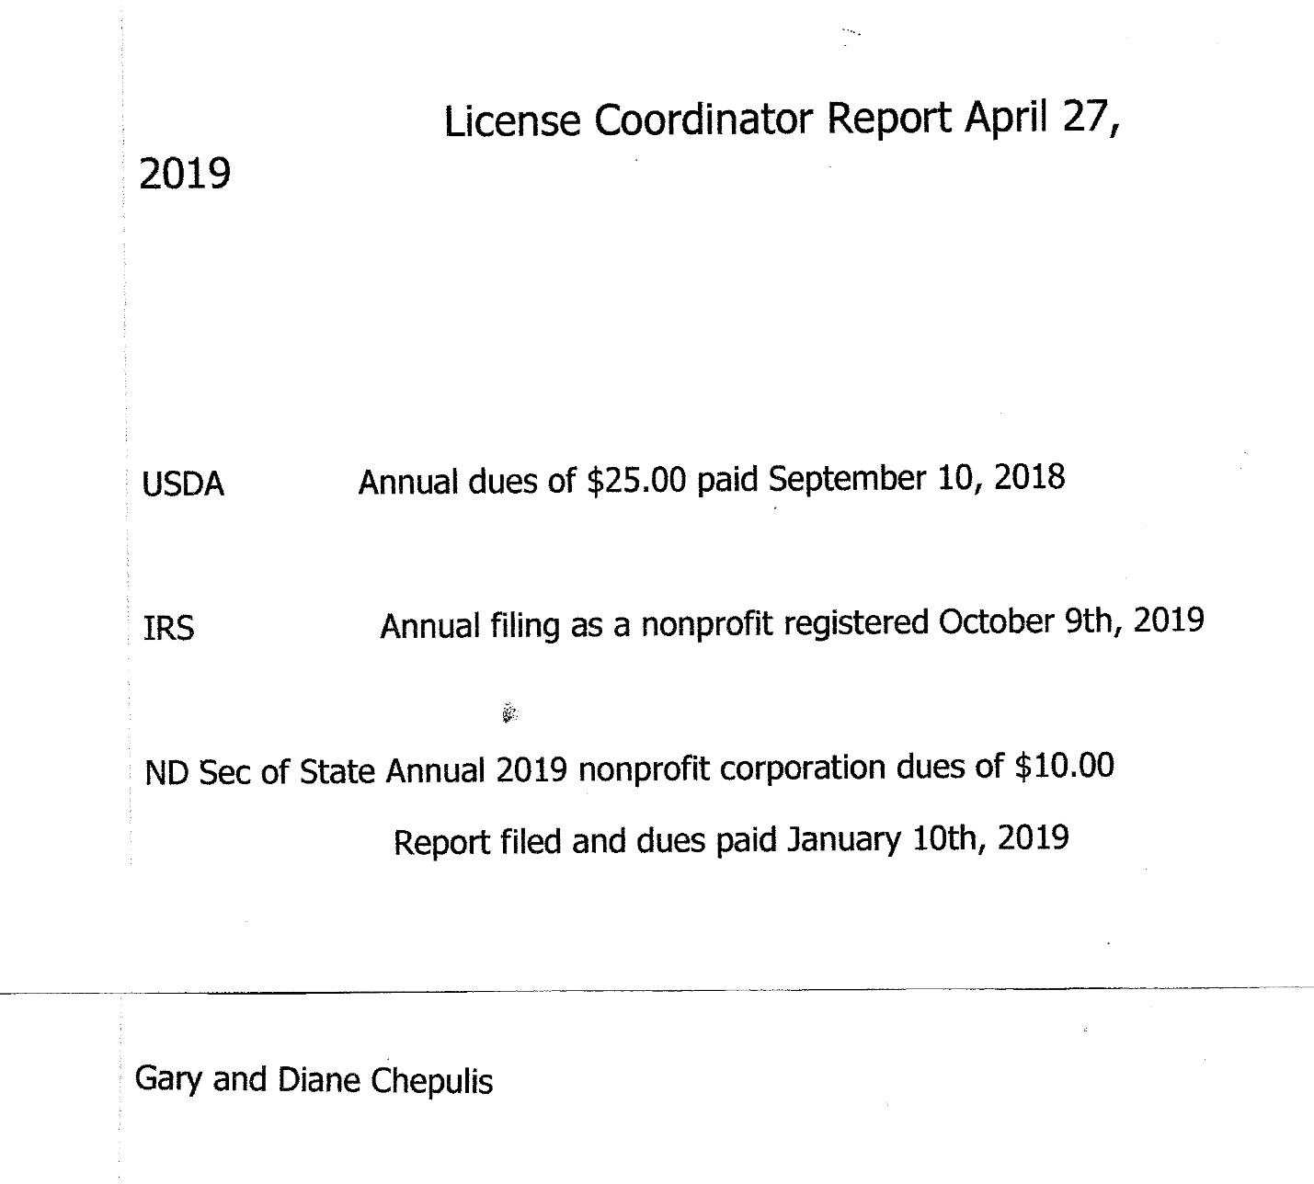

South East Region Report
Fargo-Moorhead Square Dancers Association:
The Fargo-Moorhead Square Dancers Association is comprised of the members of the three local clubs. Our purpose is to provide a connection between the clubs, coordinate advertising, and to host events on behalf of the clubs. We also maintain a website for the FM area. 2018 was a quiet year for the organization. Roger McNeil hosted lessons at his home in the fall. The initial meeting was hopeful as eight new dancers arrived and appeared to enjoy the lesson. A disappointing week followed when none of the dancers returned for the second lesson. The new year’s eve dance was cancelled due to inclement weather.

Saturday Fun Nite
Saturday Fun NIte dances on the second and fourth Saturdays of each month during the academic year and excluding holiday weekends. The organization dances at St. Anthony of Padua Catholic Church in Fargo. The alternate location is the Journey in Faith Church in West Fargo.
The club has guest callers and, if applicable, a guest cuer for each dance. The annual meeting is held generally in August
Club officers are as follows:
President: Bernadette McNeil, 421 21 Avenue North, Fargo ND 58102
701-293-6620 bernadette@rogermcneil.com
Vice President: Harvey Hegvick, 219 2 Ave W # 6, West Fargo ND 58078
701-388-5147
Secretary: Donna Alby, 1709 25th Ave S Apt. 327, Fargo, ND 58103
218-443-6615 donnajeanalby@gmail.com
Treasurer: Denny Resendahl, 3411 Cherry Lane N #15, Fargo, ND 58103
701-799-3066 dresendahl@yahoo.com

The organization is a member of Square Dance Minnesota, the North Dakota Square and Round Dance Council, Fargo-Moorhead Square Dancers Association and the Northwest Region.

Circle 8
No report submitted from Circle 8

L&M Squares, Inc.
Annual Report
April 13, 2019

L&M Squares meets the second and fourth Tuesdays of the month at the Cash Wise Community Room (1401 33rd St. S) in Fargo, ND. Currently, there are 28 members in the organization. The 2019 board of directors consist of Donna Alby, President; LuWayne Barnes, Vice President; Bernadette McNeil, Secretary/Treasurer; Roger and Bernadette, advisors. An average of two squares participate in the Tuesday evening dances.
The group participated in the Square Dance for the Heart Event in Waubun, MN, in April 2018 and 2019. The Northwest Region hosts the dance and the member clubs provide refreshments and prizes for the silent auction. Participants danced to callers from around the region and state. Over $2,700 was raised in this event.
On October 9, 2018, the organization sponsored a fund-raising event for the Breast Friends, a group dedicated to bring awareness about breast cancer and to raise funds for research. Forty-one dancers and guests attended the event. L&M Squares raised $474 for the FM Breast Friends.
Charley Huhtala continues to call some of the tips at the regular Tuesday dances. He is honing his skills under the direction of veteran caller, Roger McNeil. Charley has started calling dances on his own.
Members enjoyed dancing to three guest callers: Tom Manning on June 13, 2018, and to Tom Allen on September 11, 2018 and Bill Henke on September 25, 2018.
Respectfully submitted,
Donna Alby
President

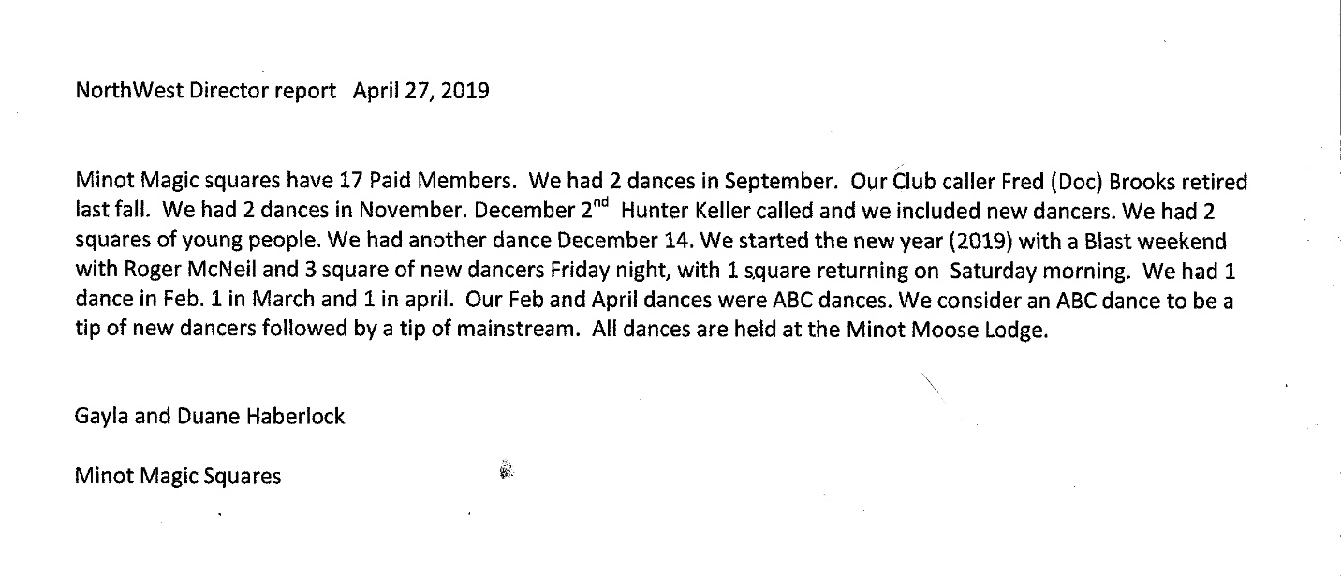
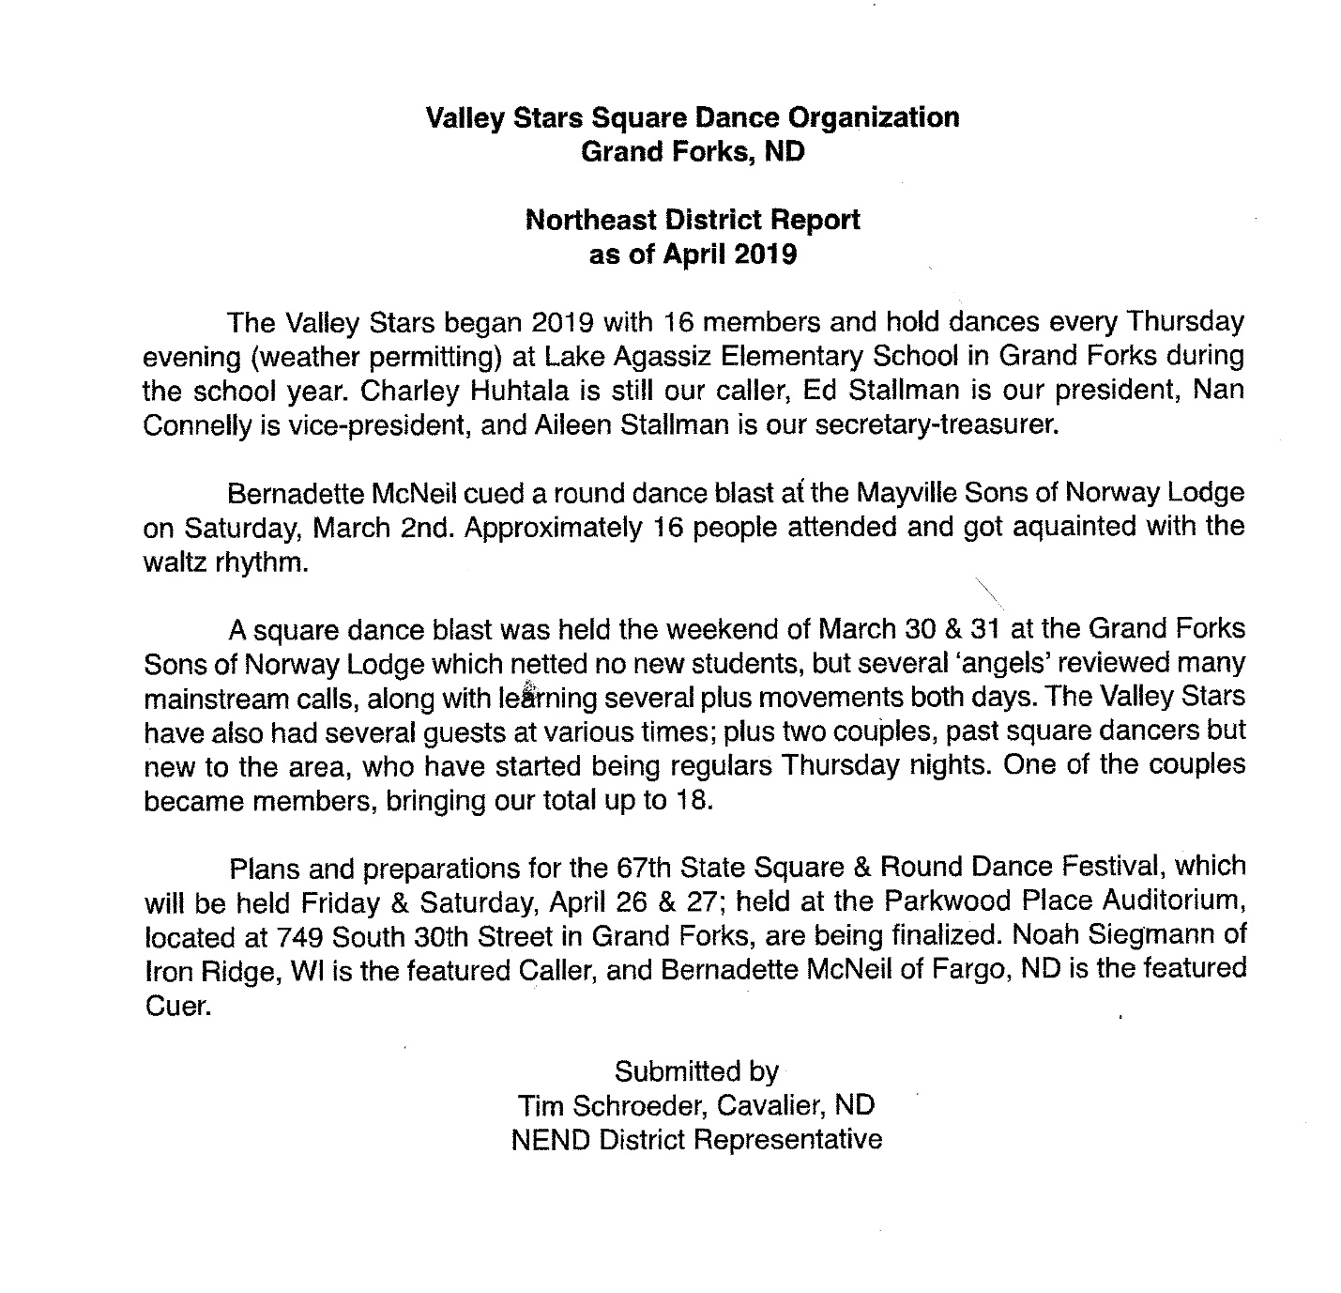

The following report from the SE Region was submitted in July 2019:
SW District Report for the 2019 State Square and Round Dance Convention
April 27, 2019 at Grand Forks.

The Belle’s and Beaux Square Dance Club in Bismarck continues to be the only active club in the Southwestern Region. We have only had one dance a month from September to December and April and May. They are held the Second Saturday of the month. We had to cancel the one scheduled in March due to weather and not enough dancers. Due to the impact of snowbirds we didn’t schedule dances in January and February.

Our Dance Venue is no longer at the Senior Center in Bismarck. We are now dancing at the Edgewood Vista, in North Bismarck.

On Dance nights we have Round dancing from 7:00-7:30, and Square Dancing (which includes mainstream and plus calls) from 7:30-9:30pm.

Doc Brooks retired this year and we are thankful for the calling he did for our club and we will miss him.

This past year we have had the honor of dancing to callers such as Arnold Strebe, Lurita Fugier, Roger & Bernadette McNeil, Jim & Rita Lizakowski , Charlie Huhtala, and Hunter Keller. Jerry Junck made his annual visit and called for us in August.

2019 we will be coordinating with the Minot Square Dance Club. We will be having dances in Washburn on June 8 with Arnold Strebe calling, and in Riverdale at the old High School on August 17 with Hunter Keller calling. August 5 Jerry Junck will be passing thru and calling at the Eagles in Bismarck.

At our 2019 annual Meeting the following new officers were elected:

President: Art and Judy Bakken
Vice President/Secretary Tim and Doretta Bornemann
Treasurer: Greg and Maryann Morford

Respectfully Submitted
Tim and Doretta Bornemann
3017 Hillside RD NW
Mandan, ND 58554

