Refresher dances!

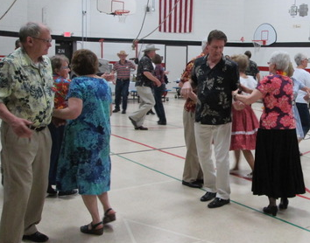

It’s a party!!

Last four Mondays in August, 2021

(August 9, 16, 23 & 30)

7:00 p.m. – 9:00 p.m.

St. Anthony of Padua

Catholic Church

710 10th St S, Fargo

Roger McNeil, caller

Hosted by Saturday Fun Nite and L & M Squares

Sponsored by FMSDA

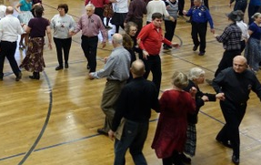

Info: Roger @ 701-367-2886 or roger@rogermcneil.com