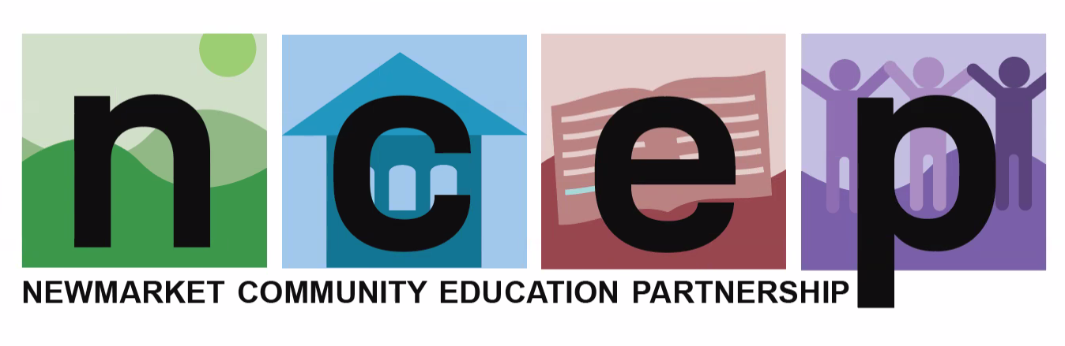
~ Nomination Form ~
2025 Nicholas Popov Memorial Award

Newmarket Community Education Partnership (NCEP) is accepting nominations from the Newmarket Jr./Sr. High School staff for the annual Nicholas Popov Memorial Award. This special award is given to members of the Newmarket community who capture the spirit of personal generosity, kindness, and service that Nicholas “Nick” Popov radiated throughout his life.
Nominate a deserving peer today!
Deadline:
Friday, May 16, 2025
Learn more about
Nick Popov at www.ncepconnects.org
Recipient(s) announced during NES field day festivities
Mr. Popov, who passed away in 2006, was a beloved resident and longtime school volunteer. The contributions he made to our town were valuable and personal. He helped others out of love for people and he shared his skills, interests, and time freely. Recipients of the Nicholas Popov Memorial Award show a commitment to Newmarket’s children and youth through their actions and efforts, and display qualities that help build a caring community.
Along with the award, recipients receive a cash grant to be used towards anything of their choosing that supports our town’s kids and NCEP’s mission. Past recipients have used their award for items such as: enrichment programs, technology, physical education, guest speakers, etc. The award, now in its 19th year, is funded by Mr. Popov’s family and administered through NCEP. In recent years, more than one winner has been chosen and the award split accordingly.

After a couple years affected by covid, NCEP is pleased to return to peer nominations, and his year we invite Newmarket Elementary School staff members to nominate individuals they feel best deserve this award. The nominating process is easy! Simply complete the requested information below by the deadline. You can e-mail the nomination (nominators will be kept confidential by NCEP) or drop in the teacher’s lounge.

Contact NCEP with questions (ncepconnects@gmail.com) or visit www.ncepconnects.org/popov-award for more information.
Please complete the following, then e-mail the nomination to: ncepconnects@gmail.com or drop in the envelope located in the teacher’s lounge by the May 16, 2025.

Name of nominee: ___________________________________________

- How does this nominee capture the spirit of personal generosity, kindness, and service in support of Newmarket’s children and youth? Please cite specific examples if possible.
- Why is this nominee deserving of the Nicholas Popov Memorial Award this year?

