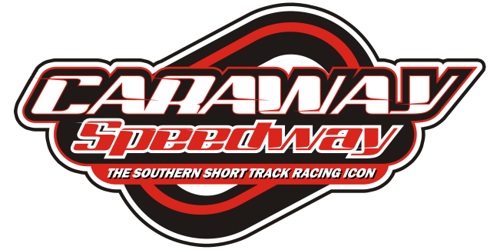
NEW TIRE ANNOUNCED FOR 602 MODIFIEDS AT CARAWAY SPEEDWAY

(Sophia, NC): Officials at Caraway Speedway are happy to announce a change in tires for the 602 Modified Division at the Asheboro, NC track. The division will compete on the popular Hoosier F-45’s beginning with the Rusty Harpe Memorial event on July 3rd.

“The division has struggled this season at Caraway and we feel part of the reason is the tire the cars used for the past couple of seasons. There are some other outlying factors in the diminished car counts but the old tire has been the reason most recognized in talks with the competitors”, said speedway representative, Randy Myers.

“We tried our best to make the old tire work. We even allowed the teams to use chemicals to soften the tires. The input from the teams in earlier conversations kept coming back to the tire choice. Darren Hackett worked hard to make the switch happen at mid-season. He even took a loss on the sale of the tires to a track in Michigan that needed them”, Myers said.

“I am happy we were able to make the sale of our D-800 inventory to the other track and the opportunity to make the switch to the F-45’s. The supply of the 45’s is still limited so we will be working with the teams and Hoosier Asphalt South to make the transition as easy and fair as possible for our competitors”, Hackett said.

Beginning with the Rusty Harpe Memorial on July 3rd, teams must purchase two new F-45’s (depending on availability). If teams have F-45’s, they will be allowed to use them to make their race set for the Harpe Memorial event. If teams do not have their own F-45’s, the track will have a supply of “scuffed” F-45’s to choose from to complete their race set. All tires used in competition will be scanned into the speedway inventory system. Those tires must be left at the track for future event use. TO BE CLEAR, if there are not enough new tires available for each team to purchase two (2) new F-45’s, we will limit the purchase to one (1) tire for each team and they can use their own tires or “scuff’s” from the track inventory to make their race set.

It is our intention to be as fair as possible with teams choosing to compete at Caraway Speedway and to that point, we will distribute new tires after all teams have registered for the event on July 3rd.

The track, may at any time, impound for inspection, any tire used in competition (qualifying or the race) at any Caraway Speedway event. If a determination on whether that tire has been altered or treated in any way, the tire’(s) in question will be subject to testing at a track approved testing facility. If the tire’(s) in question are found to be within the specifications as originally manufactured, it will be returned to the competitor. If the tire’(s) in question do not meet the specifications as originally manufactured, the competitor will be fined the applicable penalties. The competitor shall also be responsible for the costs involved in the testing of the tire’(s) in question. The costs for “basic” (Mass Spectrometer) testing is $100.00 per tire and a full analysis is $300.00 per tire.
Tires MAY NOT be altered or treated in any way. If tires are found to be altered or treated in any way, the penalty is; loss of tire, fine of $100.00 for each tire altered.

