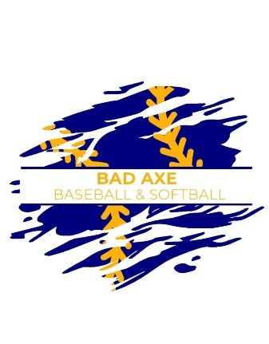**2025 Bad Axe Baseball and Softball**

**All Star Summer Tournament**

**June 27th, 28th, 29th**

**Divisions:**

**Machine Pitch 8U Baseball and Softball**

**10U Baseball and Softball**

**12U Baseball and Softball**

Based on 2025 USSSA

Age Matrix.

**Location:** Bad Axe Rotary Park

**Entry Fee:** $350 Per Team

**\*\* If you bring 3 or more teams the entry fee is $325 per team.**

Entry fee will officially reserve your spot.

**Notes of Interest:**

* Recreational All-Star Teams only, no Travel Ball Teams
* Format will be Round Robin or Bracketed play, based on number of entries. All teams guaranteed a minimum of 3 games.
* Limited to first 8 paid entries in each division.
* 1st Place Rings & 2nd Place Medals. (Maximum 12 awards per team)
* 8U Baseball will use a Jugs Pitching Machine.
* 8U Softball will use Blue Flame Pitching Machine
* 10U Softball combination of Pitching Machine and Live Pitching
* Concessions will be available on Friday, Saturday & Sunday.
* No alcohol, smoking or pets allowed on tournament premises.

PLEASE SEND REGISTRATION & ENTRY FEE PAYABLE TO:

**Bad Axe Youth Baseball**

**P.O. Box 232**

**Bad Axe, MI 48413**

**Contact: Brian Lang 989-553-1047** [**brianmlang@gmail.com**](mailto:brianmlang@gmail.com)

**Brandon Fanion 810-956-8342** [**bmfanion@svsu.edu**](mailto:bmfanion@svsu.edu)

**Michelle Davis 989-600-2476** [**madavis0222@gmail.com**](mailto:madavis0222@gmail.com)

**Registration Form**

**(Due by June 13th)**

**Complete and return this form for each team**

**along with entry fees to reserve your spot.**

Team: __________________________________

Coach: __________________________________

Phone: __________________________________

Email: __________________________________

Baseball_______ Softball_______ 8U___ 10U ___ 12U ___

Team: __________________________________

Coach: __________________________________

Phone: __________________________________

Email: __________________________________

Baseball_______ Softball_______ 8U___ 10U ___ 12U ___

Team: __________________________________

Coach: __________________________________

Phone: __________________________________

Email: __________________________________

Baseball_______ Softball_______ 8U___ 10U ___ 12U ___

Team: __________________________________

Coach: __________________________________

Phone: __________________________________

Email: __________________________________

Baseball_______ Softball_______ 8U___ 10U ___ 12U ___

Team: __________________________________

Coach: __________________________________

Phone: __________________________________

Email: __________________________________

Baseball_______ Softball_______ 8U___ 10U ___ 12U ___

Team: __________________________________

Coach: __________________________________

Phone: __________________________________

Email: __________________________________

Baseball_______ Softball_______ 8U___ 10U ___ 12U ___