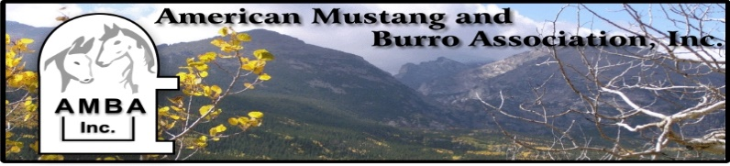

Theodora “Sis” Kunde Memorial
Academic Scholarship
The American Mustang and Burro Association awards one scholarship each year to a deserving student interested in pursuing a career in equine science related to promotion, education and preservation of wild horses and burros.

APPLICATION DEADLINE: October 15

CRITERIA:
- Currently attending or planning to attend a degree program leading towards a career in working with the wild equine or burro (ie: veterinarian medicine, animal and/or range management)
- A personal statement (See instructions below)

Name: ______________________________ Phone #:__________________E-mail_____________________

Address: ________________________________________________________________________________

School Currently Attending or Planning to Attend and Area of Study:

_________________________________________________________________________________________

  - In order for your application to be considered you must attach a Personal Statement addressing the following questions:
    - Long term goals?
    - Previous experience with wild horses or burros?
    - Why did you choose to work in the animal or range management field?
    - How will you use your funds from the scholarship?
    - Why should you be considered for this scholarship?

  - Make sure your name is on all of the attachments.

  - You will be contacted by a representative from the AMBA Scholarship Committee for a personal interview if selected as a finalist.

Please return the completed application by October 15 to:

Susie Askew Phone: 775.376.2577
1283 Creek Haven Cir Email: psa@unr.edu
Reno, NV 89509
Visit our Website: www.usamba.org

