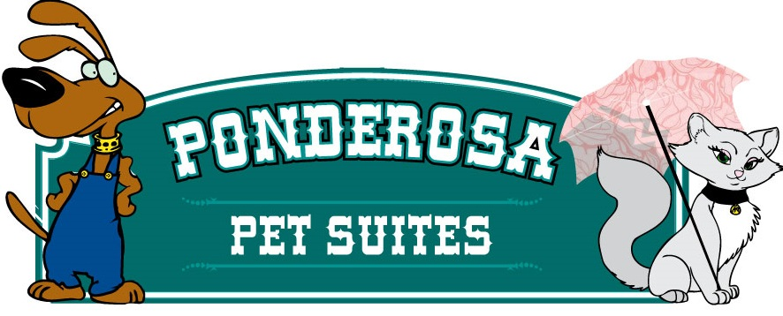
Medical Release Form

In the event of a medical emergency, I __________________________________________
(Owner’s Name)
hereby give the staff of the Ponderosa Pet Suites permission to take my dog/cat_____________________________ to the nearest animal medical facility.
(Pet’s Name)

If possible, _____________________ ___________ is our veterinarian for ________________________.
(Veterinarian and phone ) (Pet’s Name)

I agree that I am financially responsible for any and all medical treatment that my dog/cat receives as a result of a medical emergency while boarding at the Ponderosa Pet Suites.

Owner’s Signature___________________________________________ Date_______________

Print Name _____________________________________________

Emergency Contact Name/Number_________________________________________________

241 W Schrock Rd, Wasilla AK 99654 907 357-7297
Ponderosa.pet@aol.com

