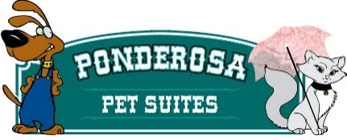
Boarding Contract
Customer Name_____________________________________ Dog/Cat Name(s) _________________
_____ I confirm that my dog/cat is in good health and current on vaccinations
_____ I confirm that my dog/cat has not injured or shown aggression or threatening behavior to any person(s)
_____ I understand that any problem with my dog/cat, behavioral, medical or otherwise will be treated as deemed best by the staff at the Ponderosa Pet Suites. I understand that I assume full financial responsibility and all liability for any and all expenses involved in regards to the behavior and health of my pet.
_____ I understand that I am solely responsible, financially or otherwise, for any harm or damage caused by my dog/cat, while my dog/cat is boarding at the Ponderosa Pet Suites. Damage to doggy suites includes destroying walls and doors which will require delaying use of this room for a period of time. Damages caused to suites will be charged a minimum of $250.00 for repairs.
_____ I agree to pick up my pet by 12noon on the agreed upon checkout date. Any animals not picked up within 48 hours will be turned over to MSB animal shelter along with Owner’s contact information.
_____ Customers are responsible for all days booked within their reservation, once pet is checked in.
_____ I confirm that my dog is NOT in HEAT. If my dog shall begin her cycle while in Ponderosa Pet Suites care there will be a $50.00 handling fee added to my invoice.
I have read and understand the above and agree to all conditions.

Owner’s signature____________________________________________ Date_______________
241 W. Schrock Rd, Wasilla, AK 99654 907 357-7297
Ponderosa.pet@aol.com

