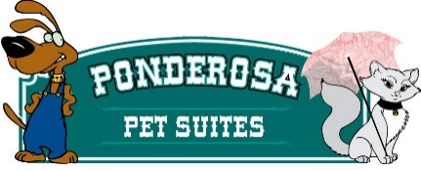
Boarding Contract
Customer Name_____________________________________ Dog/Cat Name(s) _________________
_____ I confirm that my dog/cat is in good health and current on vaccinations
_____ I confirm that my dog/cat has not injured or shown aggression or threatening behavior to any person(s)
_____ I understand that any problem with my dog/cat, behavioral, medical or otherwise will be treated as deemed best by the staff at the Ponderosa Pet Suites. I understand that I assume full financial responsibility and all liability for any and all expenses involved in regards to the behavior and health of my pet.
_____ I understand that I am solely responsible, financially or otherwise, for any harm or damage caused by my dog/cat, while my dog/cat is boarding at the Ponderosa Pet Suites. Damage to doggy suites includes destroying walls and doors which will require delaying use of this room for a period of time. Damages caused to suites will be charged a minimum of $250.00 for repairs.
_____ I agree to pick up my pet by 11:00 on the agreed upon checkout date OR I understand that if my pet is picked up between 4pm-5pm that I will be responsible for a half day boarding charge.
_____ Any animals not picked up within 48 hours will be turned over to MSB animal shelter along with Owner’s contact information.
_____ Customers are responsible for all days booked within their reservation, once pet is checked in.
_____ I confirm that my dog is NOT in HEAT. If my dog shall begin her cycle while in Ponderosa Pet Suites care there will be a $50.00 handling fee added to my invoice.
I have read and understand the above and agree to all conditions.
Owner’s signature____________________________________________ Date_______________
241 W. Schrock Rd, Wasilla, AK 99654 907 357-7297
Ponderosa.pet@aol.com
Available times for Check In or Check out are 9-11AM daily and 4-5PM daily.

