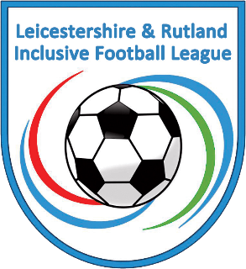
Leicestershire and Rutland Inclusive Football League

The league is a pan-disability league.

Grading for adult males

Adult Green (League)
Players with limited mobility, spatial awareness and fitness

Adult Red (Championship)
Players that are mobile, have spatial and tactile awareness, knowledge of the laws of the game and a good level of fitness

Adult Purple (Premiership)
Players with good mobility, good level of spatial awareness, excellent ability to understand tactics and good level of physical strength and fitness as well as good knowledge of the laws of the game.

When you register your team, please do make sure that players are listed under the correct ability banding

FEMALE PLAYERS ARE NOT PERMITTED TO PLAY WITHIN THE ADULT MALE DIVSIONS.

