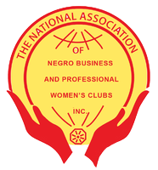
The Negro Business and Professional Women’s Club of Midland
P O Box 10233, Midland, TX 79702

Yes, I would like to support high school seniors from Midland County through scholarships at the annual Martin Luther King Jr. Day luncheon, January 19, 2026,
11:00 a.m. – 1:00 p.m. at Bush Center 105 N. Main St., Midland, TX 79705 provided by the Negro Business and Professional Women’s Club of Midland.

_______ I would like to sponsor a table for 8 for $800
_______ I would like to purchase a individual ticket for $100
_______ I would like to make a general donation in the amount of $_______________

Preferred name to be on digital and printed material:
Point of Contact:
Email:
Phone Number:
Physical Address:
_______ I would like to pay online https://nbpwcofmidland.org
_______ I would like to pay by check, mail to: PO Box 10233, Midland, TX 79702
_______ I would like to pay by Venmo: @NPBWClubMidland

Questions? Email: nbpwofmidland@gmail.com
The Negro Business & Professional Women's Club of Midland is a club formed under the domestic districts the National Association of Negro Business & Professional Women's Club. Texas Tax Exempt Number 13409773630, Federal EIN 34-097736

