Neal Winterton, President
Provo Bench Canal and Irrigation Company
1156 South State Ste. 201
Orem, UT 84097
801-592-2526
nrwinterton@orem.org
August 17, 2021
To: Provo Bench Canal and Irrigation Company Water Users
From: Provo Bench Canal and Irrigation Company
Dear Water Users,
Everyone is already aware of the current drought situation that is affecting the citizens of Utah and the Western United States. The Provo Bench Canal and Irrigation Company (PBCIC) is also affected.
The Provo River was cut to 50% in June. In August, the Provo River allocation was moved to 30%. This means that the water rights in the Provo River associated with the PBCIC is also 30%. This is very low and water users are affected. Water users will see a low volume in the stream compared to most years. As a company and individual users, we need to work together to reduce overall water use.
On August 17th and August 18th, rain and mild temperatures are predicted. The canal will be turned down. Moving forward, the water stream will be smaller so we can stretch the remaining water that is available as far as possible. Please turn your gate down and get by with as little water as possible, monitor air temperatures, and watch your soil moisture closely. Please DO NOT water for longer than your turn, modify diversions, or place boards in the canal.

Respectfully,
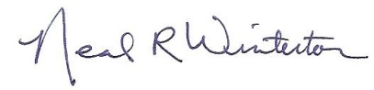
Neal R Winterton, President
Cc: Tamara Shafer, Secretary
Rick Lewis, Water Master

