
2026-2027
COMPETITION TEAM INFORMATION

This packet includes information on our award-winning competitive program and auditions for the 2026–2027 season

Please contact our Competition Director,
Kim Dercks, with any questions:
kimdercks@gmail.com

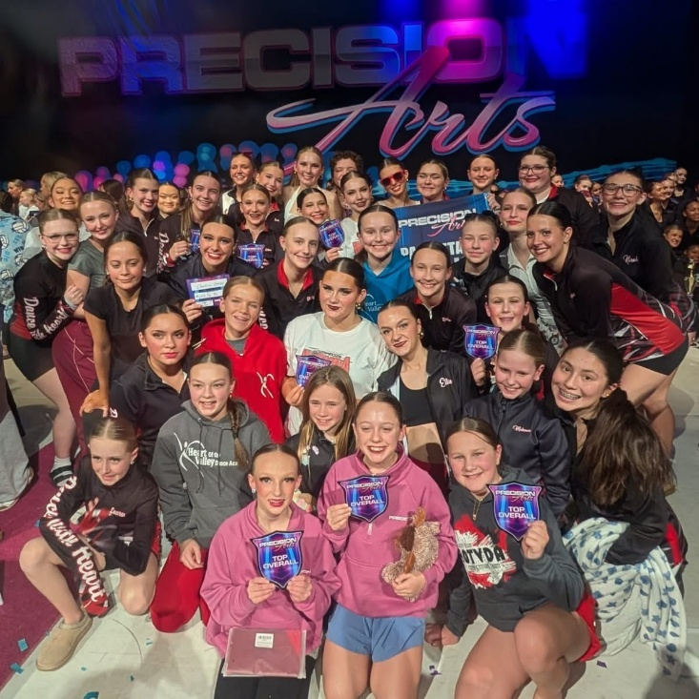
CONTENTS

- Important Dates
- Informational Meeting Details
- Competition Program Overview
- Audition Details
- Financial Investment
- Summer Classes
- Team Contract

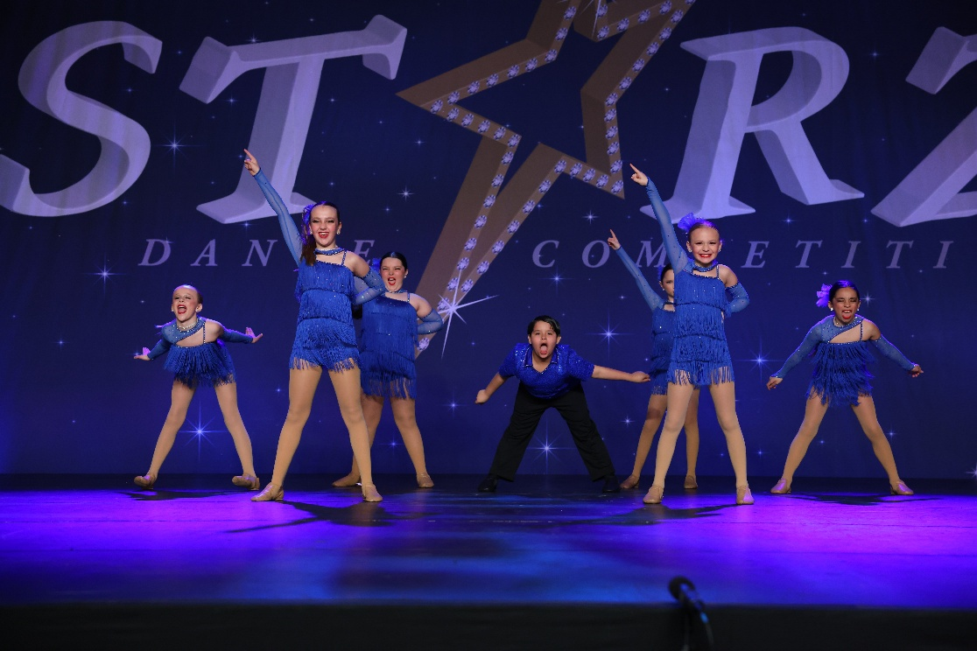
IMPORTANT DATES
Wednesday, May 27th | Informational Meeting via Zoom at 7 PM *must attend ONE meeting*
Sunday, June 7th | Informational Meeting via Zoom at 7 PM *must attend ONE meeting*
Tuesday, June 23rd | Auditions *dancers will sign up for ONE audition day*
Wednesday, June 24th | Auditions *dancers will sign up for ONE audition day*
Thursday, June 25th | Auditions *dancers will sign up for ONE audition day*
Wednesday, July 1st | Competition Team Placements Announced
Monday, July 6th | Summer Classes Begin *mandatory for all competition dancers*
Thursday, July 9th | Signed Contracts & Deposits Due
Sunday, July 12th | Mandatory Team Meeting via Zoom at 7 PM

2026-2027 INFORMATIONAL MEETING
** All NEW and RETURNING parents should attend ONE meeting**

Wednesday, May 27th at 7 PM

Sunday, June 7th at 7 PM

MEETING WILL BE HELD VIA ZOOM
ZOOM LINK WILL BE EMAILED TO CURRENT COMPETITION FAMILIES

PLEASE EMAIL KIMDERCKS@GMAIL.COM FOR ZOOM LINK

Informational Meeting Agenda
Upcoming Important Dates
Program Structure & Expectations
Time Commitment
Audition Details
Financial Investment

COMPETITION PROGRAM OVERVIEW
Any dancer (ages 5 +) interested in becoming part of a competitive dance team environment may audition. Classes are geared towards the serious dancer who shows potential for growth, those who are enthusiastic and passionate about dance and those who are driven to work hard, practice and be part of a team. Dancers must also adhere to our team contract throughout the dance season.

SEASON
Our season runs from September through June. Actual competitions take place February – May with Nationals ending our season in June. We will be attending five mandatory regional competitions this season. By adding a regional competition to our schedule, we will be attending at least two local competitions (in the Fox Valley area) to cut down on travel expenses. These regional competitions may be held in the Green Bay, Oshkosh, Stevens Point, Madison, or Milwaukee area. Our Nationals competition is optional and may be held in the Minneapolis or Wisconsin Dells area.

CLASS & PARTICIPATION REQUIREMENTS
Dancers may audition only for the styles of dance they wish to participate in. To be eligible for a solo, duo, or trio, dancers must participate in at least one group routine. In addition to the classes a dancer auditions for and accepts placement in, the following classes are required:

SCHOOL YEAR REQUIREMENTS
Required Weekly Classes
- ONE Ballet class
Held on Sundays; placement based on age and ability
- ONE Stay Strong class
Held on Sundays; placement based on age and ability
- ONE additional technique class during the week
Held Monday – Thursday. Options may include Turns & Leaps, Ballet Technique, or PBT

Additional School Year Requirement for Tap Dancers only:
- ONE Tap Technique or Developmental Tap class
Held Monday – Thursday

SUMMER REQUIREMENTS
All dancers are required to take:
- At least TWO summer classes
  - ONE must be Ballet
  - ONE may be the dancer’s choice

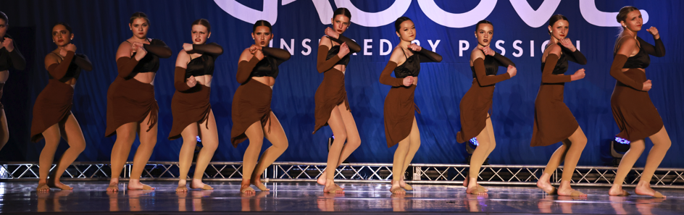
SCHEDULING INFORMATION
- Competition group classes meet on Sundays
- Solos, Duos, and Trios may be scheduled during the week based on studio and instructor availability
- Class lengths:
  - Groups: 45 minutes weekly
  - Duos & Trios: 30 minutes weekly
  - Solos: 30 minutes every other week
  - Ballet: 60 minutes weekly
  - Stay Strong: 45 minutes weekly
- Additional required technique classes are held Monday–Thursday for 30 minutes unless otherwise specified.

NOTE: Our youngest competition team members (generally Pre K – 1st Grade) will have their ballet and stay strong classes combined into a one-hour class to better meet their needs. When audition placements are announced, we will also clarify the dancers who will fall into this category for the combined ballet/stay strong class.

ATTENDANCE
SCHOOL YEAR ATTENDANCE REQUIREMENTS
Dancers are allowed four absences from each class over the course of the dance season. Practices held the week before a competition are mandatory for all dancers. Any dancer missing a mandatory practice due to illness will be required to turn in a doctor’s note. Dancers will only be allowed ONE absence per month from January – May. Any dancer with five or more absences from performance-based classes may be removed from the group. Any dancer with five or more absences from a ballet or stay strong class will be required to make those classes up at another time during the week. Dress rehearsal and our annual recitals are also mandatory events for our competition team members. When possible, injured dancers are expected to observe class.

SUMMER SESSION ATTENDANCE REQUIREMENTS
Dancers are allowed one absence per class from our 6-week summer program. Any absences exceeding the one allowed absence are expected to be made up at a different class during the week. Dancers with excessive absences may have adjustments made to their class placements by our competition staff.

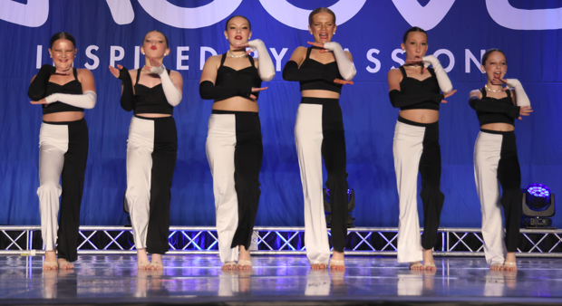

2026-2027 AUDITION DETAILS

AUDITION DATES & TIMES
Dates | Grades | Time
6/23, 6/24 or 6/25 | Pre K – 2nd | 4:00 - 5:30 PM
6/23, 6/24 or 6/25 | 3rd – 5th | 5:30 - 7:00 PM
6/23, 6/24 or 6/25 | 6th – 12th | 7:00 - 8:30 PM

WHAT TO WEAR
- Dancers must dress in plain black clothing. Leggings, tanks, etc. are all acceptable. Clothing should be fitted so we can see body lines during auditions
- Hair must be secured back in a bun (low or high is acceptable)
- Proper shoes for the style(s) of dance you are auditioning for
- No jewelry

WHAT TO BRING
- Completed registration form
- $25 audition fee
- Solo/Duo/Trios: A note explaining why you would like one of these limited routines
- Water bottle
- A positive attitude and strong work ethic!

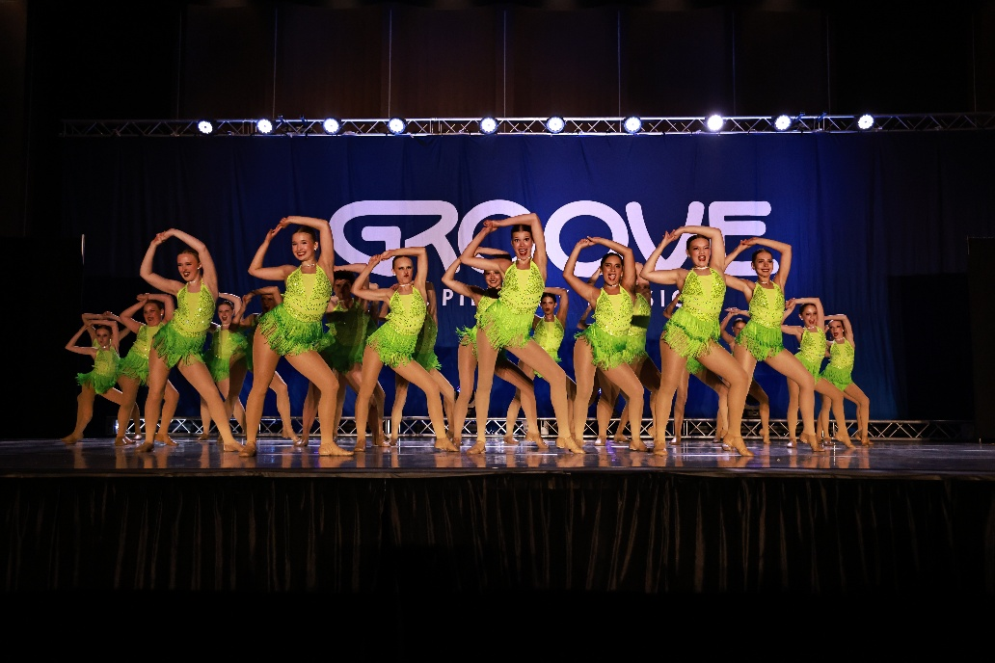

2026-2027 AUDITION DETAILS

WHAT TO EXPECT
There will be no combos to learn ahead of auditions. Our competition staff will work with dancers during the audition to learn very short combos. Dancers will also be asked to demonstrate various skills, etc. We will upload a sample of the audition scoresheet so there is complete transparency regarding what skills dancers will need to demonstrate and what dancers are being scored on during the audition process.

Dancers can arrive 30 minutes prior to the start of their audition timeslot to go through a thorough warm up and stretch lead by our competition alumni.

Audition classes will be limited to 15 dancers per slot, and dancers only need to attend one class. Dancers must sign up using the following link:

LINK TO AUDITION SIGN UP

LINK TO REGISTRATION FORM
AUDITION RESULTS WILL BE ANNOUNCED ON WEDNESDAY, JULY 1ST
(EMAILED TO ALL PARTICIPANTS AND POSTED ON OUR WEBSITE)
CONTRACTS, REGSITRATION FEE ($50) & DEPOSIT ($250) ARE DUE ON THURSDAY, JULY 9TH
Failure to return these items by the deadline will result in your dancer(s) not being placed in our competitive program. The
$250 deposit will go towards dancer’s accounts at the end of our dance season unless the team contract has been breached. In that case, the $250 DOES NOT go towards the balance of the account and will be used for the added



FINANCIAL INVESTMENT

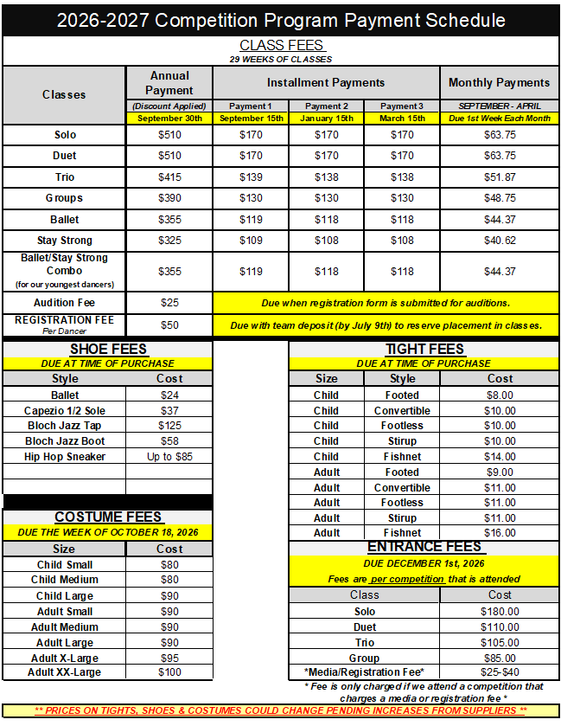

ADDITIONAL COSTS MAY INCLUDE: MAKEUP, JEWELRY, STUDIO JACKET, ETC.

MUTLIPLE FUNDRAISING OPPORTUNITIES ARE OFFERED TO HELP OFFSET COSTS

2026 SUMMER CLASSES

6 WEEK SESSION
CLASSES RUN FROM JULY 6TH – AUGUST 13TH
ALL CLASSES ARE 45 MINUTES IN LENGTH
$85 PER CLASS

All dancers on our competitive team are REQUIRED to participate in our summer dance program. Dancers must take at least TWO classes. One class MUST be ballet, while the other class(es) can be of the dancer’s choice.

Summer classes are a great opportunity for dancers to try a new style or simply continue to work on improving their skills. Registration is currently open for our summer session. Register soon to secure your spots in your preferred classes. Some classes are already near capacity!

LINK TO SUMMER SCHEDULE LINK TO SUMMER REGISTRATION FORM

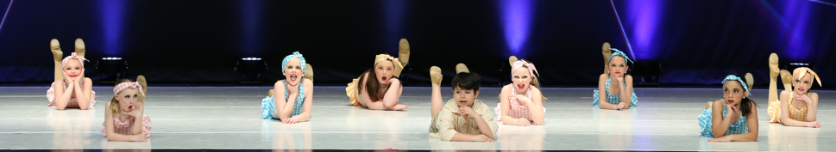

2026-2027 Competition Team Contract
Please read the following contract carefully as it’s imperative both parents and dancers understand the commitment, time, expectations and expenses that are required to be a successful, contributing member of this team.

INITIALS Parents/Dancers have read, understand and agree to the following participation guidelines upon their competition team acceptance:
________ I recognize by returning this form and deposit, I am accepting my placement in the following classes (write classes below):
___________________________________________________________________________________________________________________________________________________________________________________________________________________________________________________________________________________________________________________________________________________
________ If at any time after July 9th, 2026, I decide to drop any of the above classes, I understand I forfeit my deposit.
________ I understand there are only 4 absences allowed per class over the course of the dance season. Attendance at the last practice prior to a competition, our dress rehearsal, and our recitals are MANDATORY. Dancers are only allowed ONE absence per month from January-May. Any dancer with five or more absences from a performance-based class may be removed from the group. Any dancer with five or more absences from a ballet or stay strong class will be required to make those classes up at another time during the week. When possible, injured dancers are expected to observe class. I will make every effort to be at practice as my actions and choices affect my entire team.
________ All tuition, costume, competition entrance fees, recital and late fees are required to be paid in full by the dates set forth by HOTVDA. All payments are the sole responsibility of the competition team member/family. I also understand I am responsible for any travel related expenses for competition.
________ I will follow all studio policies for Heart of the Valley Dance Academy found in our studio handbook. Handbooks can be found on our website, www.hotvdance.com, under team documents.
________ I commit to always representing Heart of the Valley Dance Academy and our Competitive Team at the highest level. I will be respectful, courteous, kind and compassionate toward dancers and their families from both Heart of the Valley Dance Academy and other studios. This includes online interactions on social media and in person.
________ I understand that being part of the Competition Team requires hard work. I will be expected to handle personal critiques and criticism and will work towards continuous improvement of routines and technique. I understand that practice outside of the studio is expected at this competitive level. If at any time during the season a dancer falls behind the rest of the class (meaning the dancer is not performing at the same level of ability as the rest of the class), they may be removed from that class or required to take private lessons at the rate of $30 for 30 minutes or $50 for one hour.
________ I realize team bonding makes a big overall impact on the success of this program. Dancers are expected to participate in team bonding activities, as much as possible, to help create a strong connection amongst dancers.
________ I understand that a $250 deposit and $50 registration fee, along with this signed contract, is due back to the studio no later than Thursday, July 9th by 8:00 PM to secure my spot on the Competition Team. Failure to return the contact and/or deposit by the due date will result in removal from the Competition Program. If at any time over the course of the dance season (starting in September and ending with Nationals in June) this contract is breached, I understand the $250 deposit is forfeited. If the contract is upheld, the $250 deposit will be applied as a final payment to your account.
________ I have read, understand and agree to abide by the rules listed above and in the studio handbook.

Dancer Signature_______________________________________________________________________ Date _______________________
Parent Signature________________________________________________________________________ Date_______________________

PARENTS AND DANCERS, INITIAL, SIGN AND RETURN WITH YOUR $250 DEPOSIT BY 8 PM ON JULY 9TH
*** FAILURE TO RETURN CONTRACT AND DEPOSIT BY DEADLINE WILL RESULT IN REMOVAL FROM PROGRAM***

