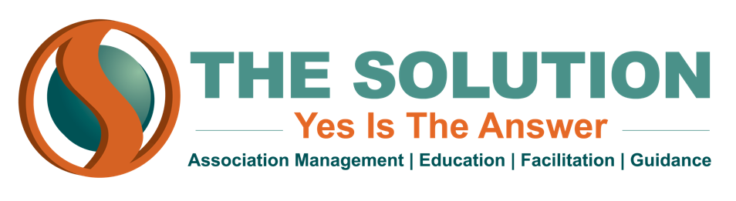
ENVIRONMENTAL SCANNING

To build an effective long-term strategic plan, you need to understand the environment that your association inhabits and how that environment might change over the time frame that you are planning for. To do this, you have to conduct an environmental scan for your association.

Environmental scans are meant to assess the forces and factors that will affect the future of your association. These forces can be split into five overarching categories:

- Sociodemographic
- Technology
- Environmental
- Economic
- Political

Assessing environmental changes in these five categories (often abbreviated as the STEEP categories) will help you envision how the landscape will look for your organization in the coming years. Then you can proceed to make a strategic plan with that landscape in mind.

Ideally, an environmental scan should be less of a one-time event and more of an ongoing process - smart associations are always updating and refreshing their environmental scan to account for changes in the environment around them. However, scanning can also be time and labor intensive, and your association may not have the manpower to do it in-house. That is why many associations hire an outside consultant to design and create their initial environmental scan; once that framework is in place, the association can then periodically refresh the scan themselves.

There are numerous sources that can be incorporated into an environmental scan. Industry trade publications and the association’s own membership can provide information about trends within the industry. The U.S. Bureau of Labor Statistics has a wealth of information about economic and sociodemographic trends in the workforce. There are also plenty of online databases that can help - just be sure the source is reliable.

