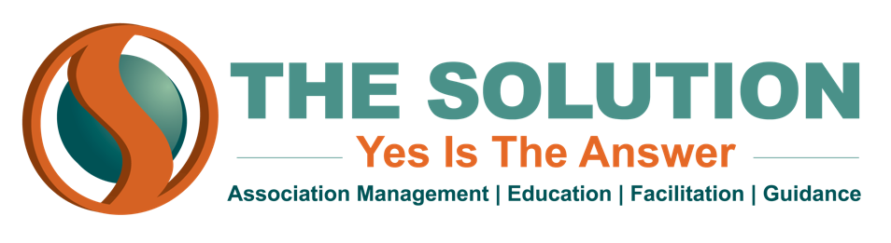

INTERNAL CONTROLS
Internal controls are necessary for any association to prevent any fraudulent financial activity. Your members are paying a lot of money to be a part of the organization, and establishing solid internal controls will ensure that your organization will use that money ethically to further your mission. Here are some controls that you should consider instituting for your association:

- Delegation of activities: Don’t leave one person in charge of all your finances--there should be multiple people involved in initiating, approving, and recording a financial transaction. This removes the possibility of someone skimming money for themselves
  - More than one person should have to sign off on any check issued by the association
  - Multiple people should also have access to the organization’s bank account(s)
- Standardized reimbursement policy: Everyone, even leadership, should have to go through the same process to receive expense reimbursements
- Proper asset safeguarding: Access to association checkbooks should be as limited as possible while also allowing for financial checks and balances
- Monthly account reconciliation: Balance your books frequently so that financial red flags don’t go unnoticed for long periods of time
- Establish processing controls: Your association should have a system for processing that always leaves a paper trail
- PCI Compliance
  - Use strong passwords and designate a password keeper
  - Maintain a firewall to protect credit/debit card data
  - Use SSL certificates to encrypt credit card information
  - Regularly update your anti-virus software
- External Review: At the end of each year, have an external audit of your association’s finances to ensure that your financial statements are free of misstatements

