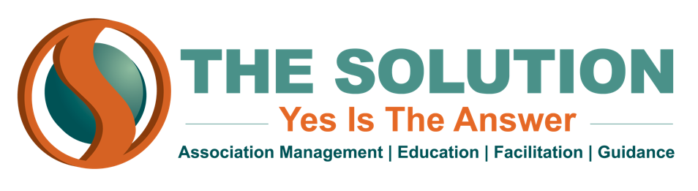

**KEY PERFORMANCE INDICATORS**

It’s not enough to simply set goals for your association; you need to have a way of tracking your progress towards those goals. Almost any goal your association has can be measured--if you have a goal that you have no way of measuring, you should stop to consider whether it is really attainable.

When your association formulates its strategic plan, the board and staff should agree on KPI’s that will allow them to measure the progress of their plan. These metrics can then be arranged on dashboards--graphic depictions of the data that allow for easy monitoring and evaluation by the board. These are fairly simple to create with Microsoft Excel, Word or PowerPoint. Having an easy, interactive tracking system reduces the need for long performance reports at every board meeting.

Here are some common KPI’s you can use to track your association’s goals:

* Membership retention rate
* Quarter-to-quarter membership growth
* Website and social media traffic
* Membership market share percentage--ratio of members to potential/desired members
* Ratio of dues income to non-dues income
* Percentage of members engaging in association programming
* Number of lobbying contacts/visits with government officials
* Rate of media mentions
* Number of member calls or emails to administrative staff

It is your responsibility to provide your board with enough data to make informed decisions for the good of the association. Effective use of KPI’s will allow you to easily compile that data.