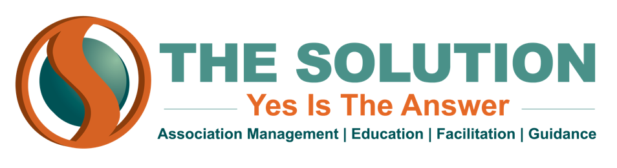

MEMBER RETENTION - TOP 10 LIST

- Have an onboarding plan - Set an outreach to schedule to keep new members engaged. First-time members are the most likely to non-renew
- Say hello with a personal touch from a member - “Here is the value I received from the organization”
- Reach out at 3 to 6 months - Email a list of upcoming events at 3 months and a list of benefits at 6 months
- Do a first-year Loyalty Assessment - Nine months into the first year, survey your new members: What do they want? What do they appreciate?
- Sell your organization - Enlist your members to help; they have a firsthand perspective on the value your organization brings
- Always stress the benefits - Update your website often with different benefits and promote your benefits in newsletters and through social media
- Keep it local
- Provide programs - Young professionals or emerging leaders, diversity & inclusion programs, industry cluster programs; use membership surveys to determine what kind of programs matter most to your members
- Capture engagement data - Social media engagement, newsletter click-throughs, event attendance
- Meet your members! - Take a road trip. Go visit your members and a get a tour of their businesses.

