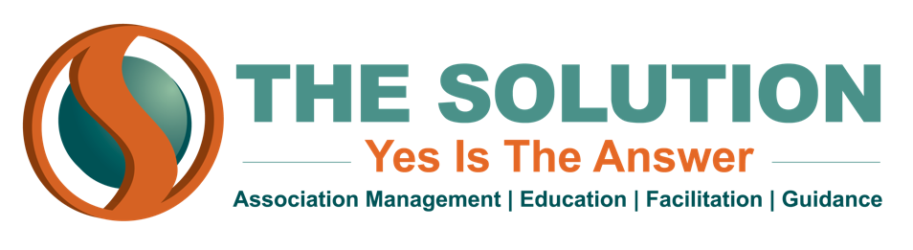

NETWORKING
Networking is the #1 career advancement strategy. It has a 75-80% success rate and a 90% success rate for executives.
Invisibility = dispensability: If people don’t know how you are doing or what you are doing, how will people know to keep you?

Brand Yourself
- How do you want people to perceive you?
- Who is your target audience? Who do you want to meet?
- Are you visible and consistent?
- What does your social media reputation look like?

Networking Tips
Be the host of the party: When you walk into a room full of people, it can be intimidating. If you change your mindset as you walk through that door to one that looks like this, it will help. In your mind, pretend you are the host of this party. It is not at all intimidating to answer your door and talk to someone that comes to your home, or your place of business. If you invited someone you know, and they arrive with someone you don’t know, it is not intimidating to say hello and introduce yourself. If you are an introvert, take a moment before you walk in that door, take a deep breath and think of it as your own party, at your own place of business, people you invited here, and introduce yourself. It works.
Be the self-appointed table captain: Many times we find ourselves sitting at a luncheon or dinner table with 9 other people, 8 of whom we may not know. Take a moment to introduce yourself around the table and get to know the others that are there.
Join a professional association: Getting involved in an organization is a great way to network. If you are in the association or chamber industry, join your local, state, national professional association and network with your peers. Get involved and serve on a committee, volunteer, serve on the Board of Directors.
Leverage your online connections: Build your LinkedIn network. Reach out and message people that you want to get to know. Reach out via message to meet, in person or a quick virtual chat.
Follow up with people you meet: When you meet someone at an event, and you have something in common with them, send them a short handwritten note following the event. If you don’t have their address, and can’t find it in a Google search, send them an email or a LinkedIn note. Thank that for the conversation and suggest connecting again. If you are not connected on LinkedIn with someone you met at an event, send them an invitation to connect, with a message about where you met and thank them for the conversation.
Ask open ended questions: The very best way to get someone talking is to say “Tell me about yourself.” Know the answer to that when they ask you to tell them about yourself.

