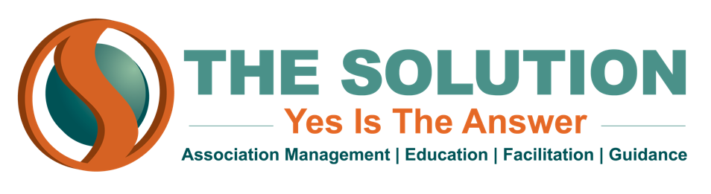

BRING BACK MOTIONS BEFORE THE ASSEMBLY
Purpose – This is to allow an organization to reopen a completed question during the same session or one that has temporarily disposed of.

Types of Bring Back Motions

Take from the Table
- Purpose – A motion that was laid on the table can be brought back before the organization with this motion.
- Requires a Second
- Is NOT Amendable
- Requires a Majority Vote
- Exampled use in a meeting – I move to take the motion from the table.

Rescind/Amend Something Previously Adopted
- Purpose – Used to cancel or change something already approved that has continuing force like a policy.
- Requires a Second
- Is Amendable
- Requires a 2/3 Vote
- Exampled use in a meeting – I move to amend the policy on the amount of annual donation we make to “X” charity.

Discharge a Committee
- Purpose – This is used to take a topic out of the hands of the committee and put it to the organization for full consideration.
- Requires a Second
- Is Amendable
- Requires a 2/3 Vote
- Exampled use in a meeting – I move that the finance committee be discharged from further consideration of the conference registration fees.

Reconsider
- Purpose – Allows the organization to bring back a motion that may have been made in haste, ill-advised, or erroneous action to be corrected.
  - The mover has to be one who voted for the motion’s final outcome. If the motions were approved, then the mover must have voted in favor of it. If the motion failed, then they had to vote against it.
- Requires a Second
- Is NOT Amendable
- Requires a Majority Vote
- Exampled use in a meeting – Based on recent financial reports of “X” charity, I move to reconsider the motion for donating to them. I originally voted on the side to approve this motion.

