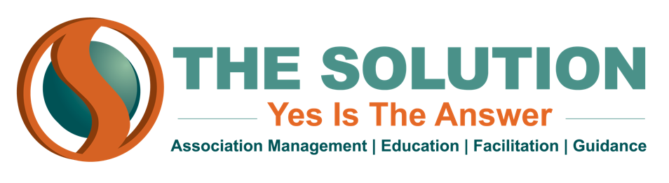

THE ROLE OF THE ASSOCIATION EXECUTIVE

One of the keys to being successful as an association/nonprofit/chamber executive director is understanding your role within the organization. But what is that role exactly? Where is the line drawn between the responsibilities of the board and the responsibilities of the executive? Many organizations struggle to execute policy effectively because they have not taken the time to clearly draw those lines, and even their own directors and staff aren’t clear on the scope of their role or authority.

Generally, it is the role of the Board to set the strategic plan, approve the budget, dictate policy and make big-picture decisions about the mission and future of the organization. The executive director, meanwhile, is primarily tasked with managing the day-to-day operation of the organization--coordinating events, collecting member dues, and overseeing social media and marketing efforts. Boards of Directors meet monthly, bi-monthly or quarterly, which means they are not always able to keep their finger on the pulse of the organization from day to day. Thus, it falls to the executive director to work in the organization, while the Board of Directors works on the organization.

However, this is not to suggest that there is no overlap in these two roles. In fact, the most effective associations are those where the executive director is a true partner of the board and works closely with them. The executive director needs to keep the board informed about the direction of the organization, the progress of its strategic plan, and the needs and morale of its membership. A good executive director should be an active contributor at every board meeting, providing insight on the workings of the organization and putting forth ideas for the board to consider. And when the Board makes decisions, it is important that the executive director fully understands what the board wants and why. Once the board has determined the what (the policy to be implemented or outcome to be achieved), it is up to the executive director to figure out the how (the steps needed to make that policy/outcome a reality).

Executive directors are often asked to wear many hats at once--organization figurehead, member liaison, board liaison, public relations director, administrator, data analyst, and more. A successful executive director must be able to juggle all those responsibilities without comprising the efficiency of the organization.

