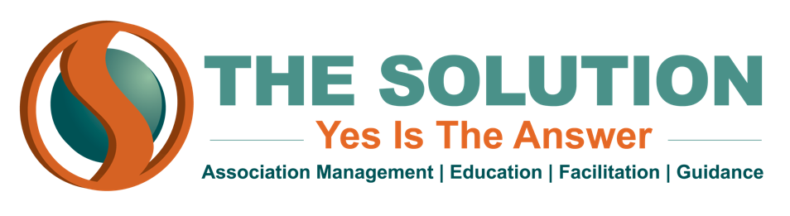

TOP 10 CONVERSATION STARTERS
Networking can be intimidating, especially for an introvert. Here are some of our favorite conversation starters.

- Start with a compliment
  - This venue is gorgeous. Have you been here before?
  - I love these little meatballs!
  - Great sweater!
- Tell me about yourself or So, what do you do?
- Ask what the other person does for a living and how long they have been in the profession
- How did you hear about this event or How do you know the host?
- Did you watch the game last night? (if you are sports fan)
- Are you originally from YOUR STATE? Where are you from?
- What brought you into the industry? (whatever line of work they do)
- What do you hope to get out of THE EVENT?
- Ask about something that is headlined in the news or a top sports story that you have read about.
- What do you enjoy doing outside of work?

