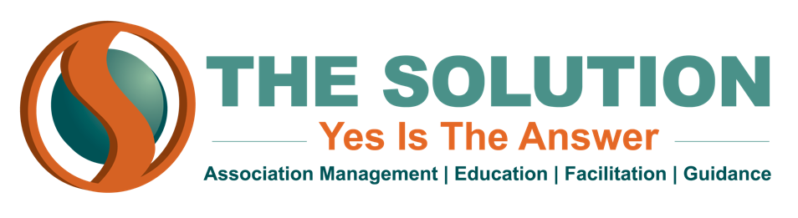

TYPES OF INSURANCE COVERAGE FOR NONPROFITS

ALL NONPROFITS NEED:
- General Liability Insurance
  - Many nonprofits list events individually on this policy
- Directors & Officers Insurance

YOU MAY ALSO NEED:
- Theft & Fraud Insurance
- Professional Liability Insurance
  - Sometimes called “Malpractice” or “Errors & Omissions” - protects against mismanagement
- Workers Compensation/Volunteer Accident Insurance
  - Provides coverage for injuries to employees/volunteers
- Property Insurance
  - If your association owns or rents a physical space
- Product Liability Insurance
  - If you sell products to the public
- Auto Insurance
  - If association staff use vehicles for association activities
- Employee Dishonesty Insurance
  - Helps mitigate losses due to employee fraud
- Umbrella Insurance
  - Greatly expands your coverage for a modest premium increase

Please talk to your insurance agent to understand the coverages your organization needs.

