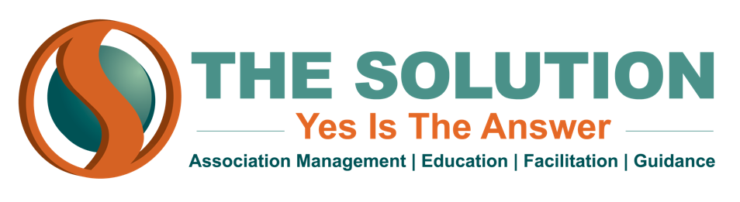

**UNRELATED BUSINESS INCOME TAX - EXAMPLES**

**ADVERTISING**

Nonprofits are allowed to receive tax-exempt donations from a sponsor in exchange for an “acknowledgement” of the sponsor’s generosity; however, if the nonprofit is advertising for the sponsor, then the income would be subject to UBIT. Examples of “advertising” a sponsor include:

* Endorsing the sponsor’s products or services
* Touting the quality or prices of a sponsor’s products or services, or indicating savings or value
* Displaying a phone number or website link from which products or services can be purchased (you can link to a sponsor’s homepage, but not a sales page)
* Accepting sponsor payments whose amount is contingent on exposure--level of event attendance, website hits, etc.

**SELLING PRODUCTS**

If a nonprofit decides to raise money for one of its programs by selling products (for example, magazines or memorabilia with the organization’s logo on it), that retail activity would likely be subject to UBIT. The exception would be if all the goods being sold were donated--such as a bake sale, or a silent auction of items donated by sponsors.

**PHYSICAL SPACE**

If your nonprofit owns a physical space, then income received through ownership of that space could be subject to UBIT. For example:

* Renting out part of the space to an unrelated organization
* Setting up a for-profit business within the space, like a food stand or coffee cart in the break area
* Charging people to park in the building parking lot