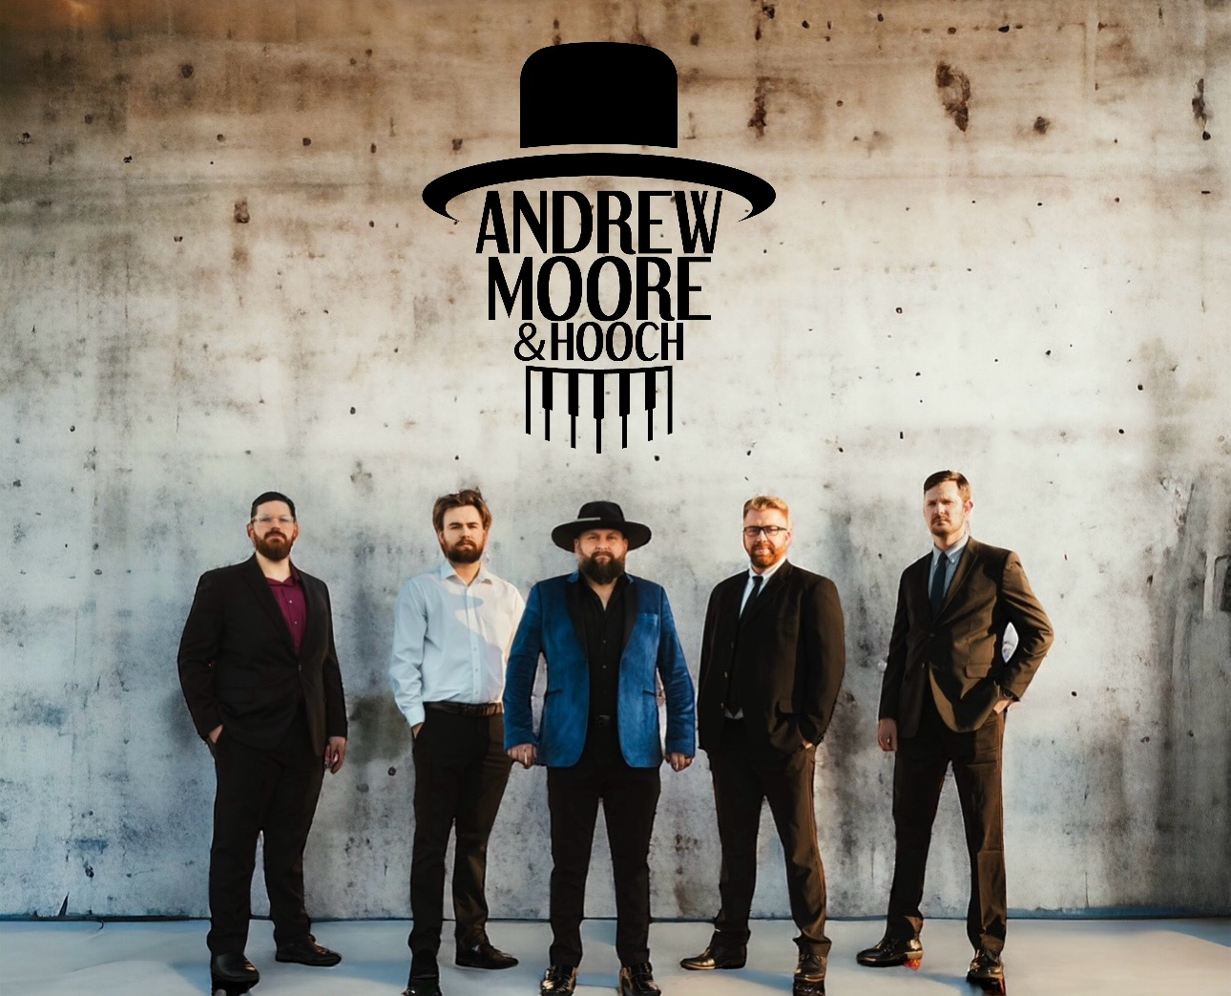**Andrew Moore and Hooch Electronic Press Kit**

Band Name: Andrew Moore and Hooch   
  
Genre: Blues/Americana/Country/Rock

Band Members: Andrew Moore: Lead Vocals, Piano - Jordan Robson: Saxophone – Gabe Crockett:   
Guitar – Logan Turner: Bass – Matthew Skaggs: Drums  
  
Biography: Formed in 2022, Andrew Moore and Hooch is a dynamic bluesy band with an americana kind of twist that has been captivating audiences with their high-energy performances and soulful, gritty sound. Led by singer and pianist Andrew Moore, the band has been making waves in the music scene with their infectious blend of blues, country, rock, soul and songwriting. Andrew Moore's heart felt lyrics, impassioned vocals and electrifying piano work, combined with the tight rhythms and soulful grooves laid down by the rest of the band, create a musical experience that is both powerful and deeply engaging. Their music draws from the rich tradition of writing their own music and lyrics in the style of country and blues while infusing it with a modern edge, resulting in a sound that is both timeless and contemporary.   
Andrew started singing and playing in 2015 to fill an entertainment void in a family run speakeasy in the Adirondack Mountains. It was there he initially formed the very first version of his band. He called it Hooch, as it fit the speakeasy vibe. When Andrew and his wife and 2 sons moved back home to Kentucky in 2019, Andrew struggled to find bandmates to reignite his passion of music and performing. Andrew found solo gigs all around the region and continued to play shows forming a relationship with Jeff Ruby’s Steakhouse after a successful audition. Eventually Andrew met Logan Turner (bass) at a jam session in Richmond Ky. Logan and Andrew continued to keep their eyes open, that is when Logan heard a young Gabe Crockett playing a guitar at a music store. Jordan Robson (sax) and Matthew Skaggs (drums) were discovered on Facebook by word of mouth recommendations. Currently, Andrew Moore and Hooch can be found weekly at Jeff Ruby’s Steakhouse 2-3 times per week in Lexington Ky and Cincinnati Oh.  
  
Discography: - “Hey Dad” – Single Release December 2023, “Train Wreck” – Single Release February 2024 “Tyrant” – Single Release April 2024, “Come Home” – Single Release May 2024, “Freedom” – Single Release July 2024, “First Love” – Single Release August 2024, “Artists of the Moon” – Debut Album Release October 5 2024, “Live Loud” – Single Release June 6 2025  
  
Noteworthy Moments: November 2022 Andrew Moore and Hooch were joined by Toby Keith on stage at Jeff Ruby’s Steakhouse in Lexington Ky. July 5 2024 Andrew Moore and Hooch opened for Drake White for the City of London Ky. In November Andrew Moore and Hooch hit song Tyrant, was #1 on 3 different FM radio networks. On August 5th 2025 Andrew Moore and Hooch recorded at the iconic Sound Stage Studio in Nashville TN with producer Nick Autry and co-producer John Daly.  
  
Recent Achievements:   
  
Andrew Moore and Hooch were nominated for 2 Hollywood Independent Music Awards 2024 for the category of Best Blues Song and are the winners!  
Winner of Best Blues Song 2024 – “Tyrant”  
Other nominated Best Blues Song – “Come Home”  
  
Andrew Moore and Hooch are nominated for a 2024 Josie Award 4 times! The Josie awards are considered the most prestigious of independent music artist awards today.  
Group of the Year – Multi Genre  
Group Entertainer of the Year   
Americana song of the year – “Train Wreck”

Americana/Folk Male Vocalist of the Year

Andrew Moore and Hooch were nominated in 6 different categories at the Lexi Music Awards 2024 in Lexington Ky!   
Andrew Moore nominated for best Keyboard Player  
Jordan Robson nominated for best Brass/Wind player  
Gabe Crockett nominated for guitar excellence award   
Andrew Moore and Hooch nominated for best Pop group   
Andrew Moore and Hooch nominated for best Variety/Cover group   
Andrew Moore and Hooch – Hey Dad nominated for Song of the Year   
  
Andrew Moore and Hooch started releasing original music in December of 2023 and on into 2024. They have 7 singles released thus far and a debut album consisting of 15 original songs. They are currently in production of recording their sophomore album of which one single is released thus far, titled “Live Loud.”

Our upcoming shows are listed on our website here: andrewmoorehooch.com along with live performance videos.

Contact Information: For booking and inquiries, please contact: Andrew Moore – 606-813-1883 – [drewskeys07@gmail.com](mailto:drewskeys07@gmail.com)  
  
Social Media Links: Website: andrewmoorehooch.com - Facebook: <https://www.facebook.com/people/Andrew-Moore-Hooch/100084194446628/?mibextid=2JQ9oc> – Instagram: <https://www.instagram.com/andrewmoorehooch/>   
YouTube: <https://www.youtube.com/@AndrewMooreandHooch>   
TikTok: https://www.tiktok.com/@andrewmooreandhooch  
  
Sample Music: Spotify - <https://open.spotify.com/track/7loxdou7jSCcLkzuxwrzEj?si=d84f1201662d4273>  
 Apple Music - <https://music.apple.com/us/artist/andrew-moore-and-hooch/1720627201>