PIP Tribunal Appeal for Jane Doe
*This is an EXAMPLE only. Tweak for your life*
Reference: ##
NI: ##
Date: ##
Please be aware that all evidence and points raised are based on Jane’s daily living at the time of her assessment on 19th August 2022 only. We have not included any changes since that.

Contents:
- Timeline PIP – Page 2
- Conditions – Page 2
- Conditions Impact to Daily Living – Page 3
- Medication- Page 4
- Appendices – Contents Page – Page 5
- Reasons for Appealing (ALL sections of PIP excluding: Reading & Making Budget Decisions) – Pages 6 to 14
- Appendices/Evidence - Pages 15 to 21

Timeline PIP:

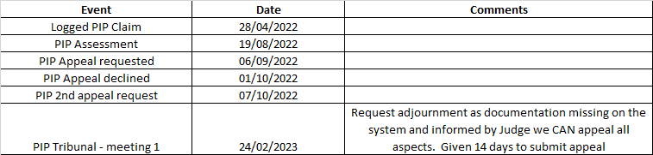

Conditions:

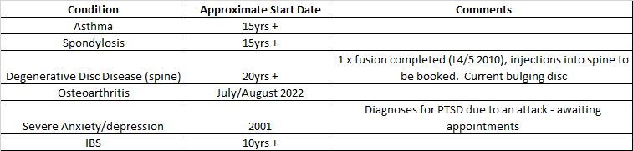

Conditions Impact to Daily Living:

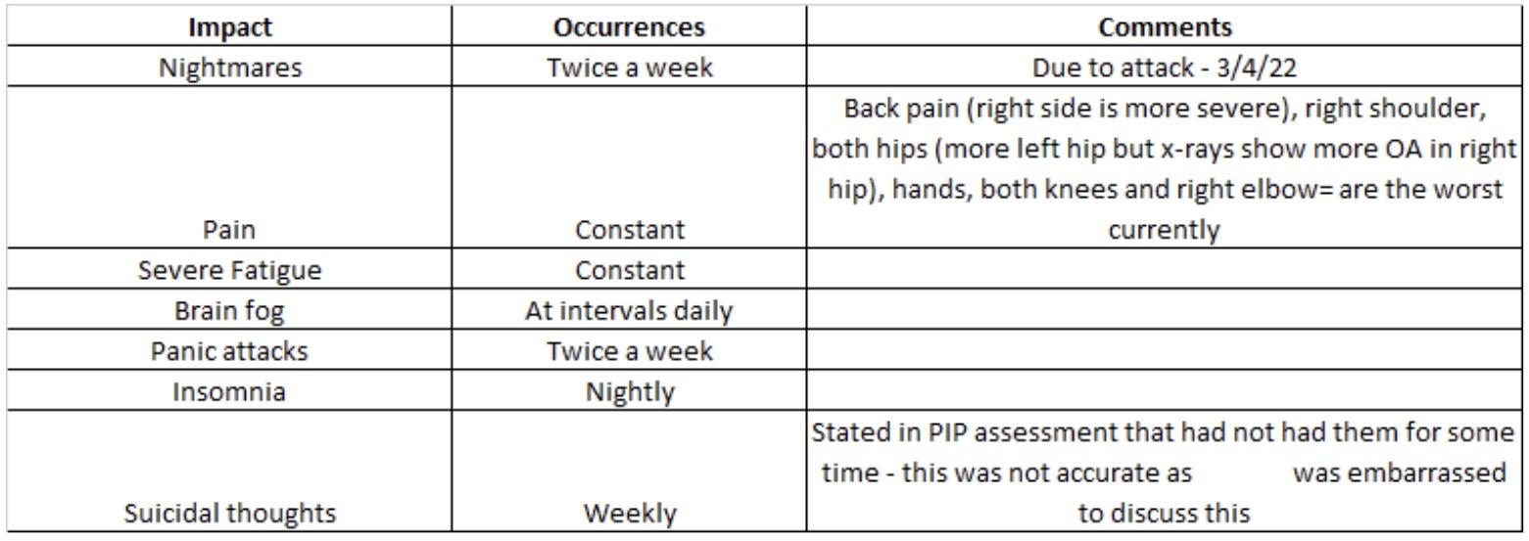

\

Medication:

Name of Medication | Dosage | How Often

Appendices – Overview:

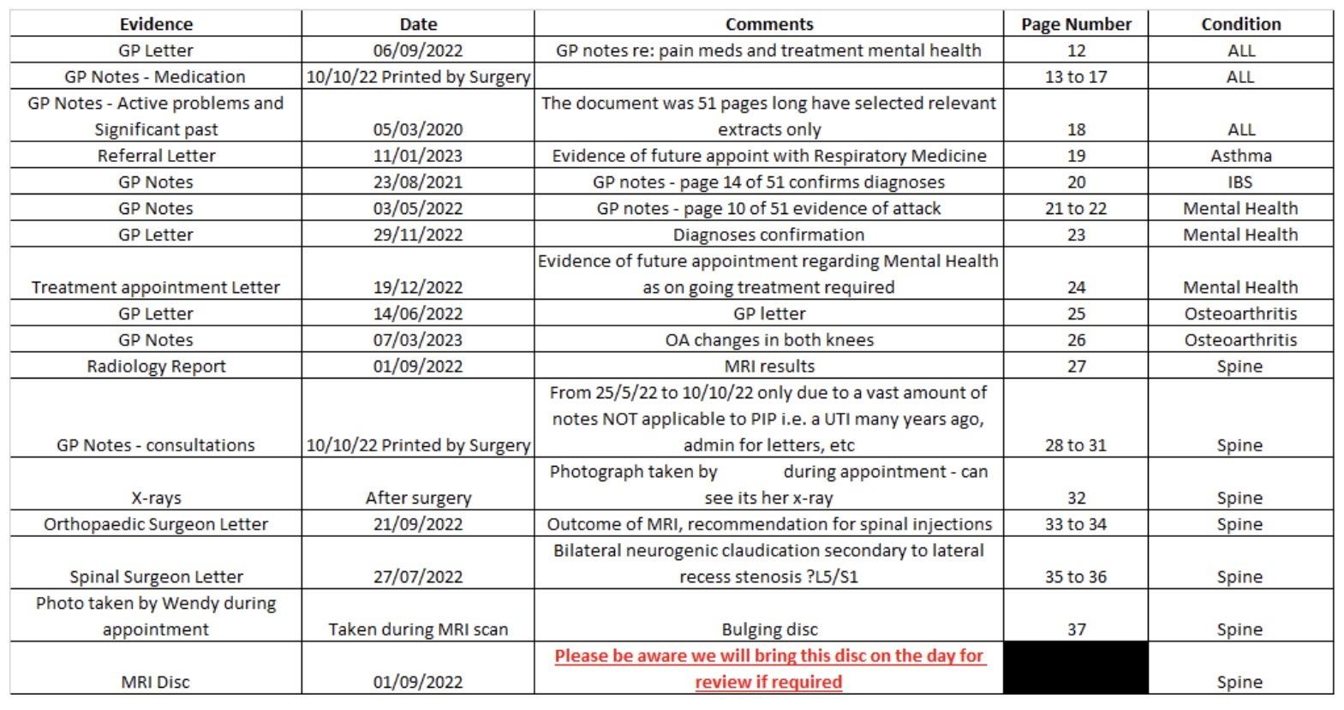

Charlie Note:
Now I have more experience, I know I put too much evidence in. I would say try to not have more than 40 pages. You do NOT need to keep including evidence of medication or every appointment. Do not get carried away.
Don’t forget, the most important thing is how you communicate the impact to your daily living and mobility in the Tribunal itself.
Charlie x

Reasons for Appealing

Ensure you use your own wording for your Tribunal. Do NOT copy this or it may go AGAINST you

Daily Living

What you disagree with:

Preparing food

Why you disagree with it:

I do NOT prepare meals; my mum cooks all meals. I am not safe to cook, I have burnt food and myself many times. I decline as the day goes on and by 13:00 daily I rarely move (expect to urinate). My brain fog also increases vastly as the day progresses.

I do not have the energy to prepare meals. If my mum did not cook, I would have to order a takeaway or buy pre-made sandwiches due to pain and severe fatigue. I cannot stand for much time and sitting is minimal as well. I am best when laid in bed on my left side as it results in a slight pain reduction.

I cannot chop food due to pain in my hands. I am NOT safe carrying/moving hot food.

What you disagree with:

Eating and drinking

Why you disagree with it:

I cannot chop food due to pain in my hands. I use ‘chunky’ cutlery to eat and my mum cuts up certain food types i.e. meat. My mum prompts me to eat, she will bring it to me in bed and wake me up to ensure I eat. If she did not do this, I would not eat as I do not have the motivation due to my depression and fatigue levels.

Also, to move causes me severe pain. It’s hard to move at all, but when my mum brings me food, I feel guilty if I do not eat it.

I mainly use a spoon when eating, sometimes a fork. No knives as my mum ensures the food is ‘fatigue friendly’ i.e. scoopable.

Charlie Note:
Now I have more experience I would insert photo’s here showing the equipment in my/your home

What you disagree with:

Managing your treatments

Why you disagree with it:

I cannot simply manage my treatments. I use a pill pot (dosette) for my medication
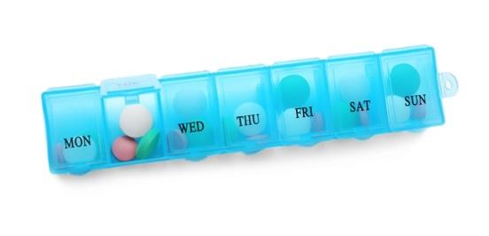
(Use your own photo)

and my mum checks every day that I have taken my meds as sometimes I forget. My mum also prompts me to take more pain medication if she sees I have declined.
The reason my mum has to help me so much is due to my depression, I struggle with motivation and it hurts to move. Also, my pain is severe so my brain fog is very unhelpful.
My mum checks on my meds in the am and pm, it does not take long to do about 5min each time as she will hand them to me and make sure I take them.

What you disagree with:

Washing and bathing

Why you disagree with it:

I use a handle to get in the shower and I sit on a chair as I cannot stand for long enough to complete the shower mainly, due to back pain. My mum washes my hair as my right shoulder is too painful to raise up high enough to do this. I am unable to wash my back and below my knees so my mum does this due to my mental health, pain and fatigue levels. And, I am so embarrassed that my 80-year-old mother has to help me, I only shower once or twice a week (if that).

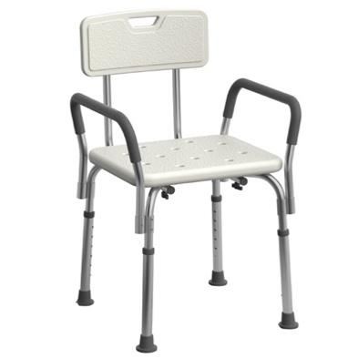
Use your own photo)

What you disagree with:

Managing your toilet needs

Why you disagree with it:

I have to use a sink as a ‘handle’ to lift myself off the toilet (add in your own photo). I am incontinent at intervals due to my IBS, I get severe diarrhoea. This happens at least 2-3 times per week (this has improved it used to be much more often).

Within this 2-3 times a week, each occasion can result in severe diarrhoea that on average means I have to use the toilet approx. 10 times. This results in very sore anus due to cleaning and extreme fatigue.

Having to go to the toilet so many times is exhausting. I avoid leaving the house if it is bad or if I think it may get bad.

I struggle to clean myself due to fatigue and being able to reach my arms around my body, twisting results in pain increase. There are times this is not possible, so my mum helps me. I do NOT want her to clean me, so, when possible, I will get in the shower and shower off the worse. Or I will have to rest when not fully clean and then go back and try again (if my mum is out).

When out I will wear a pad to minimise the risk, I always know where the toilets are. As I do not often go out any more, this has been less of an issue.

What you disagree with:

Dressing and undressing

Why you disagree with it:

I avoid wearing clothes with buttons or zips due to the pain in my hands (I have not had a diagnosis on this yet). If I do wear them, my mum assists or I have an aid I can hook on the zip to pull them up

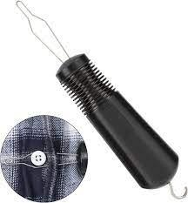
(Use your own photo)

I prefer to not use this as it is still fiddly so I avoid clothing with any zips or buttons. I also wear oversized clothing so it’s easy to go on. My mum puts my socks on as I cannot access my feet. She would have to help me with shoes but I have them that I can slip on. I would not be able to wear lace up shoes without my mum’s assistance.

Due to the pain in my right shoulder, my mum assists me daily with putting my top on. However, due to fatigue I will have at least 3-4 days in the week where I do not get dressed. I will wear comfortable clothes i.e. jogging bottoms and baggy top. I will then sleep in these clothes and they look like day wear as well. I also do this as it eases the pressure on my mum as she already does so much for me and with my depression it is hard to motivate myself, especially as it’s a pain increase when I move.

What you disagree with:

Mixing with other people

Why you disagree with it:

I do NOT want to mix with other people. I have suffered with depression and anxiety for decades but since the attack it's much worse. I get very angry and stressed, I already get panic attacks approximately twice a week. And this is when I rarely leave the home and if I do it is with people, I am very comfortable with.

My IBS, pain and fatigue levels also impact my decisions about mixing with other people.
I have been involved in an incident where I felt I was so uncomfortable I lost my temper and I threw an item at an individual. I am not proud of this; I know I cannot handle mixing.

I lose sleep (which I barely get anyway due to pain) if I have to go somewhere i.e. hospital. The PIP process has been horrendous, if I was not at rock bottom financially and physically, I would have abandoned this process when I received the 44-page document. I would not be here without my friend and I know my life is impacted by my illnesses, I believe I should receive PIP. I cannot give up and I have to ease the pressure on my mother.

I am able to drive at times. If I got with my mum to a known location (local shop, GP) I am ok. But only, if my IBS, fatigue levels and pain permits it. I go out 1-2 times a week with my mum on short journeys. This varies due to panic attacks/conditions.

Mobility

What you disagree with:

Planning and following a journey

Why you disagree with it:

I will NOT plan or go on unfamiliar journeys. Even if I had someone with me. It’s too stressful. I struggle to get out to the local shop. This is not an option for me at this time due to pain, IBS, fatigue and severe anxiety.

What you disagree with:

Moving Around (Please do not ask me in meters, use the bus example as I got confused in the assessment – my fault not the DWP individual)

Why you disagree with it:

I can slowly walk 5 bus lengths; it makes me puffed due to asthma and it increases my pain severely. I then need to take a rest. For stairs I crawl up them, sit and take rest breaks.
The time it takes varies depending on the time of day. In the evening I would NOT be able to walk 5 bus lengths. I struggle to get from my bed to the bathroom.

To give you an example, you do not have on site disabled parking. So, we used the carpark nearby. It was too far. Then in our first Tribunal meeting we were on the first floor; I was exhausted when I got to the waiting room. By the time we went in we had been waiting approx. 25mins. The rest break was brilliant so I was able to focus more and recover my breathing. The fire doors are also very challenging to open, we had assistance or my shoulder pain would have increased.

After I sat/stood up (when required) during the Tribunal I was then able to walk back to the car. But I then had to rest as it was too far, before being able to drive home.

After I walk, I then ‘crash’ I have to sleep. This sleep can last on average from 4 to 5 hours. I have to sleep part way through the day, every day as my fatigue is too much. I tend to go back to bed at 13:00.

Appendices

Charlie Note:
I have cut all of the evidence to remove her personal details) this was a letter from the GP, it was not worth how much it cost to be honest)

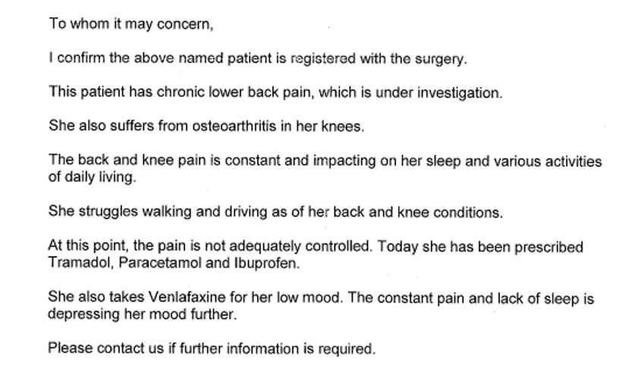

Charlie Note:
This is a copy of her GP notes – BRILLIANT evidence for the Tribunal

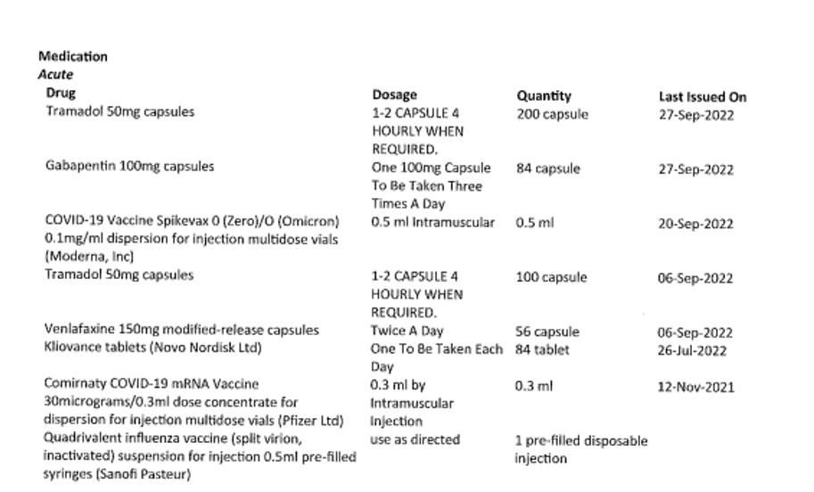

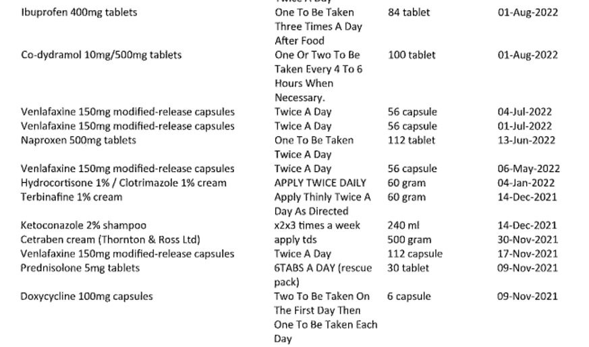

Charlie Note:
Make sure you ALWAYS include your name etc. on the evidence. Photograph the WHOLE thing so there is no risk they think it is someone else’s details. I have cut all of these to give to you, when we submitted every single piece of evidence had Jane’s details on it.

Charlie Note:
THIS evidence was STUNNING and VERY important. GP’s always have this summary on the system. When she gave this to me it was 52 pages long. I took the important bits. So, do NOT bother paying for a letter from your GP. Just ask for a copy of your notes. Then you can photograph your meds and active problems:

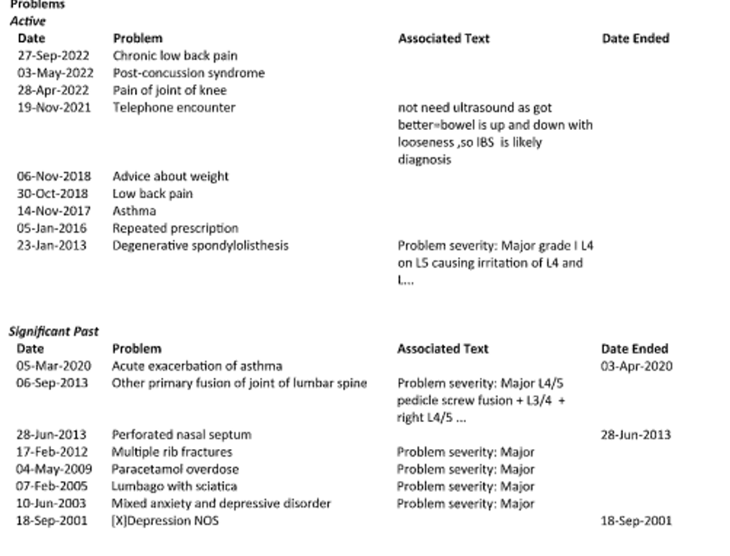

Charlie Note:
Any letters with outcomes proving conditions like this are BRILLIANT:

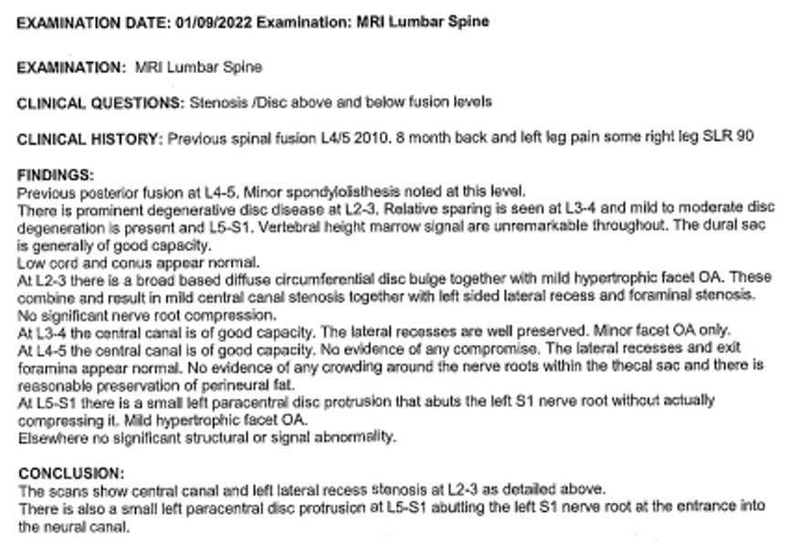

Charlie Note:
This really helped in the Tribunal

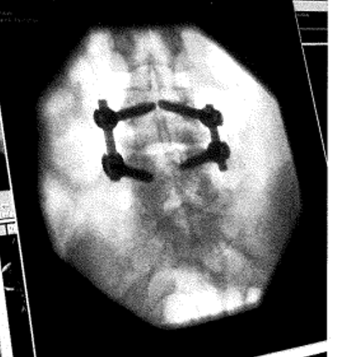

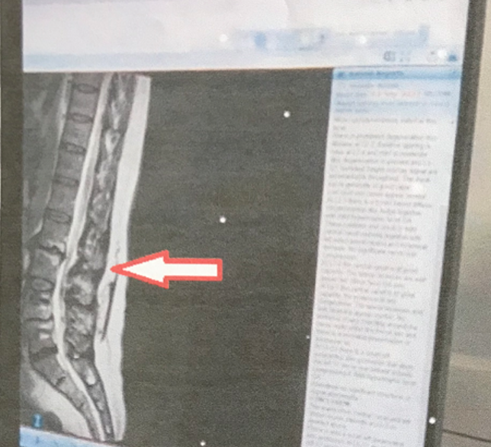

Charlie Note:
Good luck! You can do this! Remember you are NOT alone!

