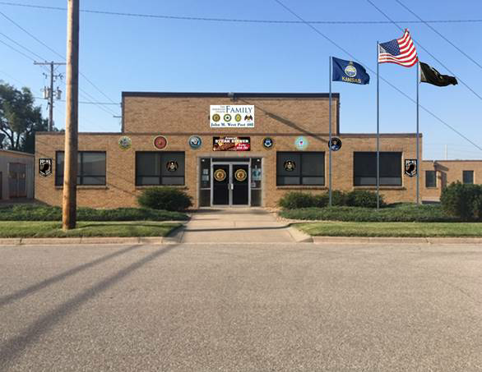
American Legion Post 408 Business Meeting 3 November 2022
At 7:00pm on 3 Nov, 2022, a quorum was present of 15 Legion Members and 6 guests were present. The meeting opened with a prayer offered by Chaplain John McCullough and a moment of silence for the POW/MIA. The Pledge of Allegiance was led by the 1st Vice Commander. The American Legion Preamble was led by the Commander. Commander Tackett declared the John M. West, Derby-Haysville Post 408, Department of Kansas business session convened.

- Roll call:
1st. Vice, Terry Gowen-excused
2nd Vice, Hugh Clare-present.
Adjutant, John McCullough-present.
Finance Officer, Joe Dinino-present.
Service Officer, John McCullough-present.
Sgt. of Arms: Jim Eliason-present.
Chaplain, Monta Plank-absent
Historian, Open.
Executive Committee, Morris Short present, Joe Williams absent, Dickie Helzer present.

- The minutes of our last meeting will be read. Motion to forgo the reading of the minutes as amended and published via email by Steve Tackett, 2nd by John McCullough. Motion passed.

- Introduction of guest and prospective members as read by Commander Tackett. Attached.

- Finance report as read by Joe Dinino. Motion to accept the October Finance Report by Steve Hinds, 2nd by Gary Chaput. Motion passed.

- Committee Reports :
Boys State: No report.
Cadet law: No report.
Children And Youth: No report.
Oratorical: No report.
Golf: No report.
Parade: Christmas Parade will be on Saturday, 3 December at 6pm.

SAL: Membership is at 35 renewed, 1 new for a total of 36 . Goal of 67 for 52.24%.
Kids Christmas party 3 December Post 408 from 1pm to 3pm. Shop for kids gifts
November 30, 7pm at the Derby Walmart. Raffle for Am-15 Rifle on going. Hope to draw for the rifle on Veterans Day. Next SAL Meeting is 13 November, 1pm. Everyone is welcome to attend. ALR Ride report read by Brian Simpson.

POW/MIA: Read by Hugh Clare. Attached.

Chaplain: Patricia Peterson will have an operation on 14 November. Everyone please keep her in your prayers.
Auxiliary : Next meeting: 14 November 7pm. 100 stainless steel cups to be sold at $25.00 each. Leslie said they are at 60% to pay for registration.
BOG: Finance report read by Mike Saindon. Motion to accept by Steve Hinds, 2nd by Pete Peterson.
Fundraising. Read by Rhonda Hundley. Attached.
Public Relations: Mike Saindon. Joe Williams of Mad Rock will have a fundraiser. Everyone please try to participate as 15% of sales will come back to the post. Possible New Year's eve party, members only and all entities???? Possible super Bowl party??? There will be a flag folding practice at the post on Wednesday, 7pm in preparation for Veterans day activities..
- 1st. Vice Commander reports on Legion membership. Read by the Adjutant.

- Adjutant report: American Legion membership is at 169 renewed for 66.53%. Membership cards for 2023 were made available for those needing to pay dues.

- Service Officer Report: The Dole VA is giving flu shots to retirees, dependants, active duty for everyone 6 months or older. Times are 0730-1215 and 1330-1615. Call: 316-759-5054 for an appointment.

9. No members were reported sick and in distress and in need of our assistance.

10. Old Business: Joe received a renewal notice for the Informer that will cost $66.12 for one year. Pat Kitterman said she would cover the fee for the one year subscription to the Informer. Thank you Pat. Joe said we received a $200.00 donation for kids Christmas. We now have $800.00. Joe Dinino made a motion to help families in need as requested by Leslie Eliason, 2nd by Frosty. John McCullough will check with Kathy at St. Mary's to see if any families are in need. Mike Saindon made a motion to purchase wreaths for $300.00, 2nd by Dan Mckelvy.

11. New Business: Commander Tackett informed the membership of the change to our bylaws that will be voted on During the December 1st Legion meeting. The change to be voted on has been provided to all members for review via email. Please be available to vote. ALR donated $450.00 for wreaths across America. Hope to have ramp railings installed sometime next week. The post "wish list" that was sent to all members for donations of many items needed for our post to get open has been a great success. Donations and items purchased by members have exceeded $5,000.00. Thanks to all who have donated. Our ceiling tiles for the post are not in the greatest condition and needed lots of work. Our 2nd Vice Commander, Hugh Clare, said he would purchase all new ceiling tiles for the post. Thank you Hugh. You're donation is greatly appreciated.

13. No items were brought up for the good of Post 408.

14. No other business items were brought before the membership.

14. Until we meet again, let us remember that our obligation to our Country can only be fulfilled
by our faithful performance and our duties as Citizens. Our next regularly scheduled meeting
will be held Thursday, December 1st, 2022, 7pm.

15. Nomination by all to close the business session. 2nd by all.

16. Commander Tackett declared the business Session closed.

