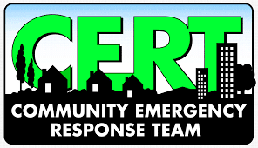
APPLICATION FOR ENROLLMENT
SAN BERNARDINO COUNTY FIRE DEPARTMENT
MORONGO BASIN CERT TRAINING ACADEMY

Name:
Address:
City, State:
Zip Code:
Telephone:
Email Address:
How did you hear about the program?

If second student?
Name:
If address different
Full Address:
City, State, Zip:
Phone:
Email:

office Submit completed application to:
Instructor: Carl Angdahl
crangdahl@earthlink.net / (562.822.4928)
www.morongobasincert.org
office use only
Period of student enrollment: | Circle one: Spring or Fall
Year of student enrollment:

