Single Entry- Recording time for Billing and Payroll.
Ensure your name is in the top left hand corner.
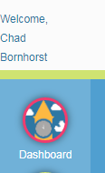
Select the Roster icon
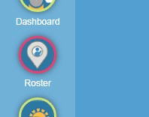
Select the Location you are at. 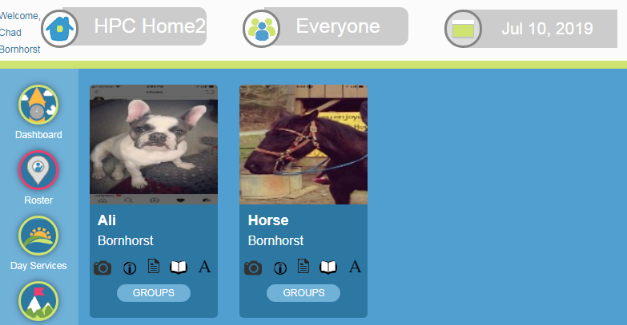

Choose the individuals you’re going to work with and move to the right. You can do this by clicking on their picture or using the arrows on the right to move everyone shown
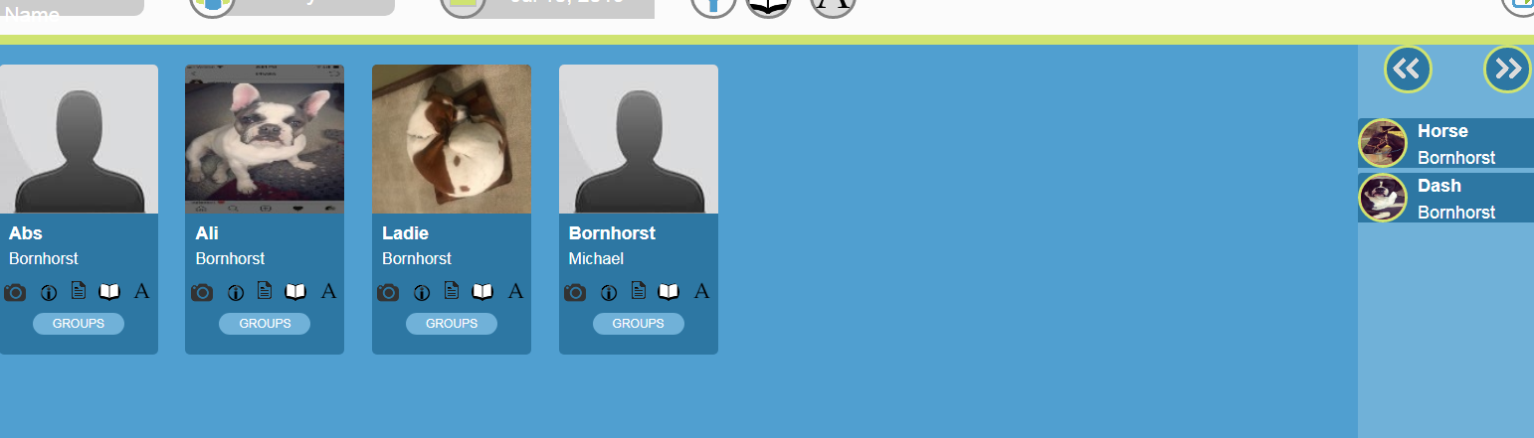
Next click on the Single Entry icon on the left side of the screen.
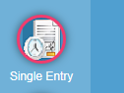

The default Pay Period will populate based on today’s date.
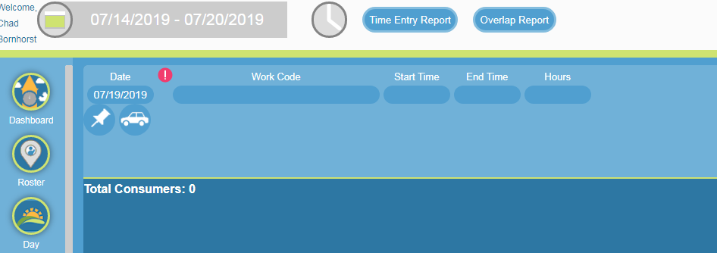

Select a Work Code for the type of service you are providing.

If the work code select requires consumers for billing purposes, ie. Awake HPC, the user must choose consumers from the right to move to the card by using the arrows to move everyone at once or by clicking on their pictures

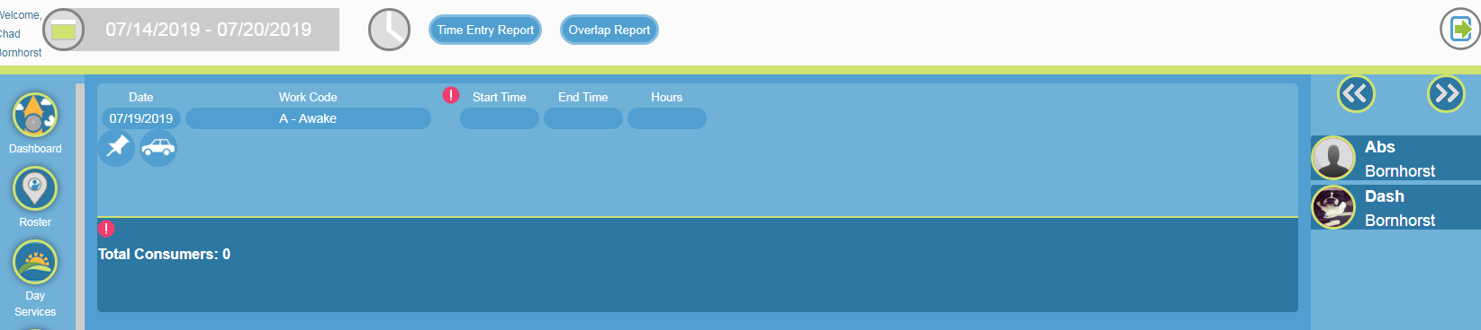

Users may enter Notes on the card if applicable by selecting the Note icon. After a note is entered the icon will appear in the color Green.

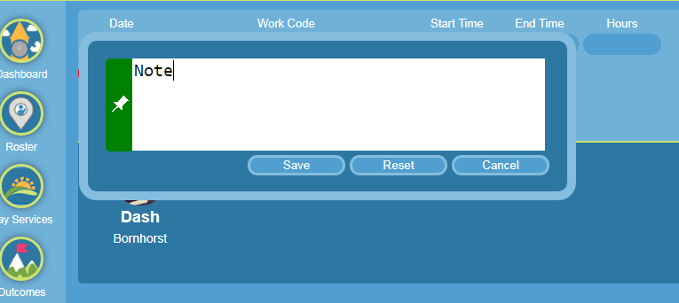

Enter your Start Time and then select SAVE.
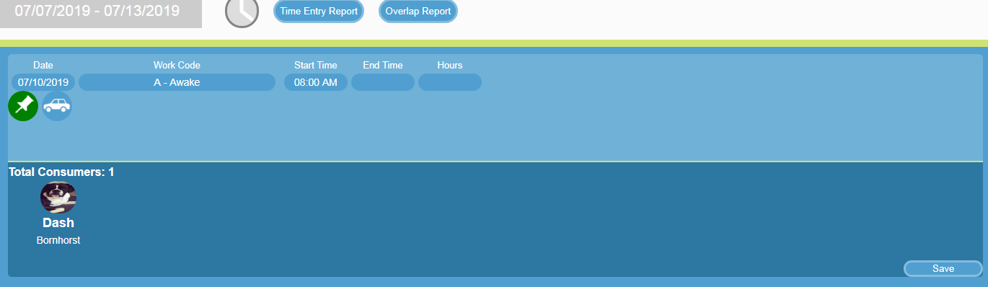

Now you are clocked in and can begin services.

At the end of a shift or a change in work code.
Go back into the Single Entry module on the left hand side.

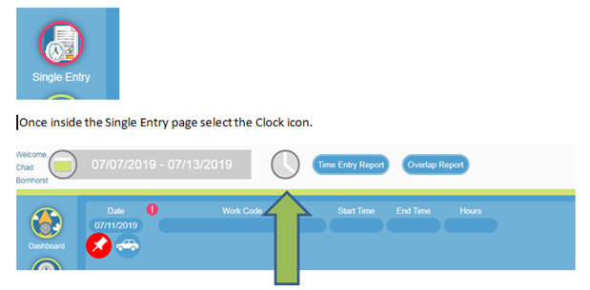
You will then see the Time Entry you entered to Start you shift. Select the Location to go into the Entry for edits or to End your shift.

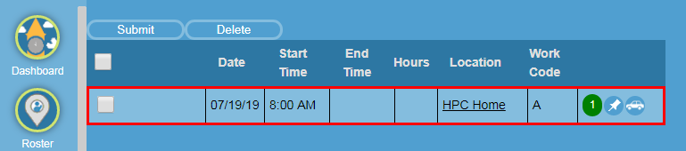

You will be brought back to the Time Entry where you can provide an End Time, Notes and/or Mileage.
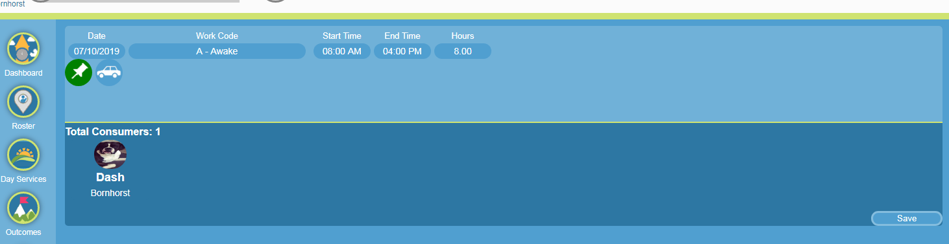

Click on the Car icon to log mileage. Select the correct Transportation Type, Company or Personal vehicle. Then fill fields that are required and Save. Once Saved the car icon will turn green.
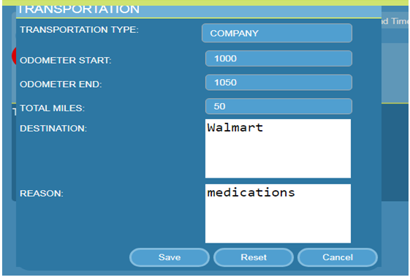

After you have entered your End time and information (if necessary) hit the SAVE button.
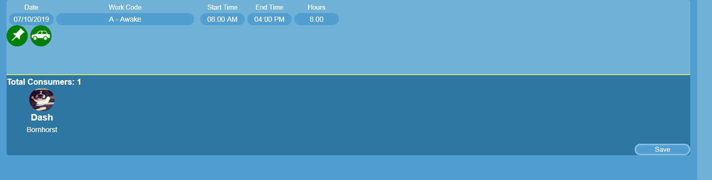

Once you have Saved a Record Saved will appear letting you know your entry is saved. 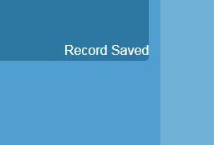

To Submit that time record. Click on the Clock in Single Entry
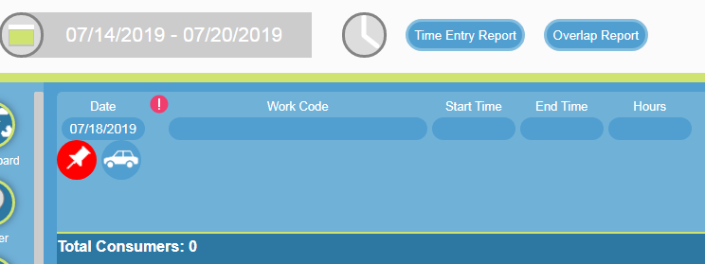

You will be brought to a page where you can Submit your Time Entry. If everything is correct, click inside the Gray box and then select Submit. That record will be sent to your supervisor for Approval.

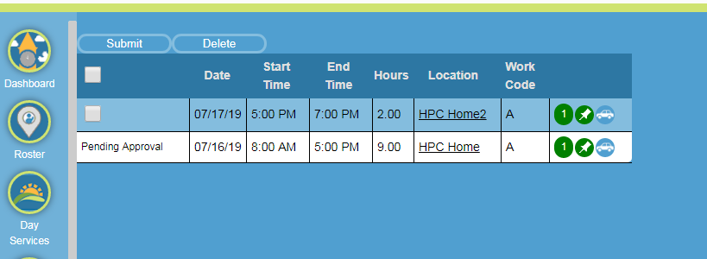

You will see that Time Entry in you My Unapproved Time Entry widget under “Needs Approval”. Once approved that time entry will disappear.

