DISHES AND THEIR ALLERGEN CONTENT
(Note – Please state the name of the cereal(s) containing gluten** in that column AND/OR the name of the nut(s)* in that column)
DISHES | 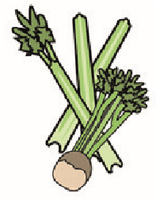 |  | 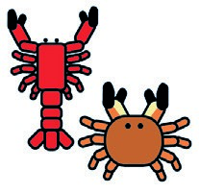 |  |  |  |  |  | 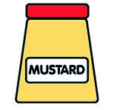 |  |  | 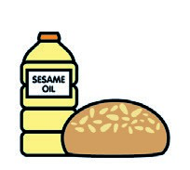 |  | 
 | Celery | Cereals containing gluten** | Crustaceans | Eggs | Fish | Lupin | Milk | Molluscs | Mustard | Nuts* | Peanuts | Sesame seeds | Soya | Sulphur dioxide
Chicken Curry |  |  |  |  |  |  |  |  |  |  |  |  | ✓ | ✓
Jerk Chicken |  |  |  |  |  |  |  |  |  |  |  |  | ✓ | ✓
Fried Chicken |  |  |  |  |  |  |  |  |  |  |  |  | ✓ | ✓
Curry Goat |  |  |  |  |  |  |  |  |  |  |  |  | ✓ | ✓
Fried Fish |  |  |  |  | ✓ |  |  |  |  |  |  |  | ✓
Akee and Saltfish |  |  |  |  | ✓ |  |  |  |  |  |  |  | ✓
Chick Pea Curry |  | ✓
Oxtail |  | ✓ |  |  |  |  |  |  |  |  |  |  | ✓ | ✓
Mac and Cheese |  | ✓ |  | ✓ |  |  | ✓
Rich and Peas |  | ✓
White Rice |  | ✓
Sweet potato Fries |  | ✓ |  |  |  |  |  |  |  |  |  |  | ✓
Jerk Fries |  | ✓ |  |  |  |  |  |  |  |  |  |  | ✓
Festival |  | ✓ |  |  |  |  |  |  |  |  |  |  | ✓
Fried Dumplings |  | ✓ |  |  |  |  |  |  |  |  |  |  | ✓
Roast Yam |  | ✓
Stir Fry Mixed Veg | ✓
Green Salad | ✓
Review date: 26/01/2022 Reviewed by Zaggas Good Food

