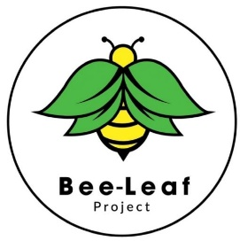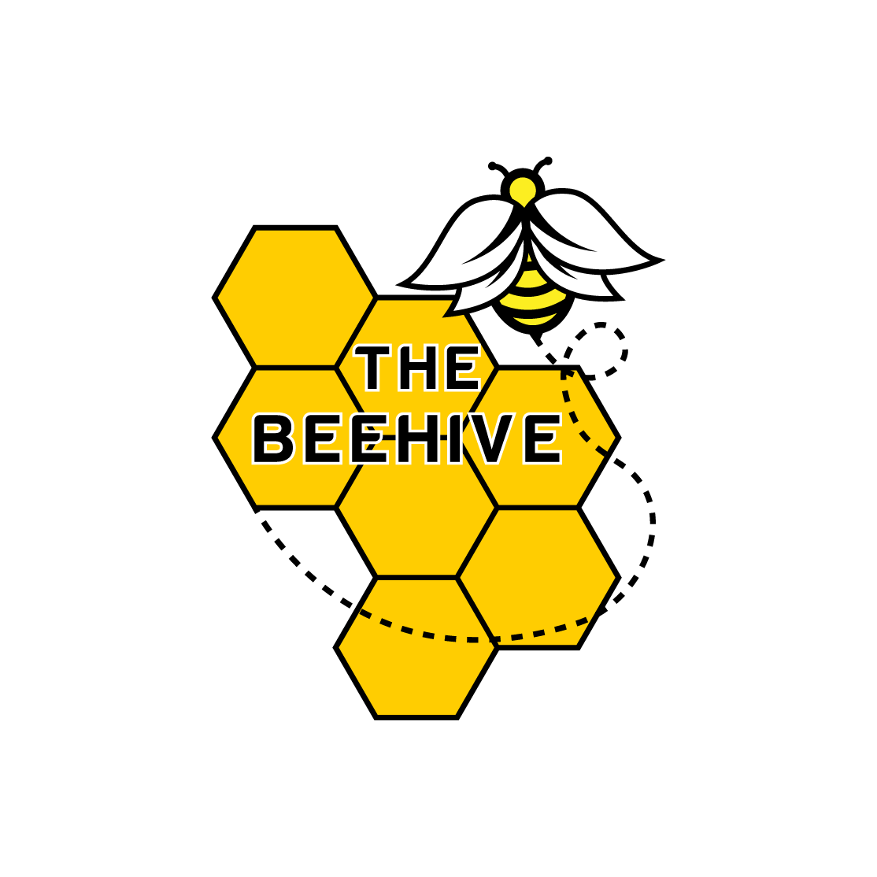

Student Code of Conduct

At Bee-Leaf Project we want to help all students achieve their very best. To do this, students must also commit to their education and try hard when they are at their sessions.

We expect all students to follow the below;

* Always work to the best of your ability
* Be polite and respectful to other students, staff, the public, buildings and possessions
* Attend your sessions regularly and on time. Talk to us about anything that is stopping you from coming to your sessions
* Do not bully other people. Be polite, kind and use kind words
* Be invested in your own education and future
* Try new things!

Date reviewed – 15.01.25