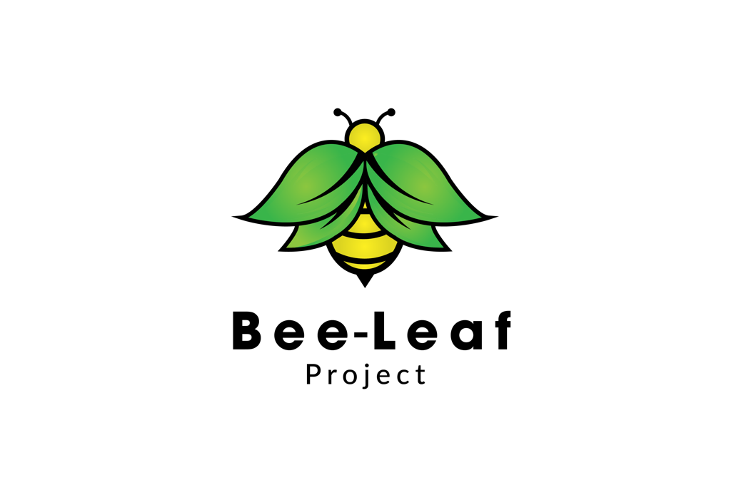

**Complaints and Grievance Policy**

**Policy**

The Bee-Leaf Project Ltd recognises that all mentors have the right to raise grievances about any matter related to their work (this could be in relation to another mentor, any other staff, or the manner in which they are being treated by the Bee-Leaf Project Ltd. In addition, any other person is entitled to make a complaint about the organisation.

It is hoped that most issues can be resolved through regular communications, such as support and supervision sessions for mentors. However, where this is not possible, this complaints and grievance procedure is in place to ensure that all difficulties, issues or problems are dealt with in a prompt and fair manner.

**Procedure**

1. If a mentor, young person, parent or member of the public has a complaint against a member of staff, or the organisation in general they should first discuss this with the Bee-Leaf Project Managing Director. A note of the meeting and any action agreed should be written, signed by all parties, kept in a secure place and a copy given to the complainant.
2. If the Managing Director is the person whom the complaint is against then the matter should be referred to East Sussex LADO.
3. If the matter is not resolved at this initial meeting the complaint should be made in writing. It will be dealt with within fourteen days and treated in a confidential manner.
4. If the grievance or complaint remains unresolved the complainant has the right to request that the issue is referred to a mutually agreed Third Party.