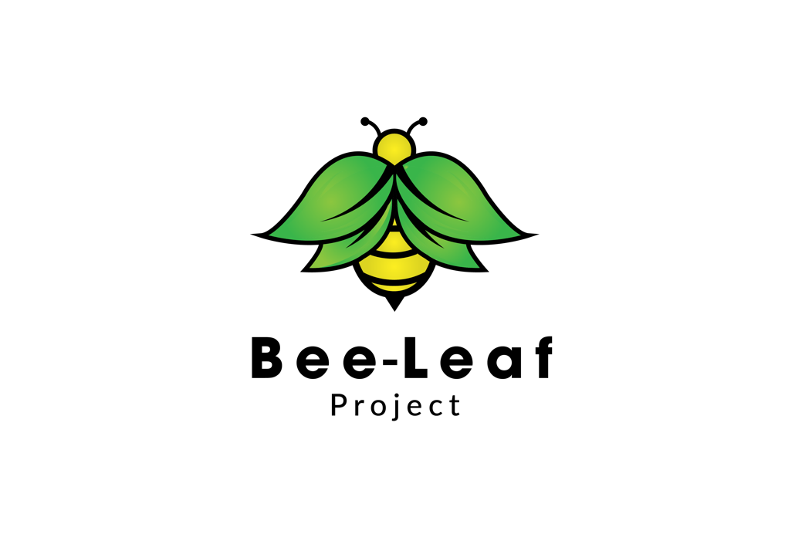

**Privacy Policy**

Welcome to the Bee-Leaf Project’s privacy policy.

The Bee-Leaf Project is operated by Bee-Leaf Project Ltd and is managed by the managing director (Taner Fikret) of the Bee-Leaf Project.

Bee-Leaf Project respects your privacy and is committed to protecting your personal data. This privacy policy will inform you as to how we look after your personal data when you visit our website (regardless of where you visit it from) and tell you about your privacy rights and how the law protects you.

**Important information and who we are**

**Purpose of this privacy policy**

This privacy policy aims to give you information on how Bee-Leaf Project collects and processes your personal data through your use of this website, including any data you may provide through this website when you sign up to the Bee-Leaf Project.

It is important that you read this privacy policy together with any other privacy policy or fair processing policy we may provide on specific occasions when we are collecting or processing personal data about you so that you are fully aware of how and why we are using your data. This privacy policy supplements the other notices and is not intended to override them.

**Controller**

Bee-Leaf Project Ltd is the controller and responsible for your personal data.

We have appointed a suitable person who is responsible for overseeing questions in relation to this privacy policy. If you have any questions about this privacy policy, including any requests to exercise your legal rights, please contact Bee-Leaf Project using the details set out below.

**Contact details**

Our details are:

Bee-Leaf Project Ltd

Taner Fikret

Managing Director & Data Protection Officer

Email address: tan@bee-leafproject.co.uk

You have the right to make a complaint at any time to the Information Commissioner’s Office (ICO), the UK supervisory authority for data protection issues (www.ico.org.uk). We would, however, appreciate the chance to deal with your concerns before you approach the ICO so please contact us in the first instance.

**Changes to the privacy policy and your duty to inform us of changes**

This version was last updated on 29/06/2020.

It is important that the personal data we hold about you is accurate and current. Please keep us informed if your personal data changes during your relationship with us.

**Third-party links**

This website may include links to third-party websites, plug-ins and applications. Clicking on those links or enabling those connections may allow third parties to collect or share data about you. We do not control these third-party websites and are not responsible for their privacy statements. When you leave our website, we encourage you to read the privacy policy of every website you visit.

**The data we collect about you**

Personal data, or personal information, means any information about an individual from which that person can be identified. It does not include data where the identity has been removed (anonymous data).

We may collect, use, store and transfer different kinds of personal data about you which we have grouped together as follows:

**Identity Data** includes first name, maiden name, last name, username or similar identifier, marital status, title, date of birth and gender.

**Contact Data** includes home address, work address, email address and telephone numbers.

**Technical Data** includes internet protocol (IP) address, your login data, browser type and version, time zone setting and location, browser plug-in types and versions, operating system and platform and other technology on the devices you use to access this website.

**Profile Data** includes your username and password, your interests, work history, your CV, information about your mentoring reasons and preferences, feedback and survey responses.

**Usage Data** includes information about how you use our website, the Bee-Leaf Project, and Bee-Leaf Project’s products and services.

**Marketing and Communications Data** includes your preferences in receiving marketing from Bee-Leaf Project and your communication preferences.

We also collect, use and share Aggregated Data such as statistical or demographic data for any purpose. Aggregated Data may be derived from your personal data but is not considered personal data in law as this data does not directly or indirectly reveal your identity. For example, we may aggregate your Usage Data to calculate the percentage of users accessing a specific website feature. However, if we combine or connect Aggregated Data with your personal data so that it can directly or indirectly identify you, we treat the combined data as personal data which will be used in accordance with this privacy policy.

**Special Categories of Personal Data**

We do collect certain Special Categories of Personal Data about you in relation to your race or ethnicity. We also collect information about any criminal convictions and offences, which although is not a part of the Special Categories of Personal Data under GDPR, it is treated similarly.

Bee-Leaf Project uses this data to:

* Carry out much-needed evaluation and monitoring about mentoring and the impact of mentoring.
* Share the data with Partner organisations who use the data to provide the mentoring connections with young people as part of our services. The data relating to criminal convictions and offences assists these organisations to make decisions with due regards given to safeguarding young people in their care.
* You have control of this data, which is part of your profile. You are given the option not to provide this information at the time you complete your profile and are free to change it at any time.

The Article 9 (of GDPR) conditions under which this is categorised under state:

(a) the data subject has given explicit consent to the processing of those personal data for one or more specified purposes, except where Union or Member State law provide that the prohibition referred to in paragraph 1 may not be lifted by the data subject; and

(j) processing is necessary for archiving purposes in the public interest, scientific or historical research purposes or statistical purposes in accordance with Article 89(1) based on Union or Member State law which shall be proportionate to the aim pursued, respect the essence of the right to data protection and provide for suitable and specific measures to safeguard the fundamental rights and the interests of the data subject.

If you fail to provide personal data

Where we need to collect personal data by law, or under the terms of a contract we have with you and you fail to provide that data when requested, we may not be able to perform the contract we have or are trying to enter into with you (for example, to provide you with goods or services). In this case, we may have to cancel a product or service you have with us but we will notify you if this is the case at the time.

**How is your personal data collected?**

We use different methods to collect data from and about you including through:

**Direct interactions.**

You may give us your Identity, Contact and Profile Data by filling in forms or by corresponding with us by post, phone, email or otherwise.

This includes personal data you provide when you:

* create an account on our website;
* subscribe to our service;
* request marketing to be sent to you; or
* give us some feedback.

**Automated technologies or interactions.**

As you interact with our website, we may automatically collect Technical Data about your equipment, browsing actions and patterns. We collect this personal data by using cookies, server logs and other similar technologies.

**Third parties or publicly available sources**.

We may receive personal data about you from various third parties as set out below:

* Technical Data from the analytics providers such as Google based outside the EU;
* Identity and Contact Data from third parties with whom we partner for the purposes of providing Bee-Leaf Project services.

**How we use your personal data**

We will only use your personal data when the law allows us to. Most commonly, we will use your personal data in the following circumstances:

* Where we need to perform the contract we are about to enter into or have entered into with you.
* Where it is necessary for our legitimate interests (or those of a third party) and your interests and fundamental rights do not override those interests.
* Where we need to comply with a legal or regulatory obligation.

See the Glossary below to find out more about the types of lawful basis that we will rely on to process your personal data.

Generally, we do not rely on consent as a legal basis for processing your personal data other than in relation to sending third party direct marketing communications to you via email or text message. You have the right to withdraw consent to marketing at any time by contacting us.

**Purposes for which we will use your personal data**

We have set out below, in a table format, a description of all the ways we plan to use your personal data, and which of the legal bases we rely on to do so. We have also identified what our legitimate interests are where appropriate.

Note that we may process your personal data for more than one lawful ground depending on the specific purpose for which we are using your data. Please contact us if you need details about the specific legal ground we are relying on to process your personal data where more than one ground has been set out in the table below.

|  |  |  |
| --- | --- | --- |
| **Purpose/Activity** | **Type of data** | **Lawful basis for processing including basis of legitimate interest** |
| To register you as a new user on the Bee-Leaf Project | (a) Identity  (b) Contact | Performance of a contract with you |
| To manage our relationship with you which will include:  (a) Notifying you about changes to our terms or privacy policy  (b) Asking you for feedback or to take a survey | (a) Identity  (b) Contact  (c) Profile  (d) Marketing and Communications | (a) Performance of a contract with you  (b) Necessary to comply with a legal obligation  (c) Necessary for our legitimate interests (to keep our records updated and to study how Bee-Leaf Project users use our products and services) |
| To enable you to complete a survey | (a) Identity  (b) Contact  (c) Profile  (d) Usage  (e) Marketing and Communications | (a) Performance of a contract with you  (b) Necessary for our legitimate interests (to study how Bee-Leaf Project users use our products and services, to develop them and grow our organisation) |
| To administer and protect our organisation, this website, and the Bee-Leaf Project (including troubleshooting, data analysis, testing, system maintenance, support, reporting and hosting of data) | (a) Identity  (b) Contact  (c) Technical | (a) Necessary for our legitimate interests (for running our organisation, provision of administration and IT services, network security, to prevent fraud and in the context of a organisations reorganisation or group restructuring exercise)  (b) Necessary to comply with a legal obligation |
| To deliver relevant website and Bee-Leaf Project content to you and measure or understand the effectiveness of the communication we serve to you | (a) Identity  (b) Contact  (c) Profile  (d) Usage  (e) Marketing and Communications  (f) Technical | Necessary for our legitimate interests (to study how users use our products and services, to develop them, to grow our organisation and to inform our marketing strategy) |
| To use data analytics to improve our website, the Bee-Leaf Project Platform, our products and services, marketing, customer relationships and experiences | (a) Technical  (b) Usage | Necessary for our legitimate interests (to define types of customers for our products and services, to keep our website updated and relevant, to develop our organisation and to inform our marketing strategy) |
| To make suggestions and recommendations to you about Bee-Leaf Project products or services that may be of interest to you | (a) Identity  (b) Contact  (c) Technical  (d) Usage  (e) Profile | Necessary for our legitimate interests (to develop our products and services, and grow our organisation) |

**Marketing**

We strive to provide you with choices regarding certain personal data uses, particularly around marketing and advertising. We have established the following personal data control mechanisms:

**Marketing offers from us**

We may use your Identity, Contact, Technical, Usage and Profile Data to form a view on what we think you may want or need, or what may be of interest to you. This is how we decide which of Bee-Leaf Project’s products, services and offers may be relevant for you (we call this marketing).

You will receive marketing communications from us if you have requested information from us or signed up to Bee-Leaf Project’s services and, in each case, you have not opted out of receiving that marketing.

**Third-party marketing**

Bee-Leaf Project does not share your data with any third parties for marketing purposes.

**Opting out**

You can ask us to stop sending you marketing messages at any time by contacting us at any time.

Where you opt out of receiving these marketing messages, this will not apply to personal data provided to us as a result of using the Bee-Leaf Project Platform.

**Cookies**

You can set your browser to refuse all or some browser cookies, or to alert you when websites set or access cookies. If you disable or refuse cookies, please note that some parts of this website may become inaccessible or not function properly. For more information about the cookies we use, please see our policy on cookies.

**Change of purpose**

We will only use your personal data for the purposes for which we collected it, unless we reasonably consider that we need to use it for another reason and that reason is compatible with the original purpose. If you wish to get an explanation as to how the processing for the new purpose is compatible with the original purpose, please contact us.

If we need to use your personal data for an unrelated purpose, we will notify you and we will explain the legal basis which allows us to do so.

Please note that we may process your personal data without your knowledge or consent, in compliance with the above rules, where this is required or permitted by law.

**Disclosures of your personal data**

We may have to share your personal data with the parties set out below for the purposes set out in the table in paragraph 4 above.

**External Third Parties as set out in the Glossary below.**

Third parties to whom we may choose to sell, transfer, or merge parts of our organisation or our assets. Alternatively, we may seek to acquire other organisations or merge with them. If a change happens to our organisation, then the new owners may use your personal data in the same way as set out in this privacy policy.

We require all third parties to respect the security of your personal data and to treat it in accordance with the law. We do not allow our third-party service providers to use your personal data for their own purposes and only permit them to process your personal data for specified purposes and in accordance with our instructions.

**International transfers**

We do not transfer your personal data outside the European Economic Area (EEA).

**Data security**

We have put in place appropriate security measures to prevent your personal data from being accidentally lost, used or accessed in an unauthorised way, altered or disclosed. In addition, we limit access to your personal data to those employees, agents, contractors and other third parties who have a organisational need to know. They will only process your personal data on our instructions and they are subject to a duty of confidentiality.

We have put in place procedures to deal with any suspected personal data breach and will notify you and any applicable regulator of a breach where we are legally required to do so.

**Data retention**

**How long will you use my personal data for?**

We will only retain your personal data for as long as necessary to fulfil the purposes we collected it for, including for the purposes of satisfying any legal, accounting, or reporting requirements.

To determine the appropriate retention period for personal data, we consider the amount, nature, and sensitivity of the personal data, the potential risk of harm from unauthorised use or disclosure of your personal data, the purposes for which we process your personal data and whether we can achieve those purposes through other means, and the applicable legal requirements.

Details of retention periods for different aspects of your personal data are available in our retention policy which you can request from us by contacting us.

**Your legal rights**

Under certain circumstances, you have rights under data protection laws in relation to your personal data. Please see the Glossary (paragraph 10) for more about each of these rights:

* Request access to your personal data.
* Request correction of your personal data.
* Request erasure of your personal data.
* Object to processing of your personal data.
* Request restriction of processing your personal data.
* Request transfer of your personal data.
* Right to withdraw consent.

If you wish to exercise any of the rights set out above, please contact us.

**What we may need from you**

We may need to request specific information from you to help us confirm your identity and ensure your right to access your personal data (or to exercise any of your other rights). This is a security measure to ensure that personal data is not disclosed to any person who has no right to receive it. We may also contact you to ask you for further information in relation to your request to speed up our response.

**Time limit to respond**

We try to respond to all legitimate requests as soon as possible, usually within one month of the request. Occasionally it may take us longer than a month if your request is particularly complex or you have made a number of requests. In this case, we will notify you and keep you updated.

**Glossary**

**LAWFUL BASIS**

Legitimate Interest means the interest of our organisations in conducting and managing our organisations to enable us to give you the best service/product and the best and most secure experience. We make sure we consider and balance any potential impact on you (both positive and negative) and your rights before we process your personal data for our legitimate interests. We do not use your personal data for activities where our interests are overridden by the impact on you (unless we have your consent or are otherwise required or permitted to by law). You can obtain further information about how we assess our legitimate interests against any potential impact on you in respect of specific activities by contacting us

Performance of Contract means processing your data where it is necessary for the performance of a contract to which you are a party or to take steps at your request before entering into such a contract.

Comply with a legal or regulatory obligation means processing your personal data where it is necessary for compliance with a legal or regulatory obligation that we are subject to.

**THIRD PARTIES**

**External Third Parties**

Service providers acting as processors based in the United Kingdom, who provide IT and system administration services.

Professional advisers acting as processors or joint controllers including lawyers, auditors and insurers based in the United Kingdom who provide consultancy, legal, insurance and accounting services.

Partner organisations acting as processors or joint controllers including schools, colleges, youth organisations and universities, who provide the mentoring connections with young people as part of our services.

**YOUR LEGAL RIGHTS**

You have the right to:

Request access to your personal data (commonly known as a “data subject access request”). This enables you to receive a copy of the personal data we hold about you and to check that we are lawfully processing it.

Request correction of the personal data that we hold about you. This enables you to have any incomplete or inaccurate data we hold about you corrected, though we may need to verify the accuracy of the new data you provide to us.

Request erasure of your personal data. This enables you to ask us to delete or remove personal data where there is no good reason for us continuing to process it. You also have the right to ask us to delete or remove your personal data where you have successfully exercised your right to object to processing (see below), where we may have processed your information unlawfully or where we are required to erase your personal data to comply with local law. Note, however, that we may not always be able to comply with your request of erasure for specific legal reasons which will be notified to you, if applicable, at the time of your request.

Object to processing of your personal data where we are relying on a legitimate interest (or those of a third party) and there is something about your particular situation which makes you want to object to processing on this ground as you feel it impacts on your fundamental rights and freedoms. You also have the right to object where we are processing your personal data for direct marketing purposes. In some cases, we may demonstrate that we have compelling legitimate grounds to process your information which override your rights and freedoms.

Request restriction of processing of your personal data. This enables you to ask us to suspend the processing of your personal data in the following scenarios:

(a) if you want us to establish the data’s accuracy;

(b) where our use of the data is unlawful but you do not want us to erase it;

(c) where you need us to hold the data even if we no longer require it as you need it to establish, exercise or defend legal claims; or

(d) you have objected to our use of your data but we need to verify whether we have overriding legitimate grounds to use it.

Request the transfer of your personal data to you or to a third party. We will provide to you, or a third party you have chosen, your personal data in a structured, commonly used, machine-readable format. Note that this right only applies to automated information which you initially provided consent for us to use or where we used the information to perform a contract with you.

Withdraw consent at any time where we are relying on consent to process your personal data. However, this will not affect the lawfulness of any processing carried out before you withdraw your consent. If you withdraw your consent, we may not be able to provide certain products or services to you. We will advise you if this is the case at the time you withdraw your consent.