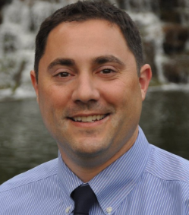

Dr. Jonathan Vlahos is a native of Dayton, Ohio with a Bachelor’s Degree from Wright State University in 2001 and Doctorate in Dental Medicine degree from the University of Louisville School of Dentistry in 2007. He was commissioned as a Lieutenant and fleet Dental officer with the U.S. Navy Dental Corp. in Okinawa, Japan. He completed a General Practice Residency in San Diego, California, and Endodontic Residency with Master’s Degree from the University of Louisville School of Dentistry in 2013. He is a member of the American Dental Association and the American Association of Endodontics. He maintains a part-time teaching commitment at the University of Louisville School of Dentistry. His non-professional interests include cooking, carpentry and landscaping.



Dr. Lisa Foster is a Mississippi native and former Registered Nurse. She received her Bachelor’s Degree from the University of Southern Mississippi in 1994 and worked for seven years in medical/surgical and critical care settings. A desire for greater autonomy and academic challenge led Dr. Foster to the University of Louisville where she completed her Doctorate in Dental Medicine degree in 2005, followed by a General Practice Residency in 2006. Following a 12-year career as a General Dentist, she returned to the University of Louisville School of Dentistry to complete an Endodontic Residency with Master’s Degree. She is a member of the American Dental Association and the American Association of Endodontists. Dr. Foster is married with three young sons.


East End Endodontics
Dr. Jonathan Vlahos
Dr. Lisa Foster

Professional Towers, Suite 524A 4010 Dupont Circle
Louisville, Kentucky 40207

Telephone: (502) 897-2040
Facsimile: (502) 897-2432
eee@eastendendo.com

What is an Endodontist?
Endodontists are highly skilled specialists limited to practice of the diagnosis and treatment of root canals or endodontic treatment and all corresponding procedures.
We have an additional two to three years of advanced training beyond dental school, as well as use the most advanced technology to assist you in saving your natural dentition.

Why have I been referred to an endodontic specialist?
Your dentist has most likely referred you to us because of a problem with the pulp tissue inside your tooth. The complexity and difficulty of the case requires extra knowledge and special instruments that endodontists have.

How long with the treatment take?
Normally, treatment can be accomplished in one visit of 1-1.5 hours. However, more difficult cases may require you to return to our office more than once in order to assure for the best possible outcome.

Before your visit:
- Please know the name & dosage of your medications
- Inform us if you have a prosthetic heart valve, joint, or other need for pre-medication
- We welcome any special needs or concerns you wish to communicate.

What will happen during the treatment?
After collecting some information about your overall health, the dentist will anesthetize or “numb” the problem tooth to eliminate any discomfort. Decayed or damaged tooth structure will be removed, and the root canal system of the tooth will be slightly enlarged with delicate instruments and disinfected with antiseptic medicine. Then the empty root canals will be filled with a pliable rubber-based material and sealed with a special type of cement. A temporary filling will be placed into your tooth and you will return to your regular dentist to have a final restoration placed. This restoration can be a simple filling, or a core build up and crown. Your general dentist will help you correctly pick the right restoration.

Where can I get more information about your practice?

You can check out our web page at
Eastendendodontics.com
Or
Our facebook page
East End Endodontics

Directions

From 264 (Watterson)
Take exit 18 B (Breckinridge North). At the first main intersection, turn right onto Dutchman’s Lane. Once on Dutchman’s Lane, turn right at the third stoplight onto Dupont Circle (Stock Yards Bank and Korrect Optical are on the right corner, Norton Women’s Children’s Hospital is on the left). As the road starts to curve to the right, our building is on the left of Dupont Circle. It is called the Professional Towers, and it is a seven-story red brick building.

Quick Map
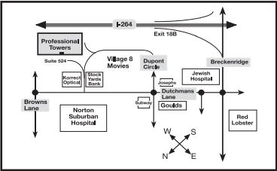

East End Endodontics
Dr. Jonathan Vlahos
Dr. Lisa Foster
Phone # 502-897-2040
Dentist’s Referral Information

Patient Name: ________________________________
Referred by Dr.: _______________________________
Date: ___/___/____ Time: ________ AM / PM

Accompanying X-ray? Yes No

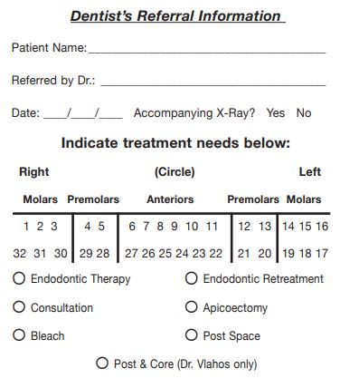

Special remarks:
________________________________________________________________________________________________________________________________________________________________________________________________

