

**Wonderful World Preschool**

**Parent Handbook**

20 Green Grove Drive, St. Albert, AB T8N5H6

[wonderfulworldpreschool@outlook.com](mailto:wonderfulworldpreschool@outlook.com) (email)

wonderfulworldpreschool.ca (website)

825-963-8599

Welcome to **Wonderful World Preschool**. We are committed to providing an all inclusive, supportive and intentional learning environment for all of the children in our care. Wonderful World Preschool is a play-based program focusing on early literacy and math foundations. We will facilitate support in all aspects of growth and development while guiding and nurturing the children spiritually, intellectually, physically, socially and emotionally. We believe all children are capable of reaching their full potential given the opportunity.

We are a privately owned/operated, non-denominational licensed preschool operating in the beautiful City of St. Albert.

The following handbook contains basic policies and procedures and is subject to change. Should you have any questions concerning any of the policies/procedures listed, please do not hesitate to ask.

We are looking forward to getting to know our valued families. Thank you for choosing us on this amazing journey.

**Our Programs**

What is Play? “Play can be defined as a means by which children develop their physical, intellectual, emotional, social and moral capacities.”

~ Dr. Peter Gray~

All of our programs are designed with intention. We use structured, guided, free, intellectual and physical types of play. We change centres frequently offering continual growth opportunities. Our smaller class sizes allow us to offer large and small group activities as well as some one-on-one time.

We offer a safe, secure environment that promotes total development of each child (spiritual, intellectual, physical, social and emotional) through cognitive and hands-on activities.

We will support social and emotional learning by embracing and nurturing the five core skills that are widely recognized. (Self-awareness, self-management, social awareness, relationships, responsible decision making)

Our programs are designed to emphasize love and acceptance for each child as unique individuals. Diversity is respected and valued in our preschool. We are focused on encouraging positive self image. We welcome students of any culture, race, nationality, ethnic origin, religion, economic status.

We will support and promote enthusiastic, competent and trustworthy staff. Our staff members are committed to being good role models and here to help nurture a life-long love of learning.

We will provide a supportive and inviting atmosphere for parents to feel welcome. We believe communication (on both ends) is imperative. Supports for parents will always be available.

**Child Guidance and Discipline Policy**

Effective discipline helps children gain self-control and aids in developing a positive self image. We hope to encourage children to be self-directed, exhibit self-control and become problem solvers. We will practice the use of positive techniques of guidance, including: redirection, anticipation of and elimination of potential problems, positive reinforcement, appropriate alternatives, encouragement and praise.

**Child Abuse**

Child abuse, as defined by the *Child, Youth and Family Enhancement Act* and where child intervention services may become involved, is any act of maltreatment of a child by a parent or guardian that result in injury or harm. Child abuse by someone other than a parent or guardian must be reported by law to the police.

We are bound *by Alberta’s Child, Youth and Family Enhancement Act and Canada’s Criminal Code*, which tell us what behaviours and conditions might be so harmful to children that it is necessary to stop them.

If you suspect a child is being abused, neglected or exposed to family violence, you are required by law to report your suspicions immediately. Call 911, your local Child and Family Services Authority or the 24-hour **Child Abuse Hotline at 1-800-387-KIDS (5437)**

**Potty Training and Toileting**

Your child does not need to be potty trained in order to begin school. Our teachers will work with families to assist with this process. Please provide and extra change of clothes, wipes and additional pull ups.

**Transportation**

There is no transportation available. Parents are responsible for drop off and pick up on scheduled school days and all scheduled fieldtrips.

**Arrival and Departure**

Arrival and departure are busy times during a school day. Please insure you are cautious when entering and leaving the parking lot.

Parents are expected to walk their child to the classroom and sign them in.

Approximately 20 minutes after class start time the entrance access door will be locked and then unlocked again approximately 20 minutes before class ends. This will help to ensure there aren’t any unknown guests/strangers entering our building. If you are going to be late for either drop off or pick up, please contact the staff so we can help accommodate you.

Children will not be allowed to leave school with anyone except parents/guardians and/or persons designated to pick up the child. Anyone picking up your child will need to show photo identification.

**\*NOTE\*** This form can be found on the website, please fill out and submit it with your registration forms.

All children have difficulty separating from parents, occasionally. New children usually have an adjustment period during which separation is difficult. We encourage you to view with as normal and typical behavior for a young child and not to be unduly upset over it. It is easier if you separate quickly and matter-of-factly when arriving with your child. The staff is trained to help your child in his/her/their transition to the school and we will be responsive to each child’s needs.

**Late Pick-Ups**

While we understand that ‘life happens’, late pick-ups often make for an anxious and/or upset child. Not to mention, this is disruptive/inconvenient/disrespectful to staff members. If you are going to be delayed in picking up your child, please notify the staff as soon as possible. There will be a late fee ($40) applied to your monthly invoice if this occurs.

**Attendance**

**Please notify the preschool if your child is unable to attend**. This can be done via phone call/message, email or text message

**Fieldtrips**

We will do our best to plan/facilitate fieldtrips but they are **not** guaranteed. If we are able to schedule a fieldtrip, parents will be given notice well in advance. Fees may be applicable. Parents are required to sign a consent form in order for their child to be included on the fieldtrip. The parents are responsible for dropping off and picking up their child at the designated fieldtrip location. On occasion, there may be an opportunity for siblings to be included. This would require parental supervision. Staff will let you know if siblings are allowed.

**School Cancelation Policy**

Should there be days of extreme weather or hazardous conditions that would require us to close the school, the decision would be made by 7:00am that morning. Tuition will not be refunded and there will be no classes in lieu for such a cancellation. Staff will contact parents to make sure they are advised of the situation.

**Change of Address/Phone/Personal Information**

Please inform the staff if any important information has changed or needs to be revised. We would also appreciate you letting us know of any significant changes in living arrangements or other circumstances in your home. Our knowing will allow us to better assist your child in dealing with these changes.

**Classroom Newsletters/Calendar**

A yearly school calendar is provided at the beginning of the school year in print (extra copies are available) but is available on our website and is posted on our communication board outside the classroom. Monthly newsletters will be placed in your child’s backpack. The monthly newsletter will also be posted on the communication board outside the classroom.

**Snacks**

Parents are responsible for sending in snacks and a water bottle for their child. All snacks must be **NUT FREE**. Please take special precautions when preparing snacks before sending them to school. (We have children/staff in our preschool that have lethal allergies to peanuts/nut products. We are trying to be proactive to eliminate any unwanted emergencies. Thank you for your understanding.)

**Clothing**

Please dress your child comfortably. Please make sure your child has a pair of **non slip/non marking indoor shoes**. Every child needs to have a complete change of clothing including underwear and socks. (Pull ups if necessary) Please put these in a zip lock bag and label them-as we store these in the bathroom for easy access. Please make sure that your child has appropriate footwear, jacket, mittens etc., and are dressed for the weather. We like to explore around our facility and often picnic outside. When we have great weather, we like to take advantage of it!

**Birthdays**

We LOVE parties! Birthdays are welcome to be celebrated! If you choose to send in a special treat to share with the class, please be mindful of our peanut/nut free policy. Store bought, peanut free treats only please! Please note that this is not expected.

**Cultural Celebrations**

Celebrations of any culture are welcome!! Holiday celebrations/traditions are a wonderful opportunity for our students to learn about the beliefs, traditions and values that are important around the world. If your family would like to celebrate a tradition or holiday celebrated in your home, please make sure to speak with a staff member so we can help co-ordinate a respectful/mindful/age-appropriate learning experience for the class.

**Toys From Home**

We ask that our preschoolers **DO NOT** bring toys from home into the classroom. While we understand that your children are often excited to bring in special toys from home, we do not want their precious treasures to be misplaced or accidentally broken.

**Refunds/Payments**

**Payments** are due on the 1st of each month. A late fee of $50 will be applied unless there have been alternative arrangements made. If payment is more than 7 days in arrears, the owner has the right to refuse entry until the payment is made. If this is reoccurring the owner has the right to dismiss the child/family from the program.

**Refunds** will not be issued if a child is required to isolate, or is unwell and unable to attend school. As a parent/guardian your child’s attendance is your responsibility and not that of the preschools. The preschool is not responsible to give refunds or hold a spot in the classroom if your child does not attend. In the event that the school has to close as a result of a health-related outbreak, there will be no refunds issued. All other situations will be reviewed by the owner/operator on a case-by-case basis.

**Health and Hygiene**

Our preschool will make every effort to protect the health and safety of the children. Cooperation of parents in helping to prevent the spread of communicable diseases is of great importance.

If you should detect lice on your child, *please notify our staff immediately*. Children will not be permitted to return to school without being treated and must be ‘nit free’. This is a health regulation.

Children should NOT attend school if they have any of the following symptoms:

* Nausea
* Undiagnosed cough
* Discharge in eyes/ears
* Vomiting
* Fever
* Diarrhea
* Colored runny nose
* Any form of skin rash (until diagnosed)

Children cannot return to school until they have been completely symptom free for 24/48 hours.

NOTE: They must be fever free without Tylenol, Advil, Motrin etc. for 24/48 hours before returning to school. If your child requires any type of medication in order to alleviate symptoms, we kindly ask that you keep them at home.

If your child develops any of these symptoms at preschool, you will be notified and expected to pick your child up immediately.

**Covid 19**

The preschool follows all AHS, WHO and government guidelines with respect to Covid 19.

**(HFMD) Hand Foot & Mouth Disease**

HFMD is highly contagious, especially amongst preschoolers. If your child has HFMD (or a sibling has been diagnosed), we kindly ask that you *notify staff immediately*, and keep your child home for a minimum of 7 days from the onset of the symptoms or until all sores and symptoms have resolved themselves.

**\*\*PLEASE KEEP YOUR CHILDREN HOME IF THEY ARE NOT FEELING WELL\*\***

While we want all of our children to attend on a regular/consistent basis; if your child is sick, has the beginning of a cold, a consistently runny nose, stomach irritation, a continuous cough or is complaining of not feeling well, please **keep them home**. Bringing in sick children not only compromised our other students, but other WWP families and well as staff members and their families.

**Allergies**

If your child has allergies/seasonal allergies (constant runny nose and/or cough), a doctor’s note is required.

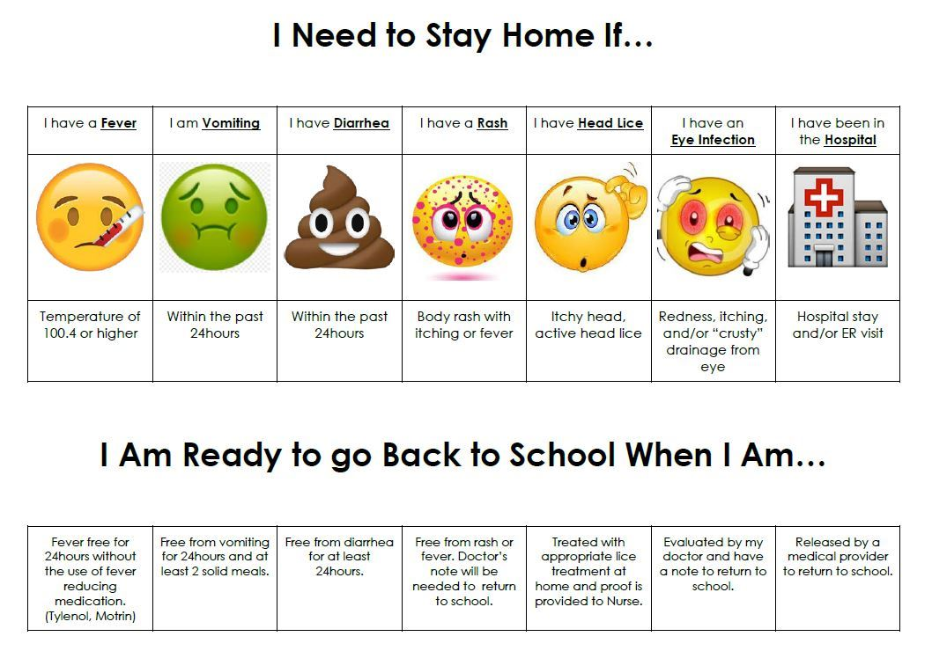

**Cleaning**

Our preschool will adhere to existing facilities cleaning practices and procedures outlined by our local health department, and the standards set out in the Alberta Childcare and Licensing Facility handbook. The preschool has a schedule for increased routine cleaning and disinfecting, especially of frequently touched surfaces and objects. The bathroom will be cleaned and sanitized daily and between use as much as possible.

**Safety Precautions**

* Emergency phone numbers are clearly posted
* Fire drills and safety drill are clearly marked and practiced
* Staff members are required to have up to date First Aid Training
* Our classroom is equipped with a standard First Aid Kit
* Medicines are stored out of children’s reach and administered with written permission of parent/guardian
* Children are supervised at all times and appropriate child: staff ratios are maintained.
* Cleaning supplies are stored in a secured area and kept out of children’s reach
* Staff will properly document accidents, incidents and health-related situations
* Universal precautions for blood related incidents are followed
* Latex gloves are always available for staff
* Toys are checked frequently and broken toys are discarded
* Anti-bullying, character education and mindfulness are built into our preschool curriculum